**Migrate to the path where you want to create your project: -**

cd..

cd..

cd MSc

cd Project

dir

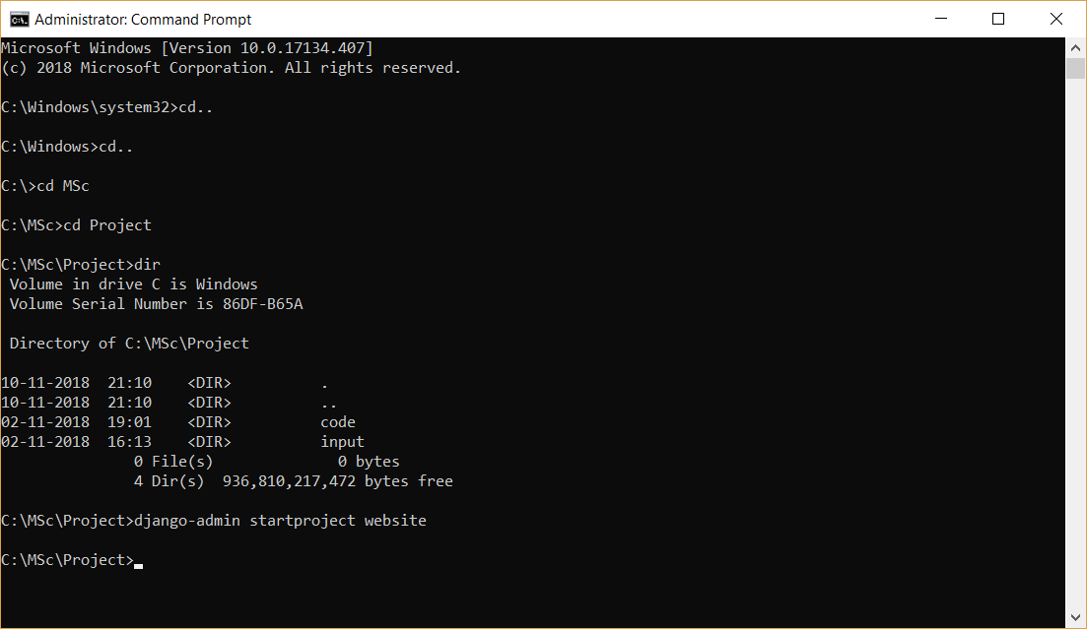

**Creating project “website”:-**

django-admin startproject website



**Opening project in Atom:-**

Drag and drop “website” folder in Atom.

**Migrate to the “website” folder:-**

cd website

dir

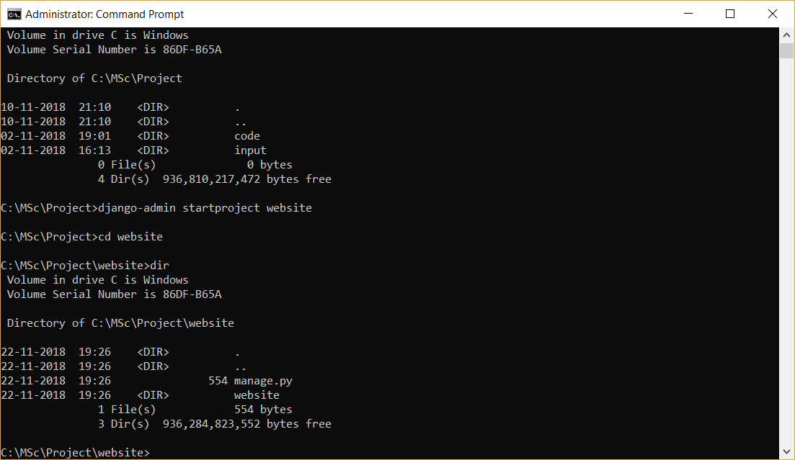

**Creating app inside project: -**

python manage.py startapp notifications

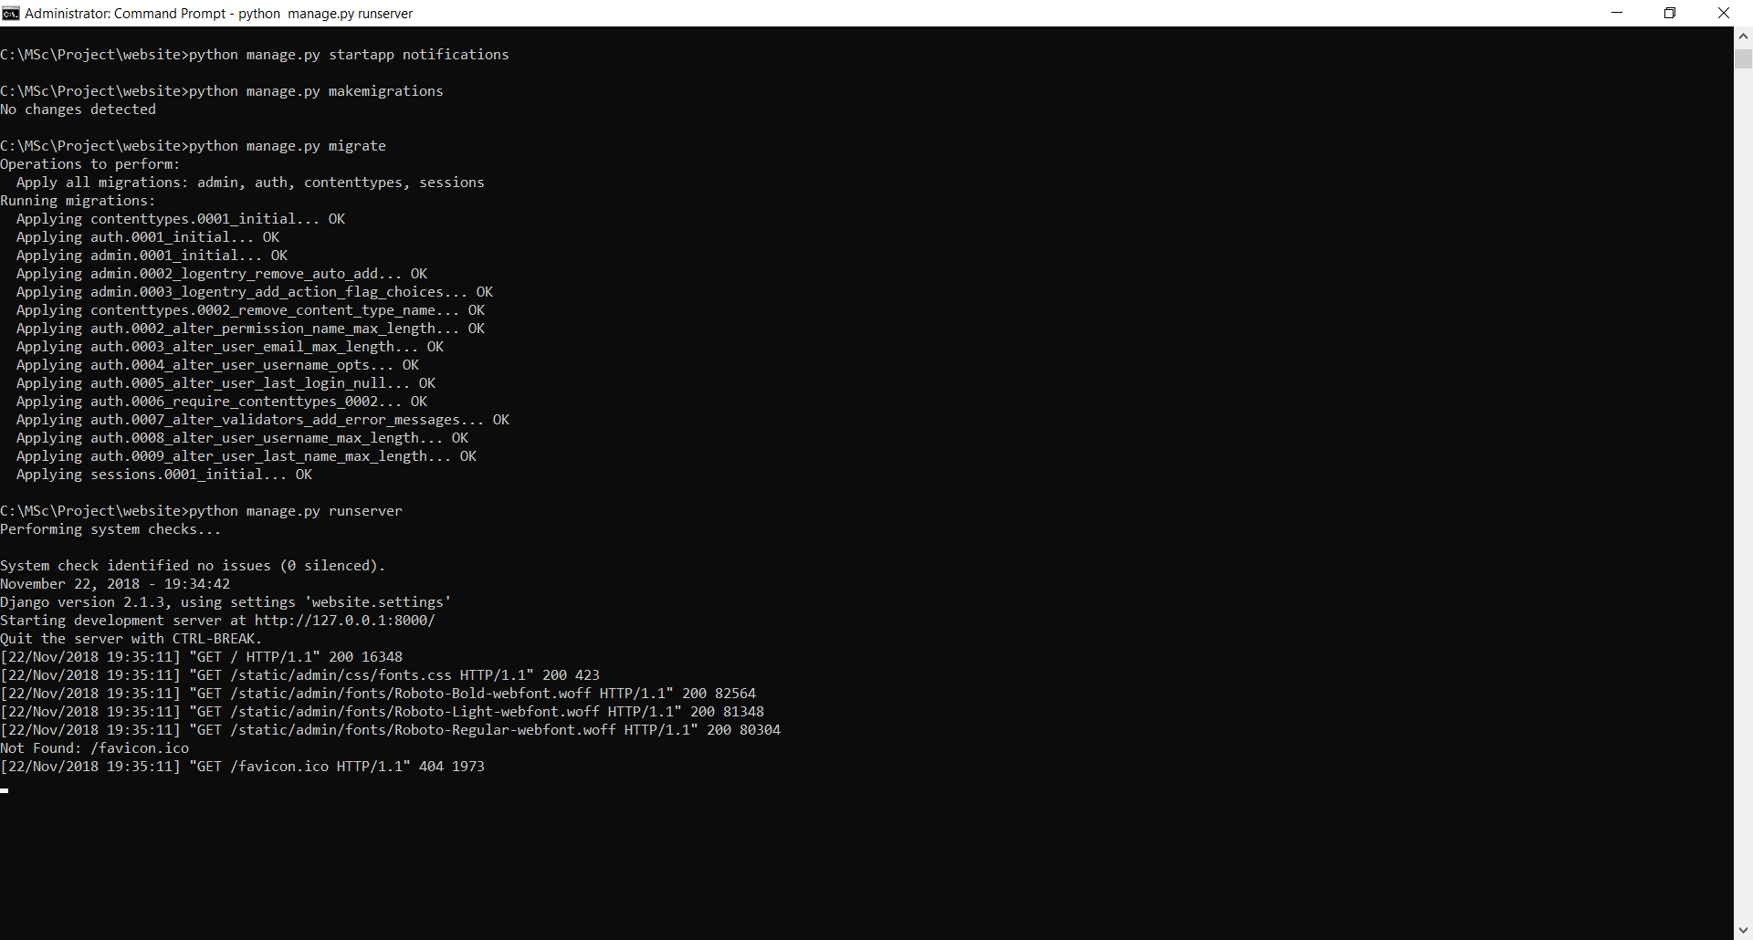

In website –> settings.py file, add “notifications” in INSTALLED_APPS: -

‘notifications’,

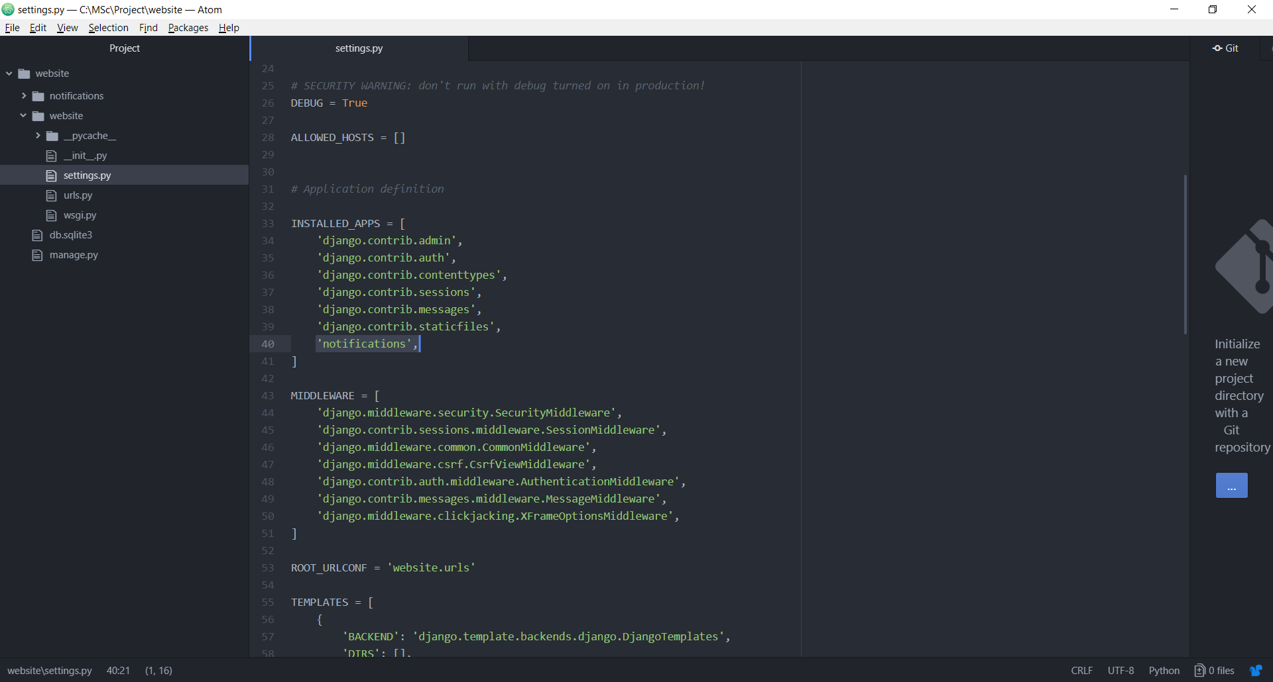

Make necessary migrations so that there’s no warning message while running the server: -

Preparing for migration: -

python manage.py makemigrations



Making migration: -

python manage.py migrate



Deploying the project on development server: -

python manage.py runserver



Open the browser and type the following URL:- <http://127.0.0.1:8000/> .This project has deployed successfully.

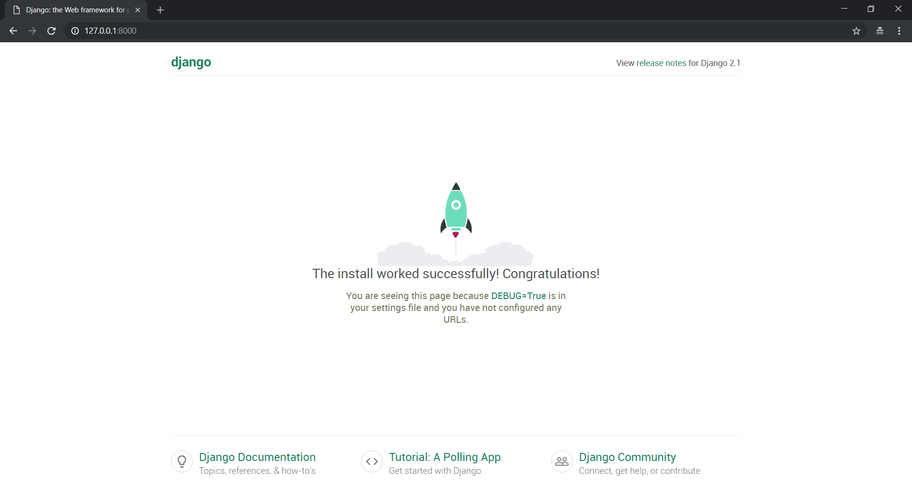

Hit Fn +B to break.

**Create admin user:-** sushmita/America@2020

python manage.py createsuperuser

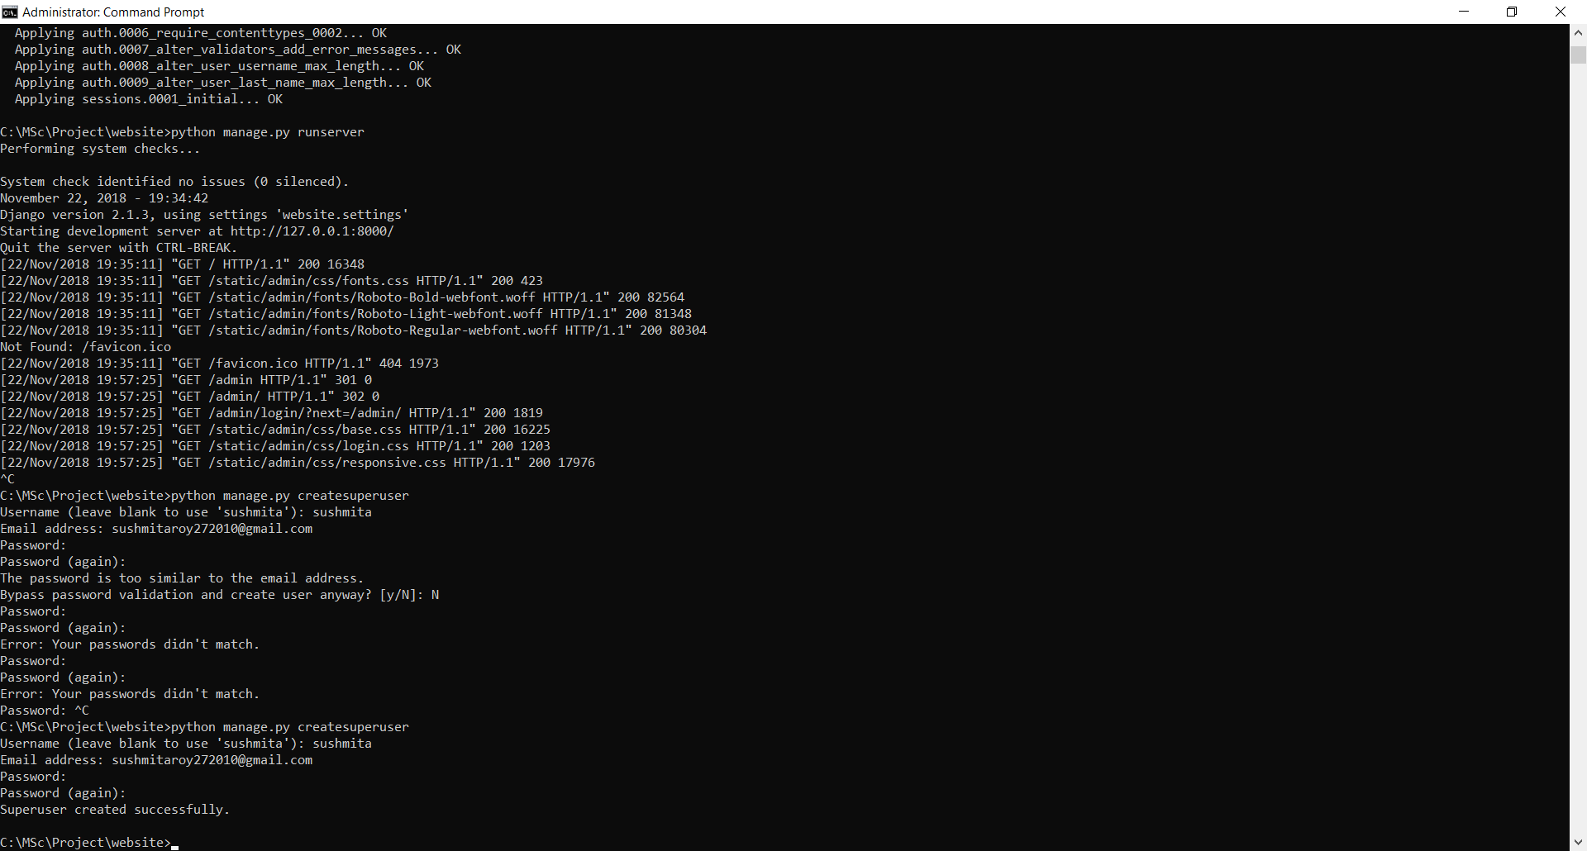

Run project again as:-

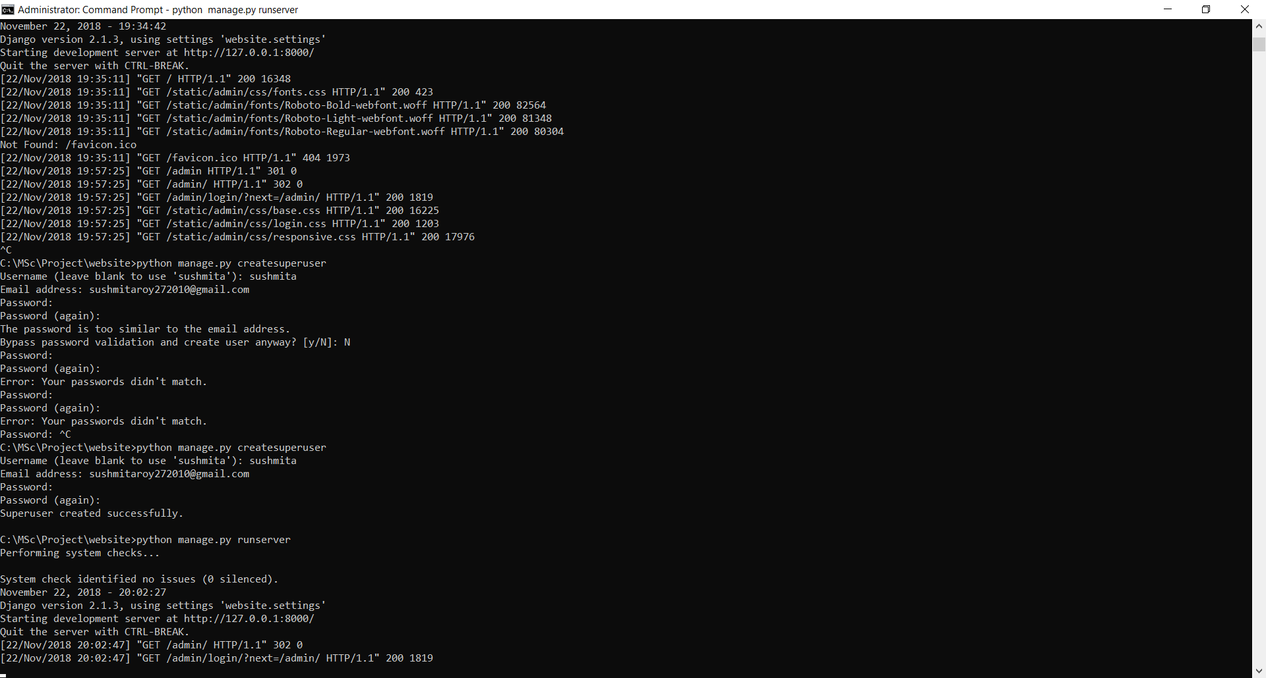

Open the browser and type the following URL:- <http://127.0.0.1:8000/admin>

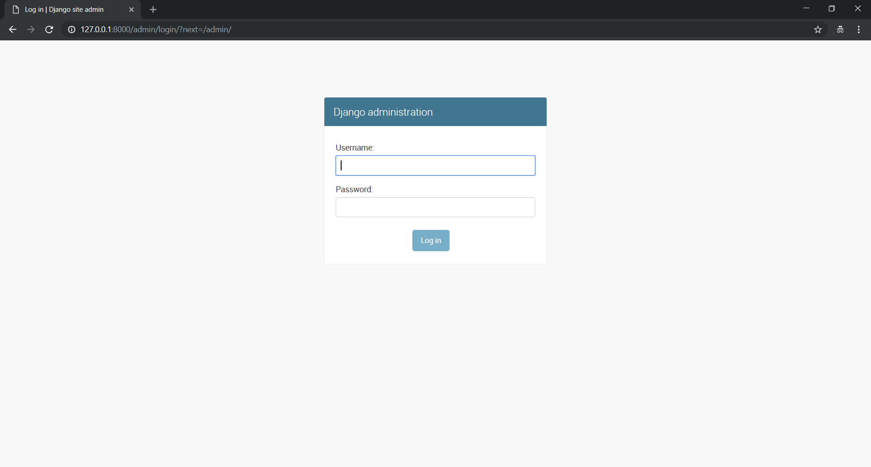

Login with your credentials:-

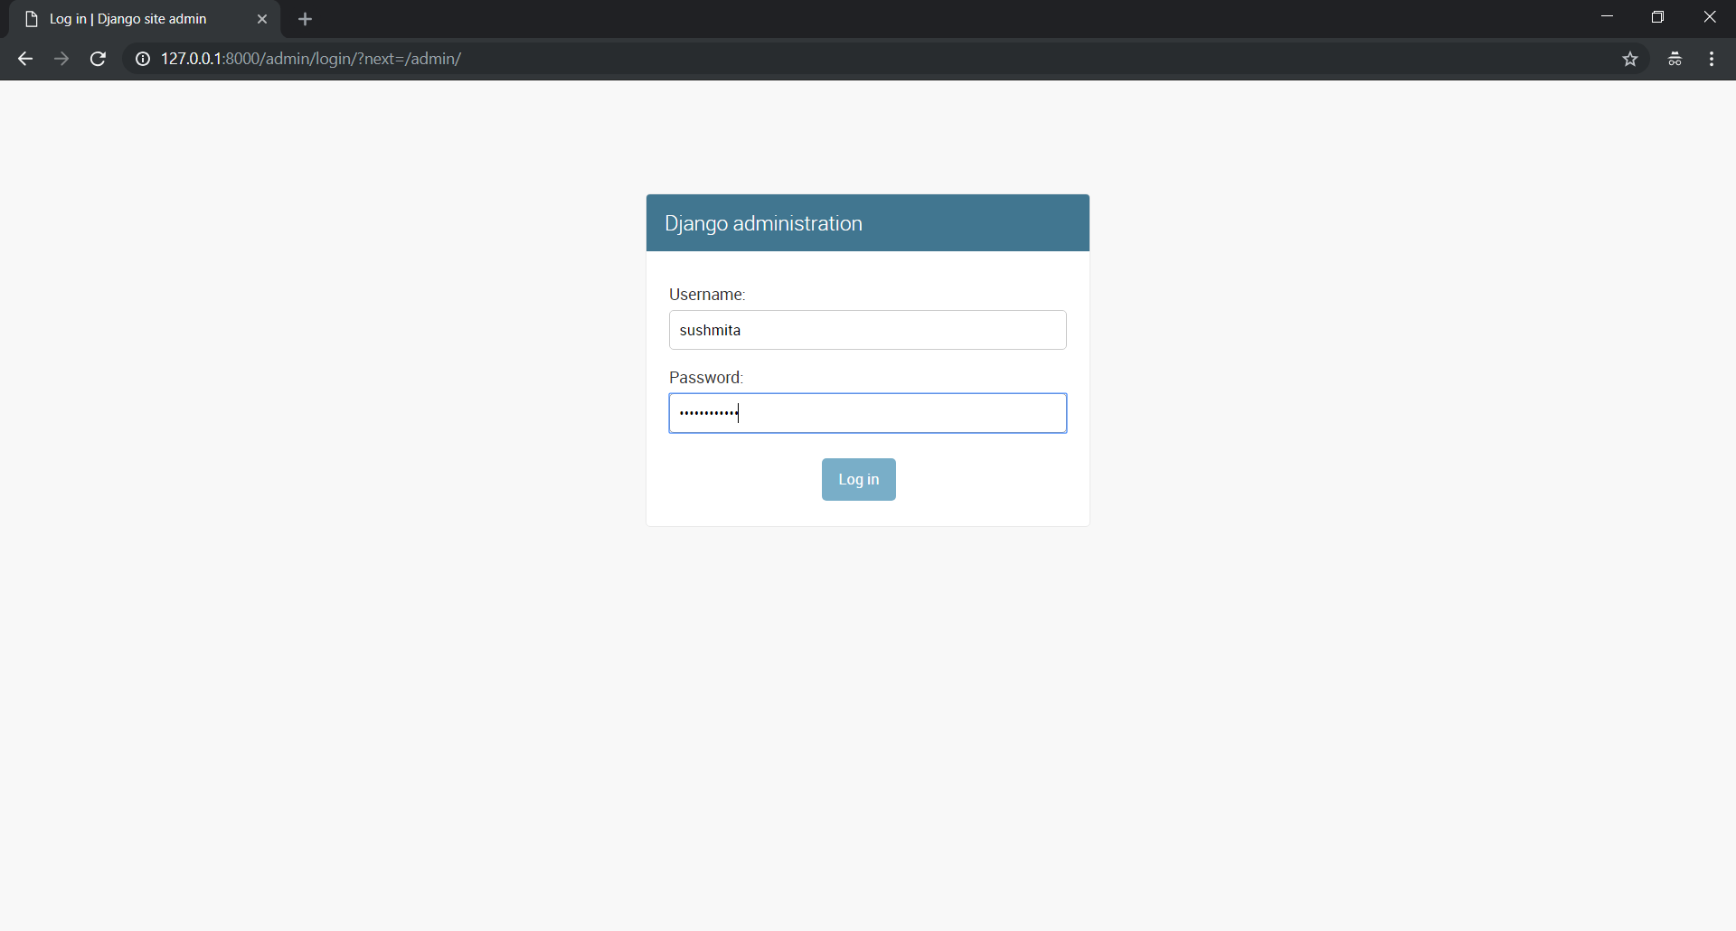

This is the default view for the admin:-

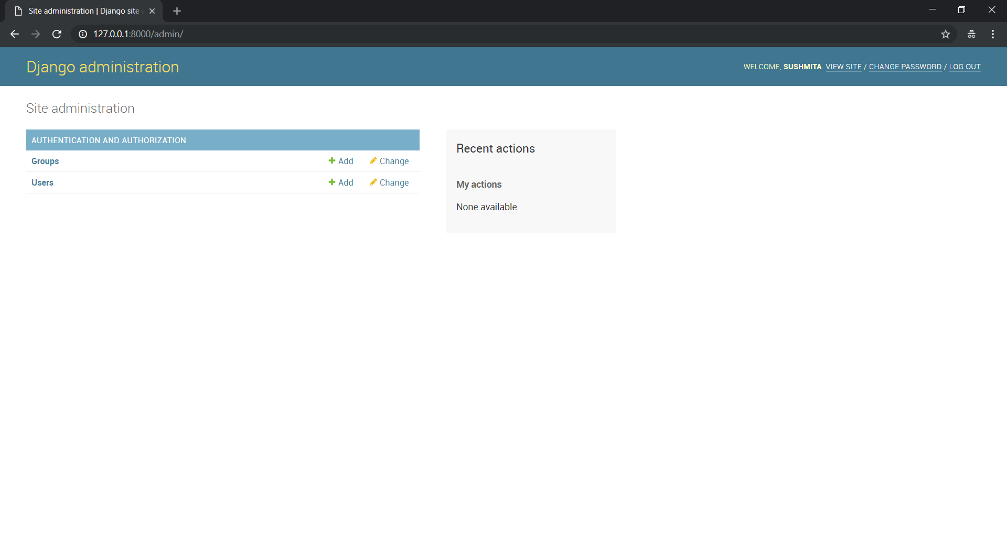

Go to notifications -> models.py and write the following code: -

class Notification(models.Model):

author = models.ForeignKey(

'auth.user',

on_delete = models.CASCADE,

)

title = models.CharField(max_length=200)

text = models.TextField()

def __str__(self):

return self.title

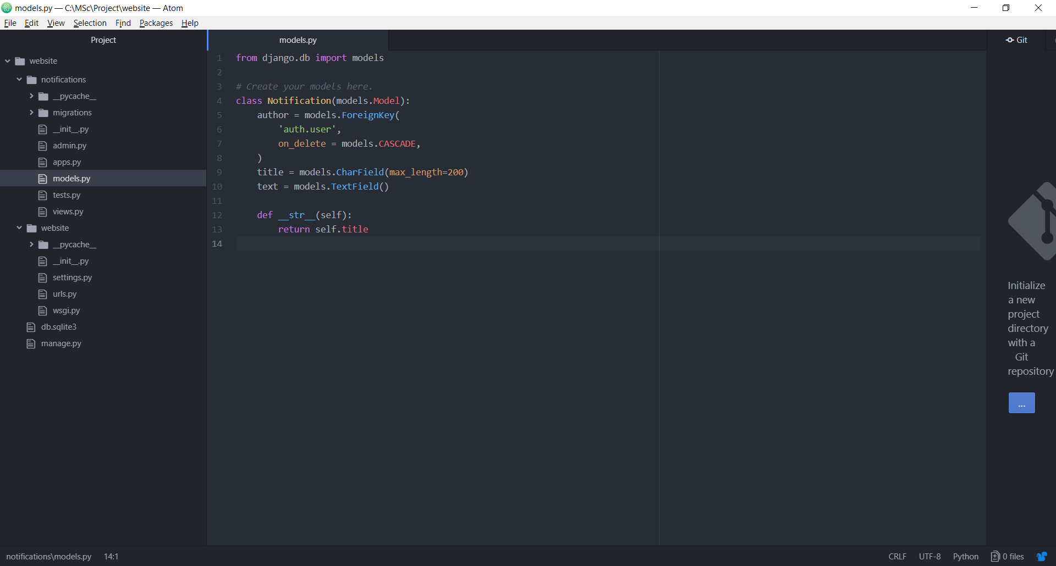

**Registering the models to admin.py so that it is visible in the admin section:-**

Go to notifications -> admin.py and write the following code: -

from .models import Notification

admin.site.register(Notification)

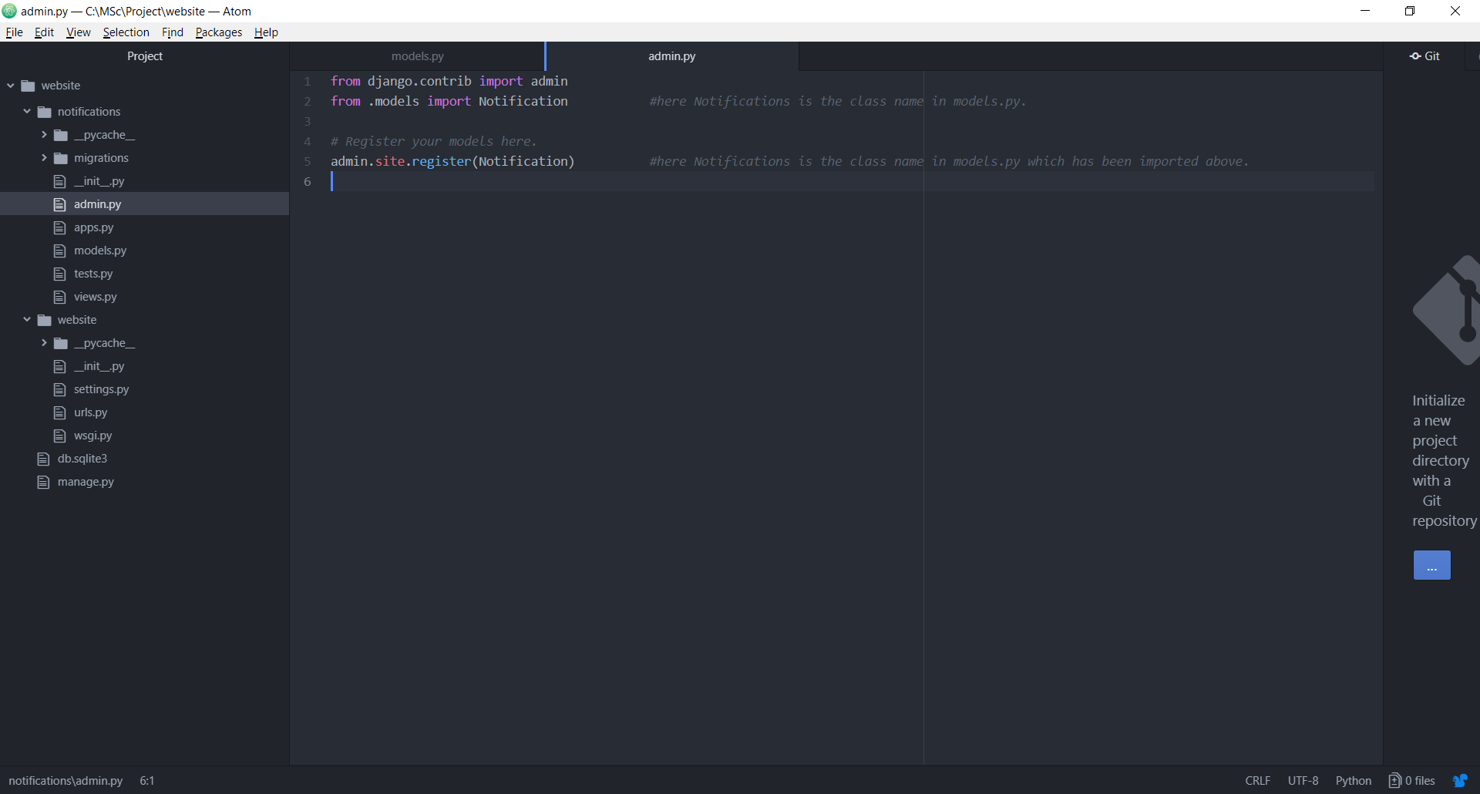

Preparing for migration: -

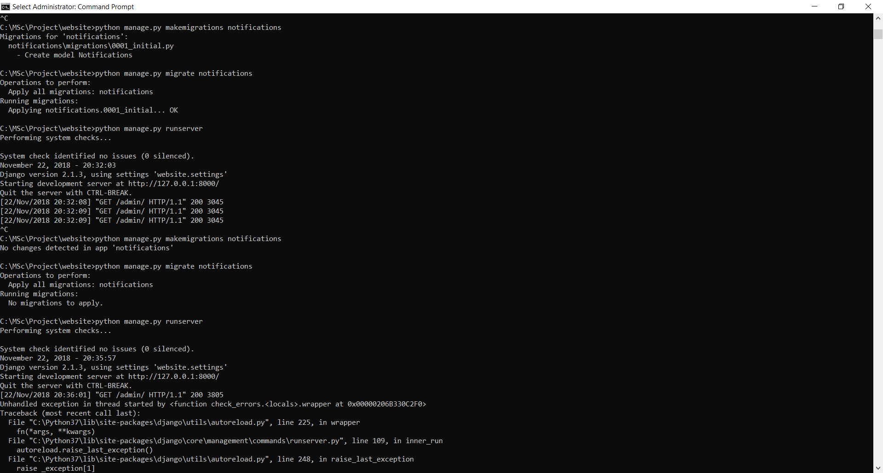

Make migration: -



Run the server: -

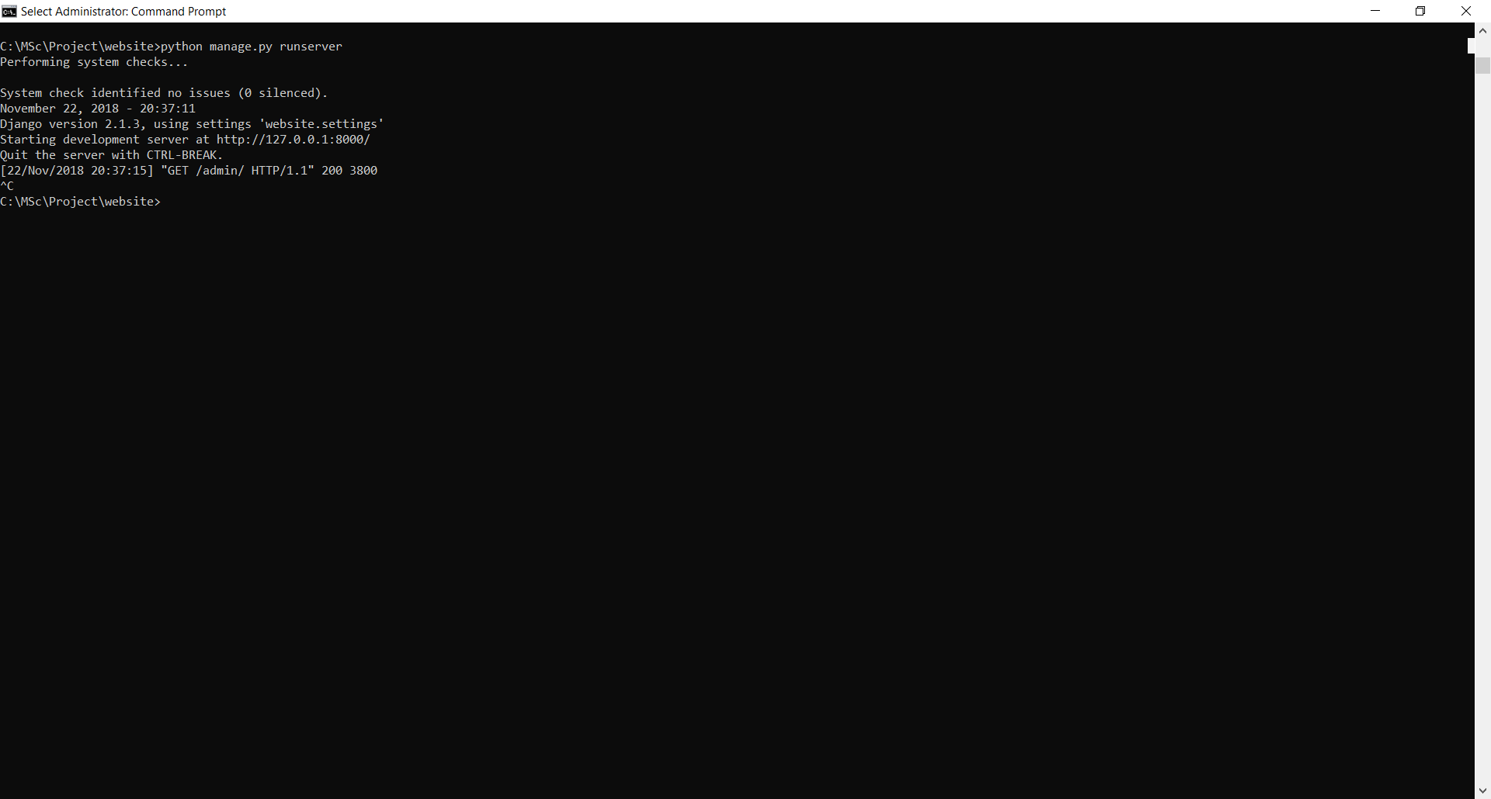

Open the browser and type the following URL:- <http://127.0.0.1:8000/admin>

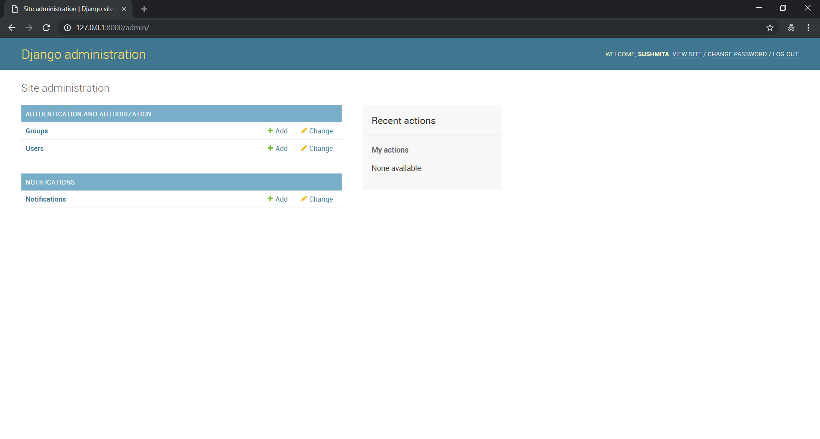

Click on “Add” besides “Notifications”. The following form is displayed:-

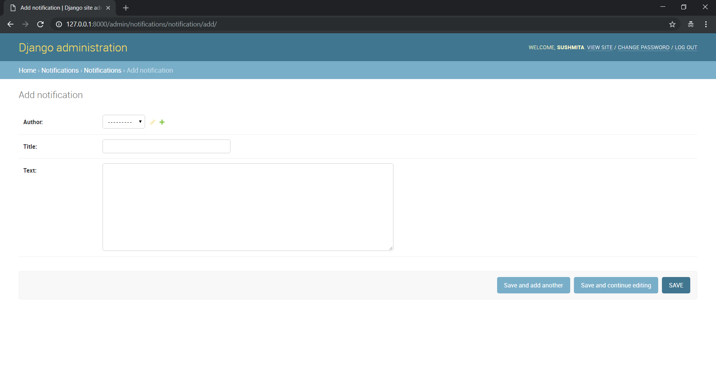

Write contents as below and click on “Save”.

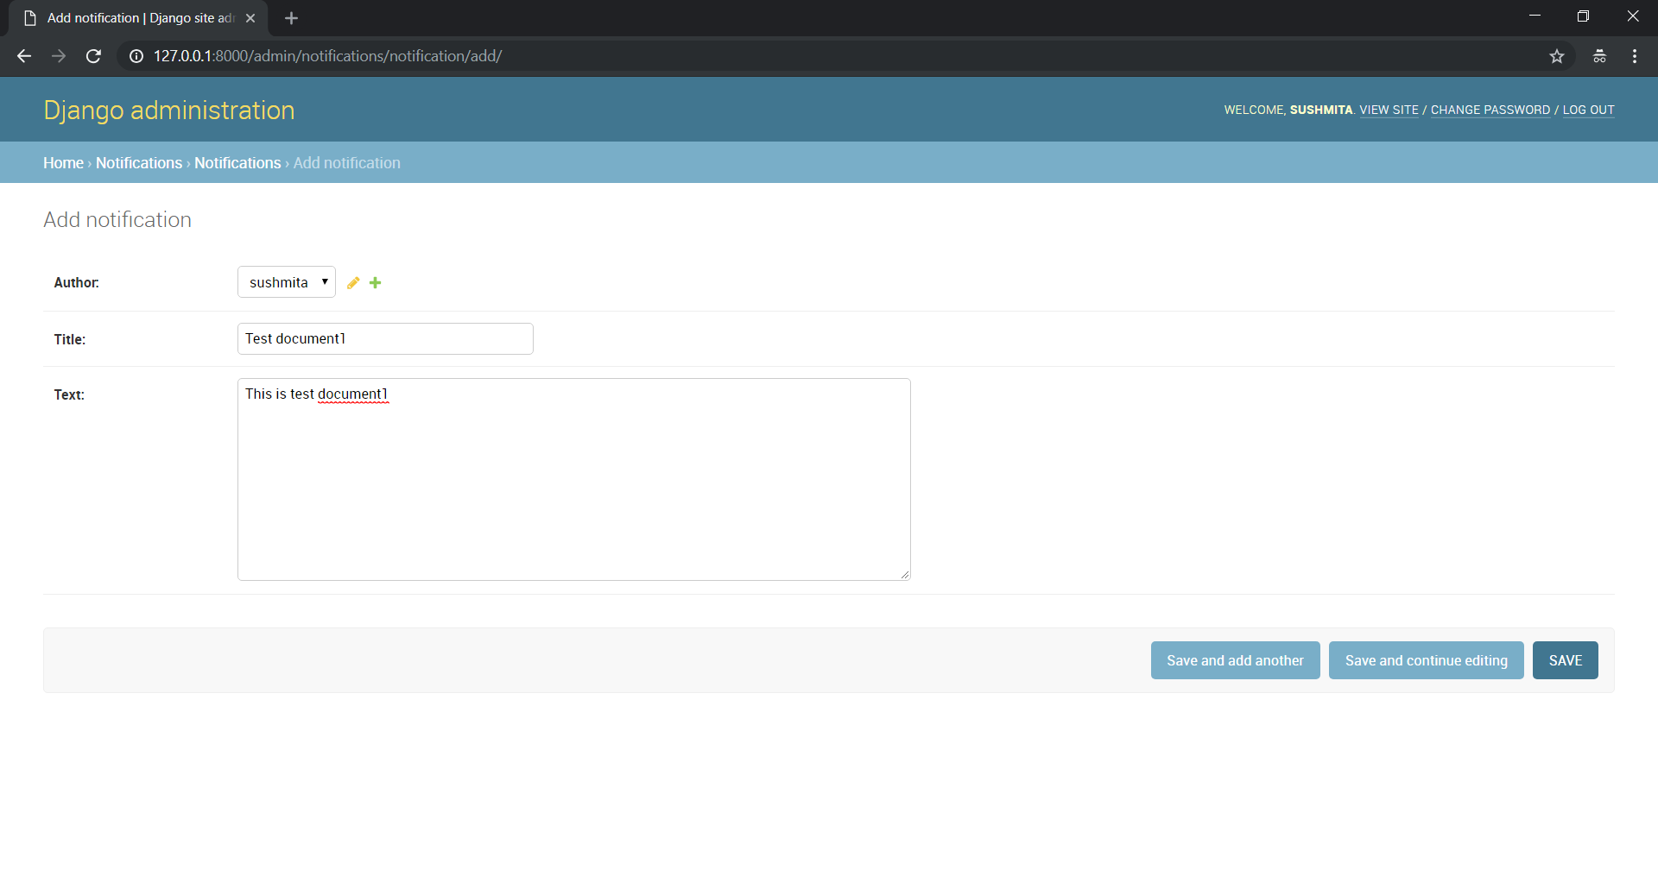

The following is displayed: -

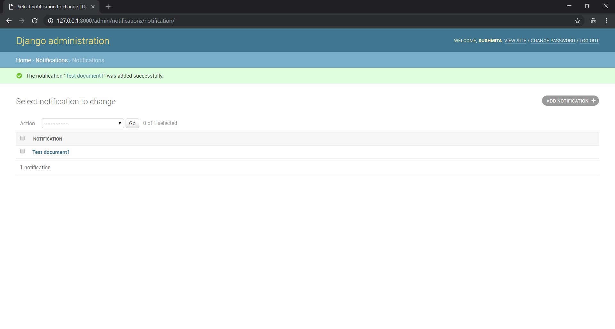

Similarly add another notification.

**Configuring the URL i.e. whatever admin is writing should be visible to user on the home page: -**

Go to website -> urls.py: -

from django.urls import path

from django.urls import include

urlpatterns = [

path('admin/', admin.site.urls),

path('', include('notifications.urls')),

]

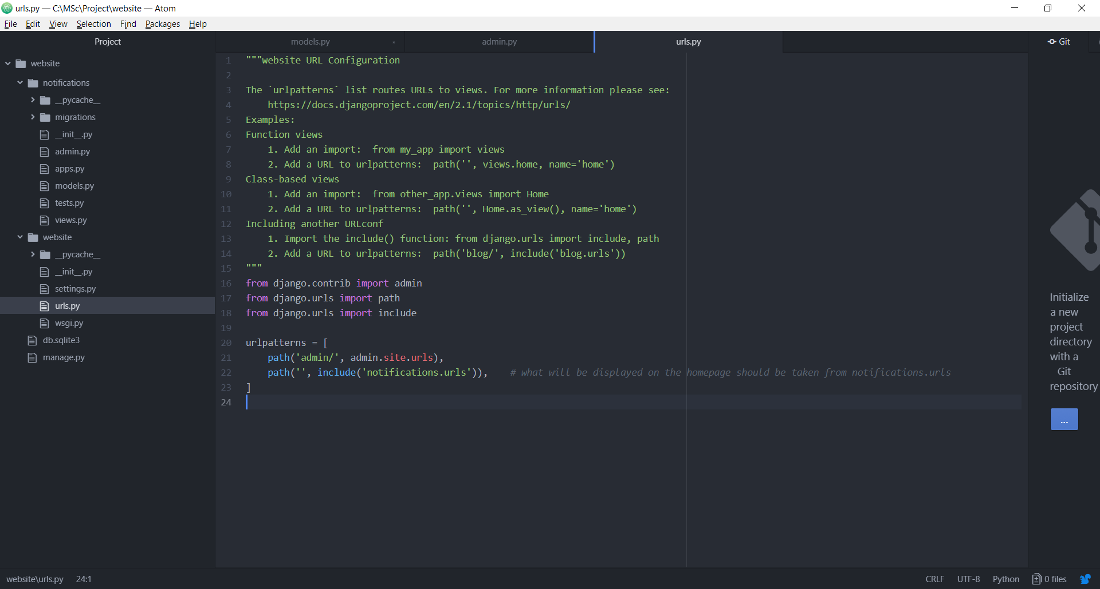

Since “urls.py” does not exist in the “notifications” app, we need to create this file. Right click on “notifications” app -> New File -> urls.py

from django.urls import path

from . import views

urlpatterns = [

path('', views.NotificationListView.as_view(), name = 'home'),

]

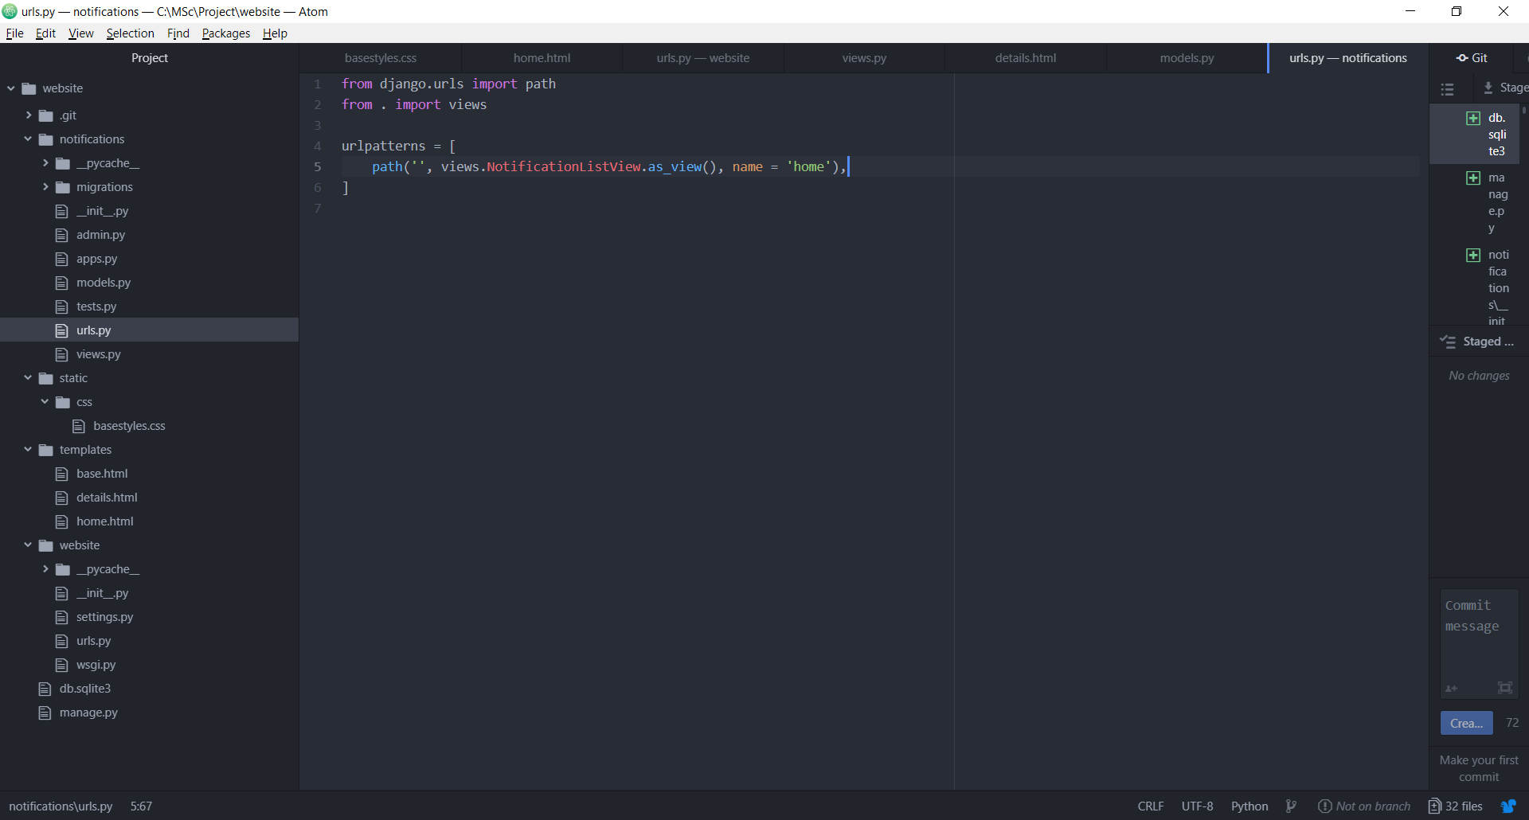

Go to notifications -> views.py: -

from django.views.generic import ListView

from .models import Notification

class NotificationListView(ListView):

model = Notification

template_name = 'home.html'

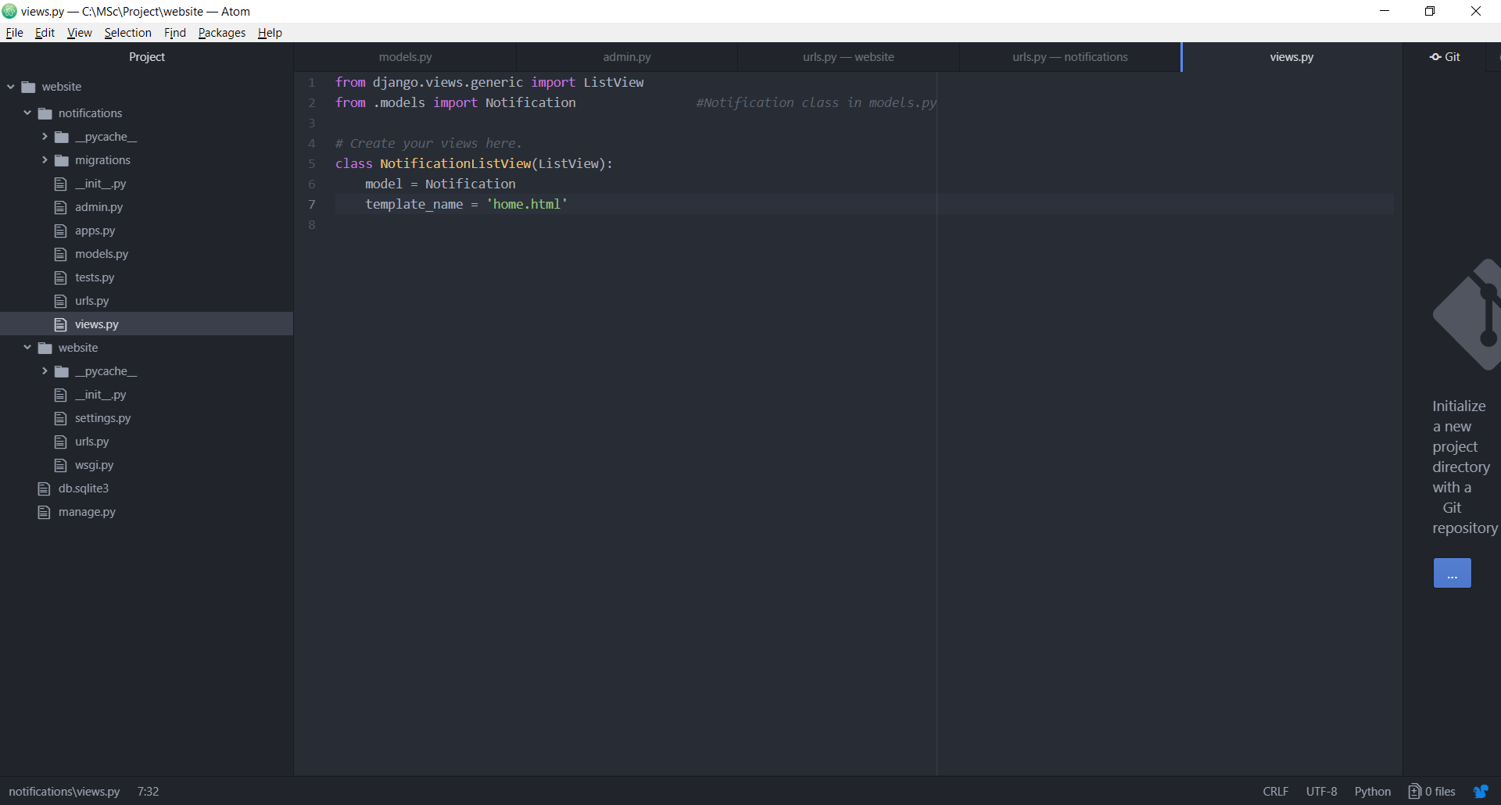

Right click on website i.e. the 1st one i.e. the project folder -> New Folder -> Name: templates

Right click on templates -> New File -> Name: home.html

Right click on templates -> New File -> Name: base.html

Go to website -> settings.py, add templates here now: -

'DIRS': [os.path.join(BASE_DIR,'templates')],

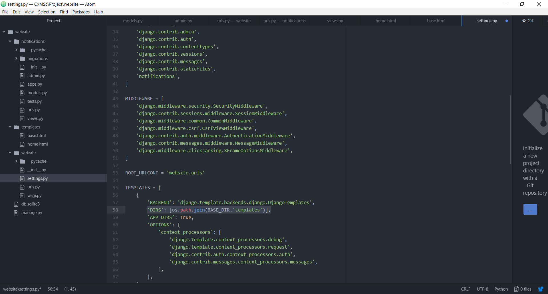

**Setting up the home page: -**

Go to base.html: -

<!DOCTYPE>

<html lang = "en">

<head>

<meta charset = "UTF-8">

<meta name = "viewport" content = "width = device-width, initial-scale = 1.0">

<meta http-equiv = "X-UA-Compatible" content = "ie = edge">

<title>Cloud-based Movie Recommendation System</title>

</head>

<body>

<header>

<h1> Notifications </h1>

</header>

<div class="container">

{% block content %}

{% endblock content %}

</div>

</body>

</html>

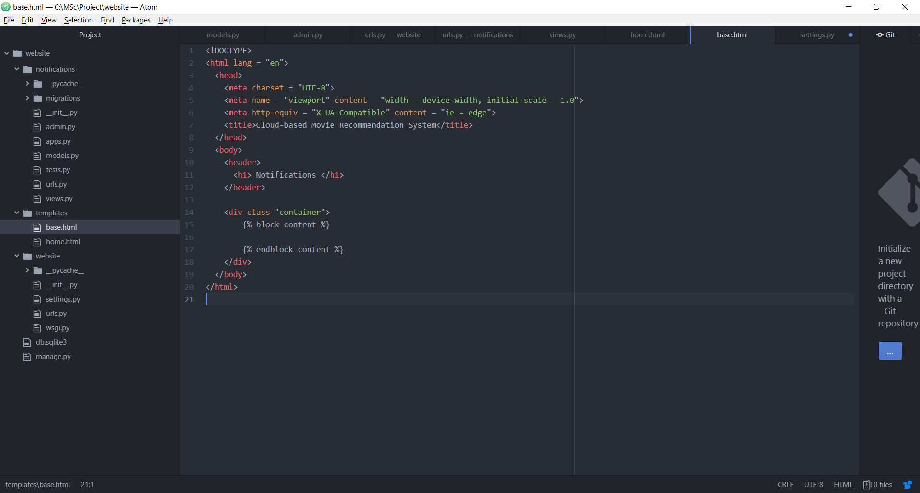

Go to home.html: -

{% extends 'base.html' %}

{% block content %}

{% for num_notifications in object_list %}

<div class = "notification">

<h3><a href = "">{{num_notifications.title}}</a></h3>

<p>{{num_notifications.text}}</p>

</div>

{% endfor %}

{% endblock content %}

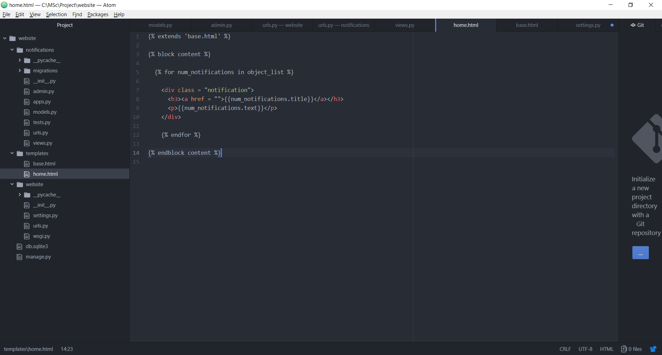

**Add static files for CSS: -**

Right click on website i.e. the 1st project name and select New Folder -> Name: static

Go to website -> settings.py

STATICFILES_DIRS = [os.path.join(BASE_DIR,'static')]

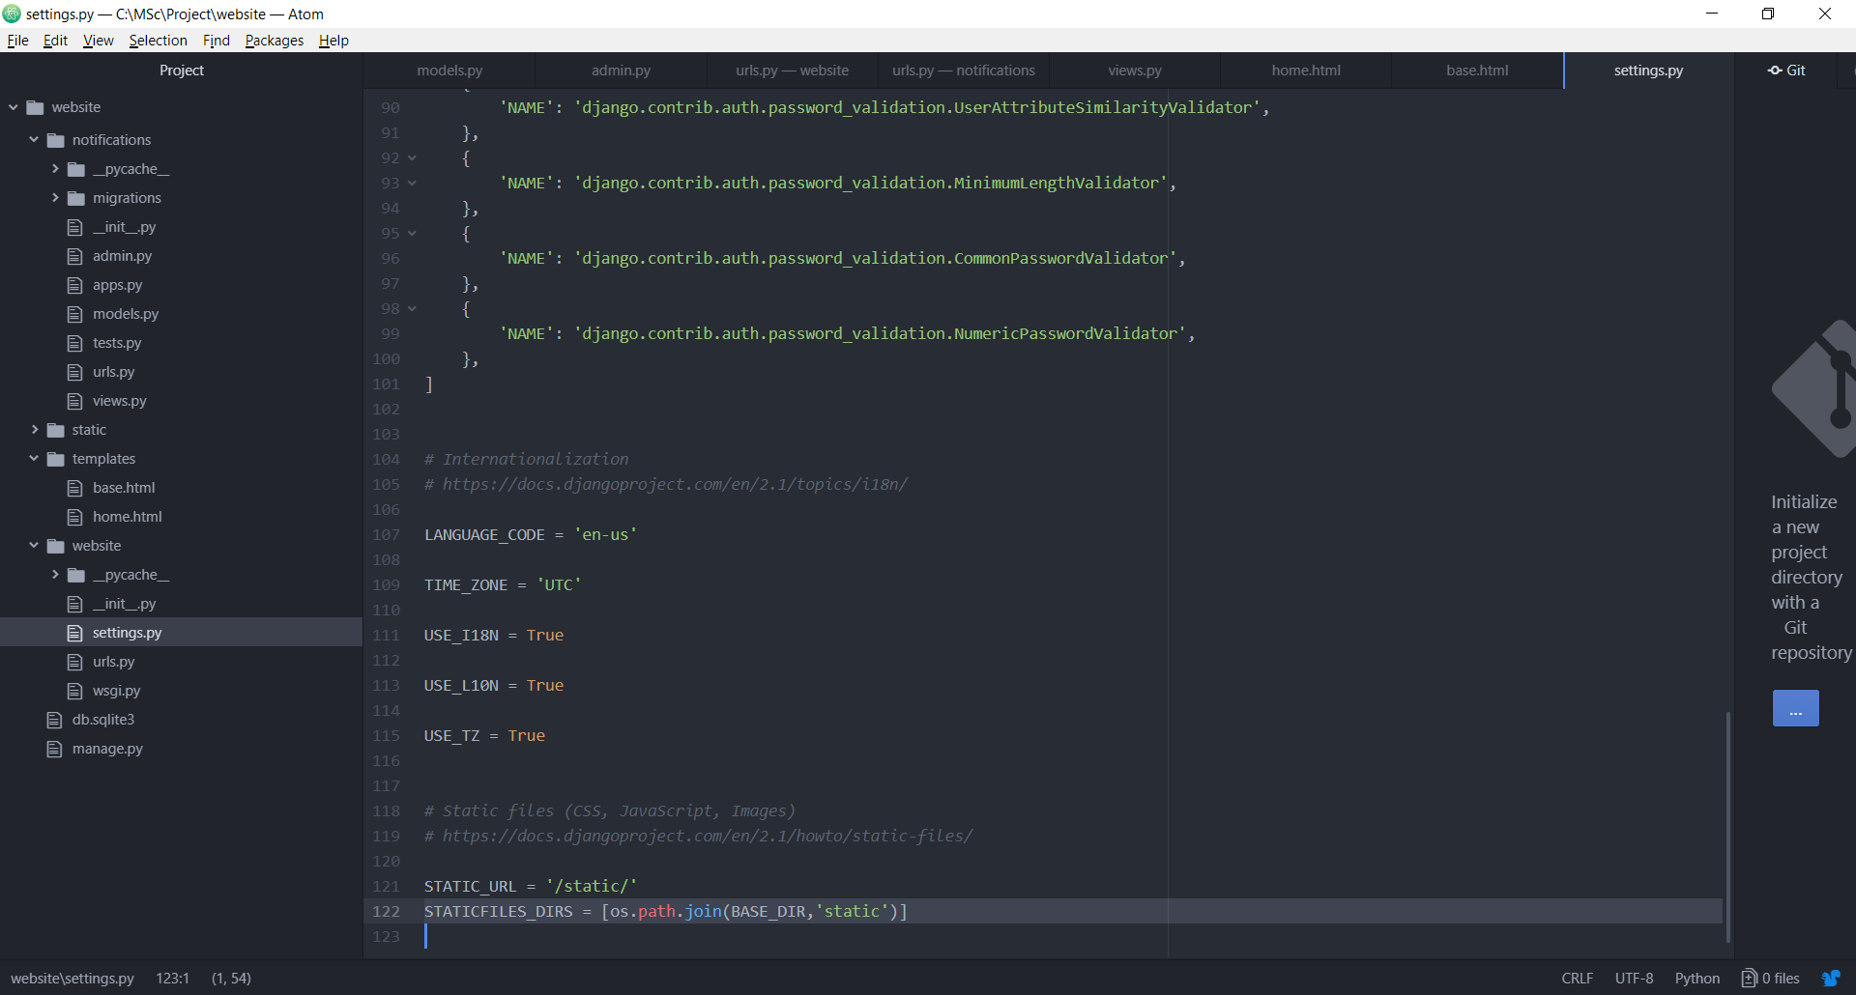

Right click static and select New Folder -> Name: css

Right click css and select New File -> Name: basestyles.css

body

{

background-color: #C1C1C1;

color: #FFF;

}

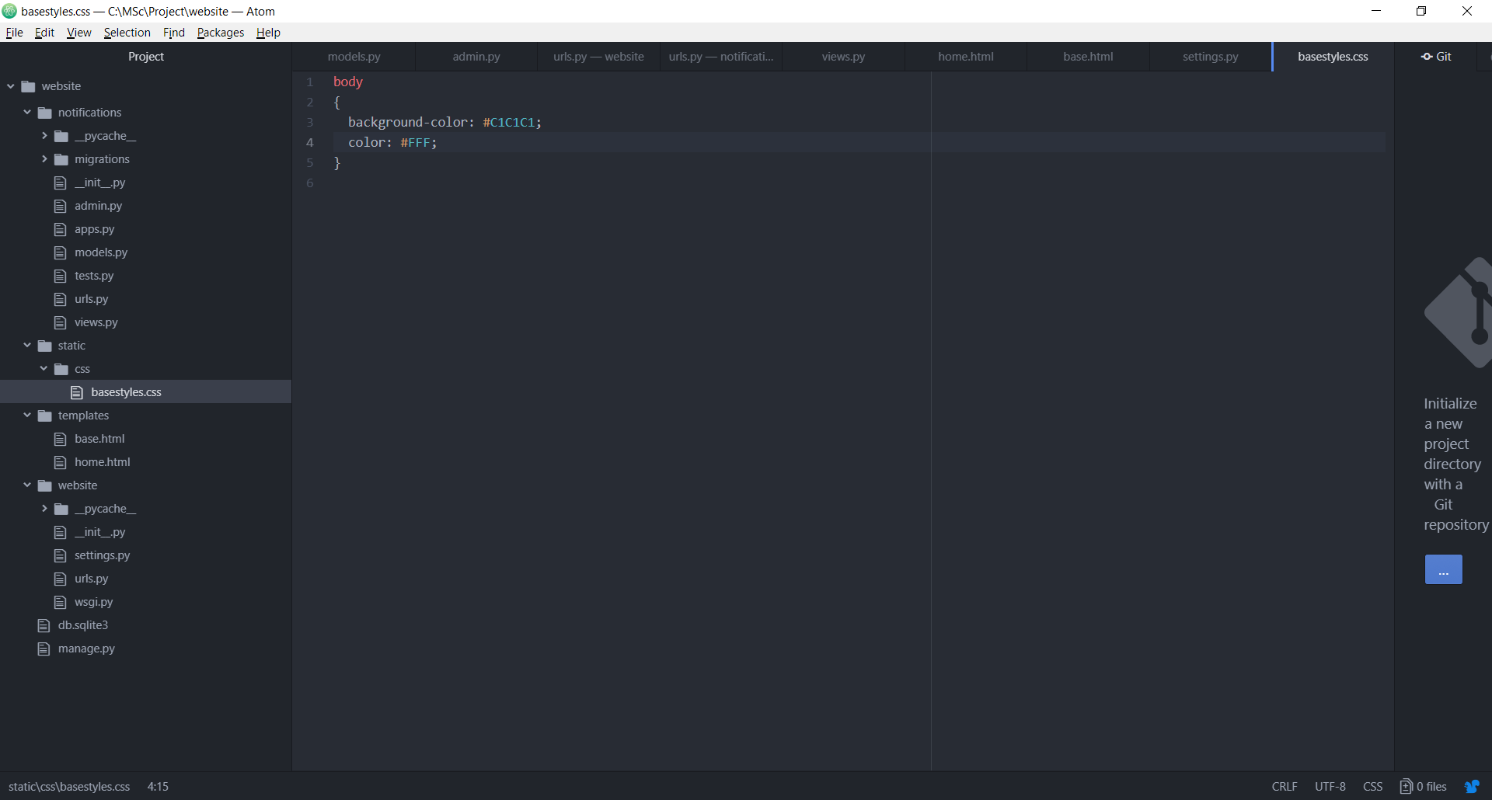

Write the first line in base.html and link tag: -

{% load staticfiles %}

<link rel = "stylesheet" href = "{% static 'css/basestyles.css' %}">

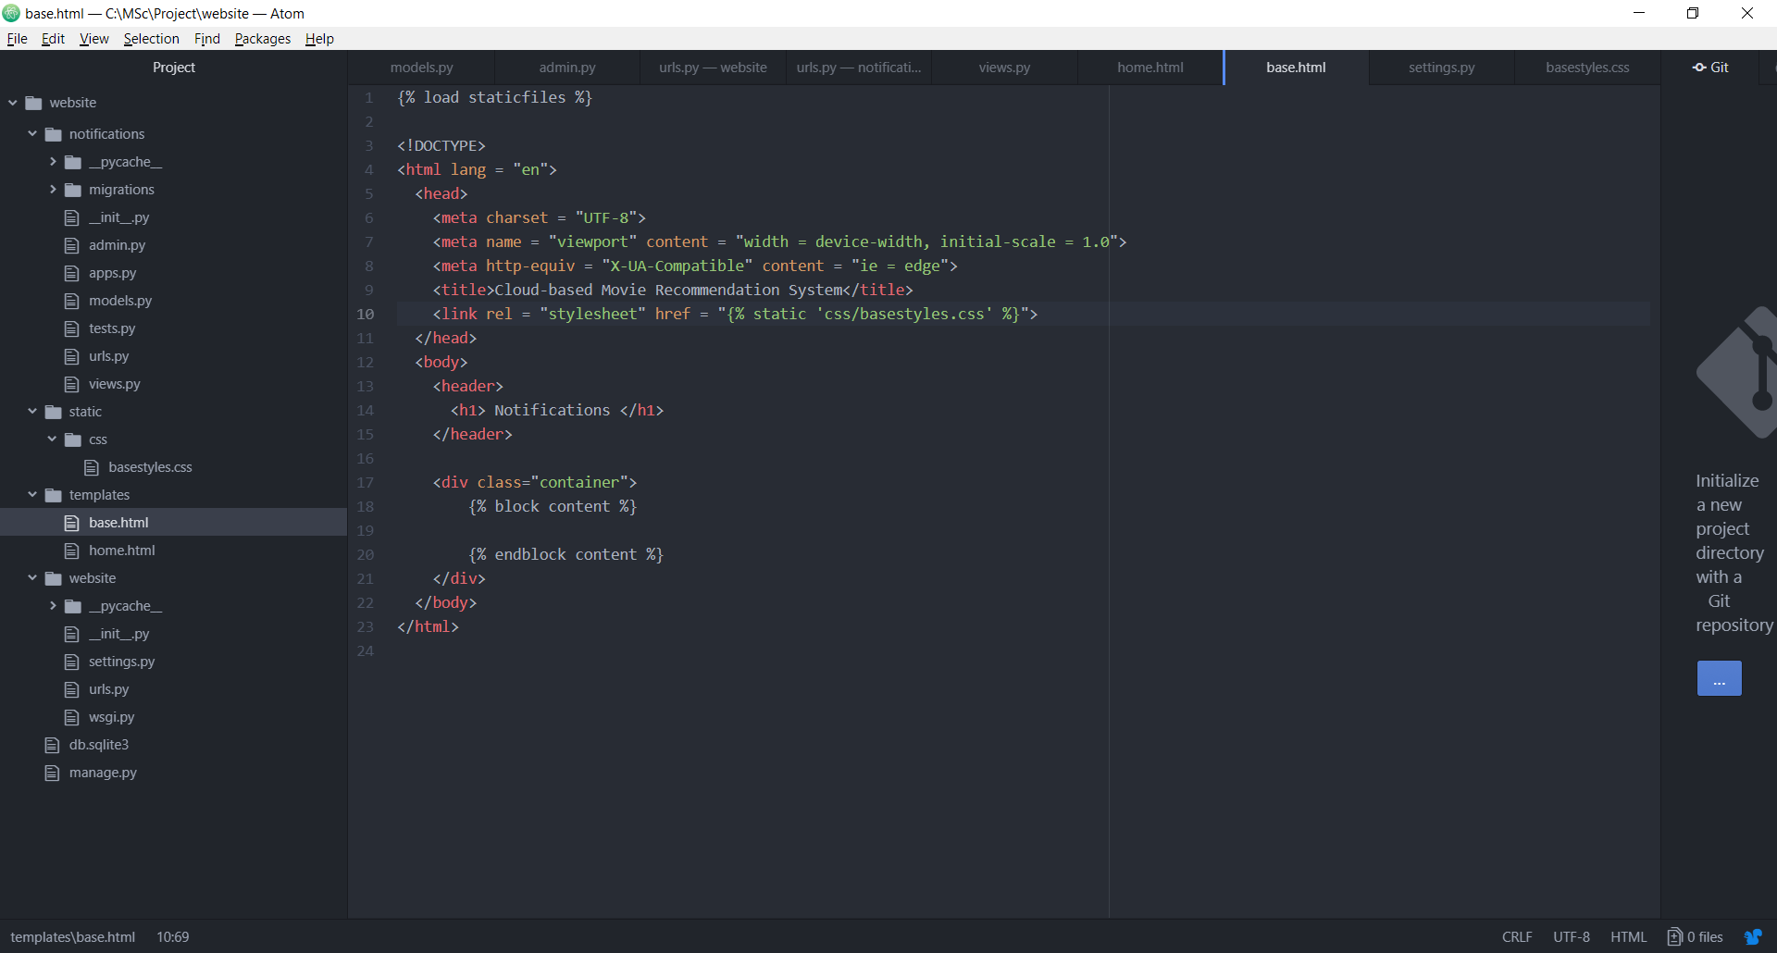

**Unique URL for all articles: -**

Go to notifications -> views.py

from django.views.generic import DetailView

class NotificationDetailView(DetailView):

model = Notification

template_name = 'details.html'

context_object_name = 'notify'

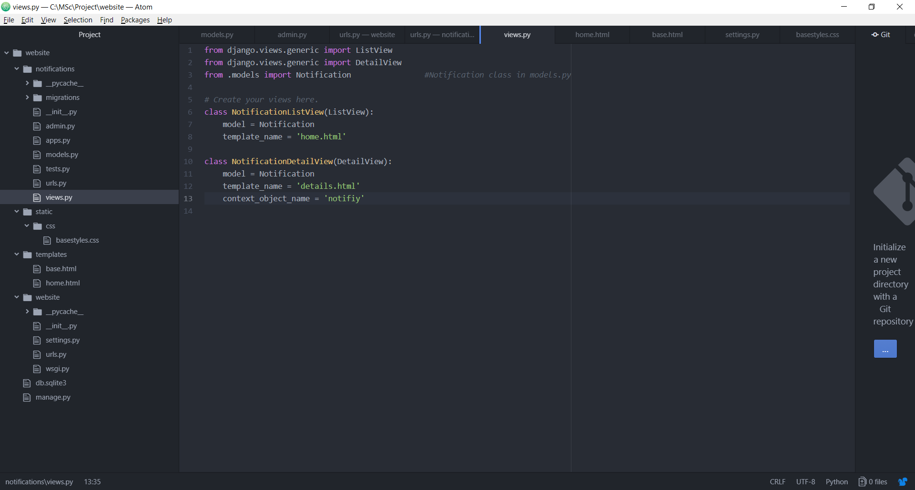

Right click on templates and select New File -> Name: details.html

{% extends 'base.html' %}

{% block content %}

<div class = "details">

<h2>{{notify.title}}</h2>

<p>{{notify.text}}</p>

</div>

{% endblock content %}

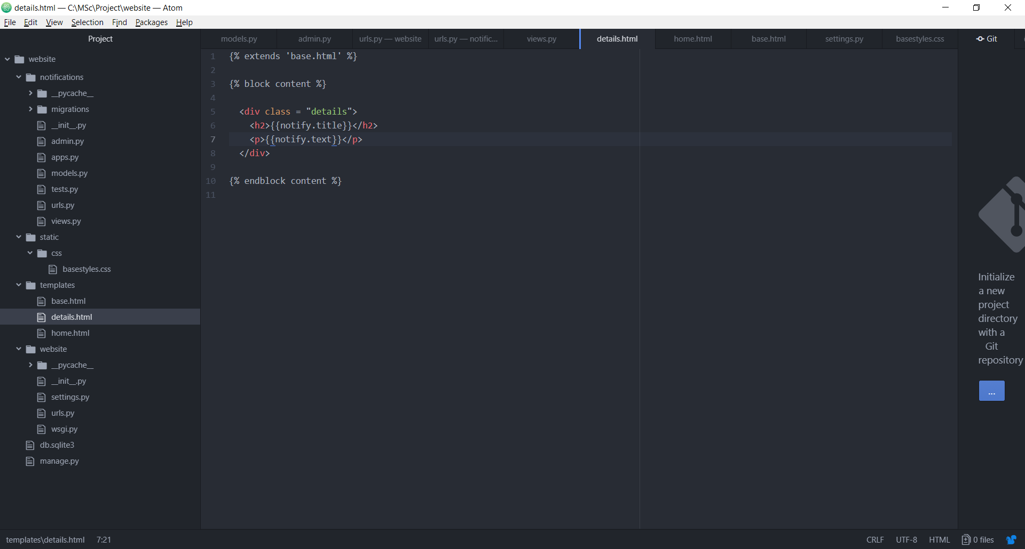

Go to notifications -> urls.py: -

path('notification/<int:pk>', views.NotificationDetailView.as_view(), name = 'notification_page'),

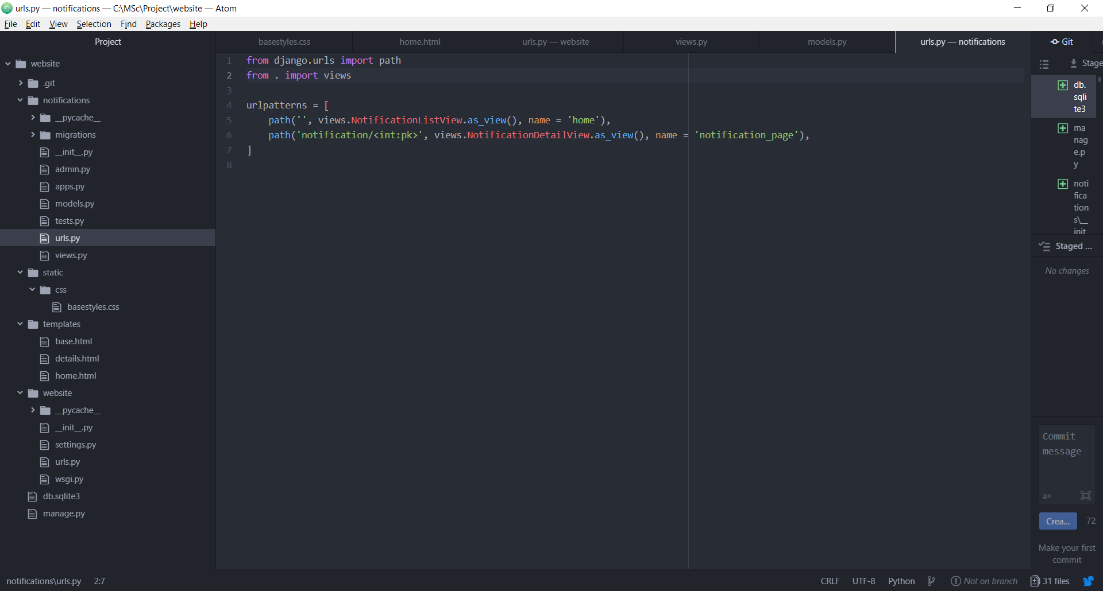

Go to home.html: -

<a href = "{% url 'notification_page' num_notifications.pk %}">{{num_notifications.title}}</a>

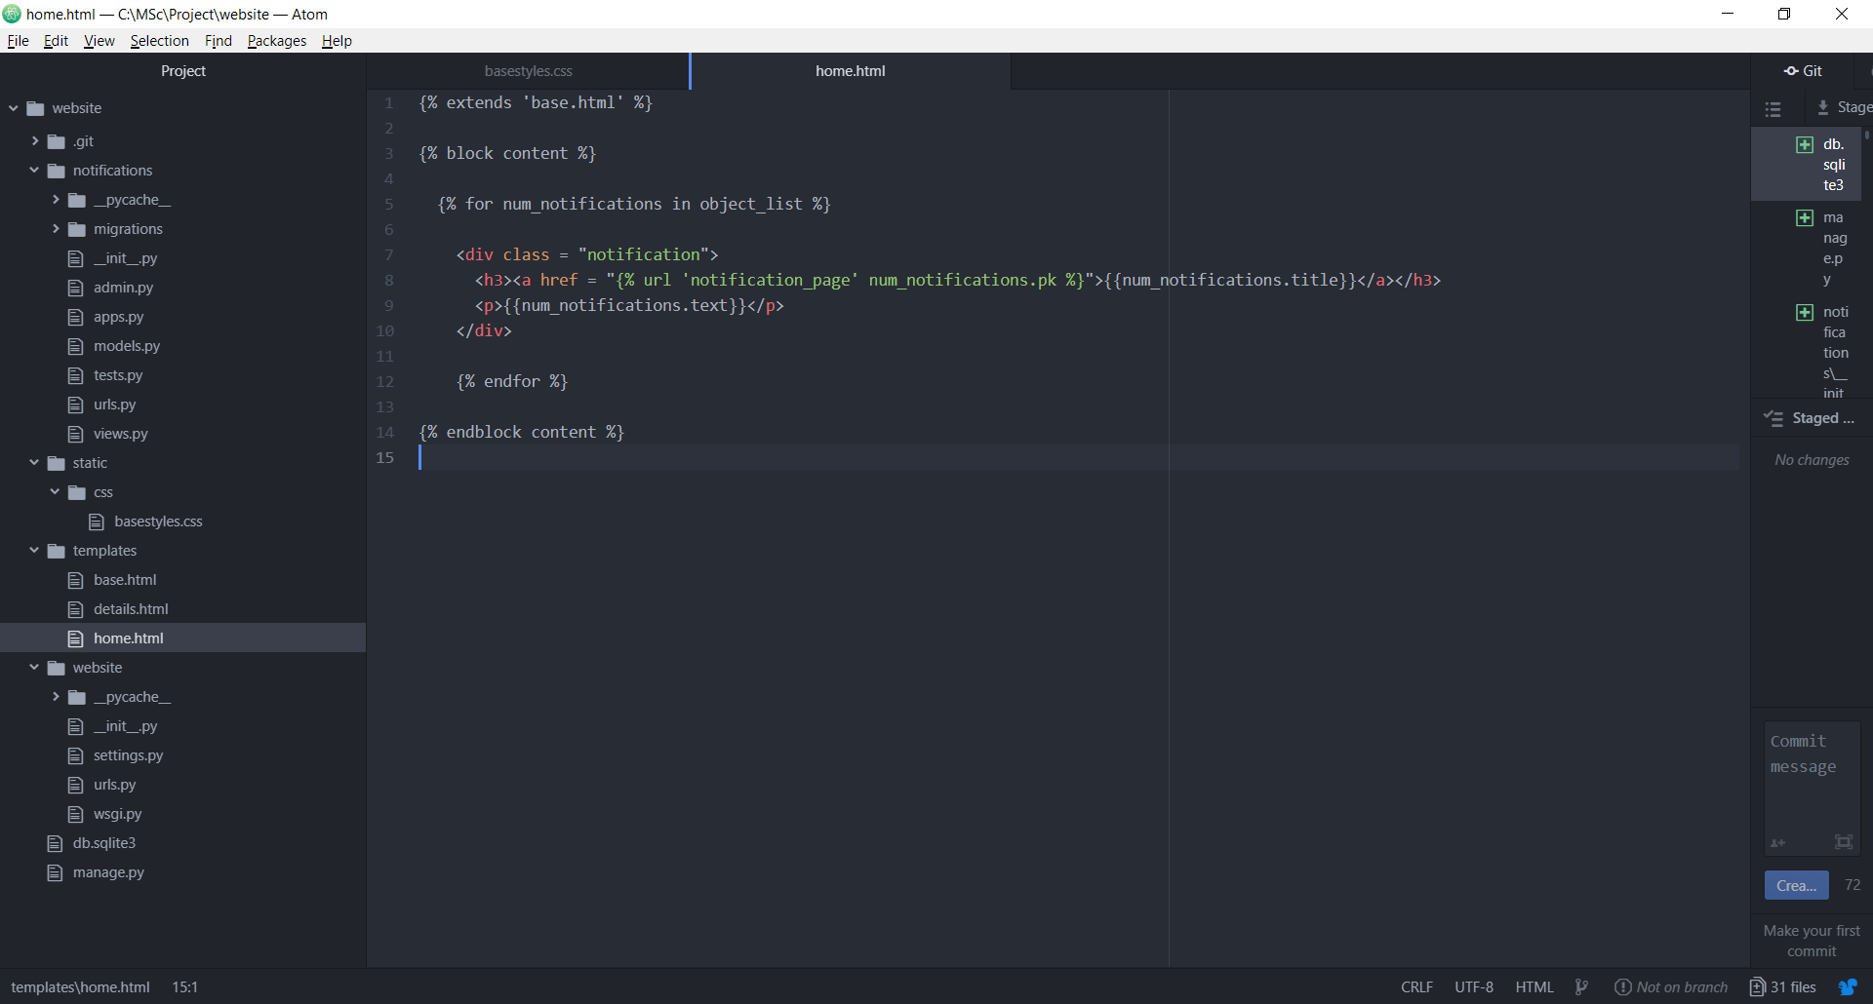

Preparing for migration: -

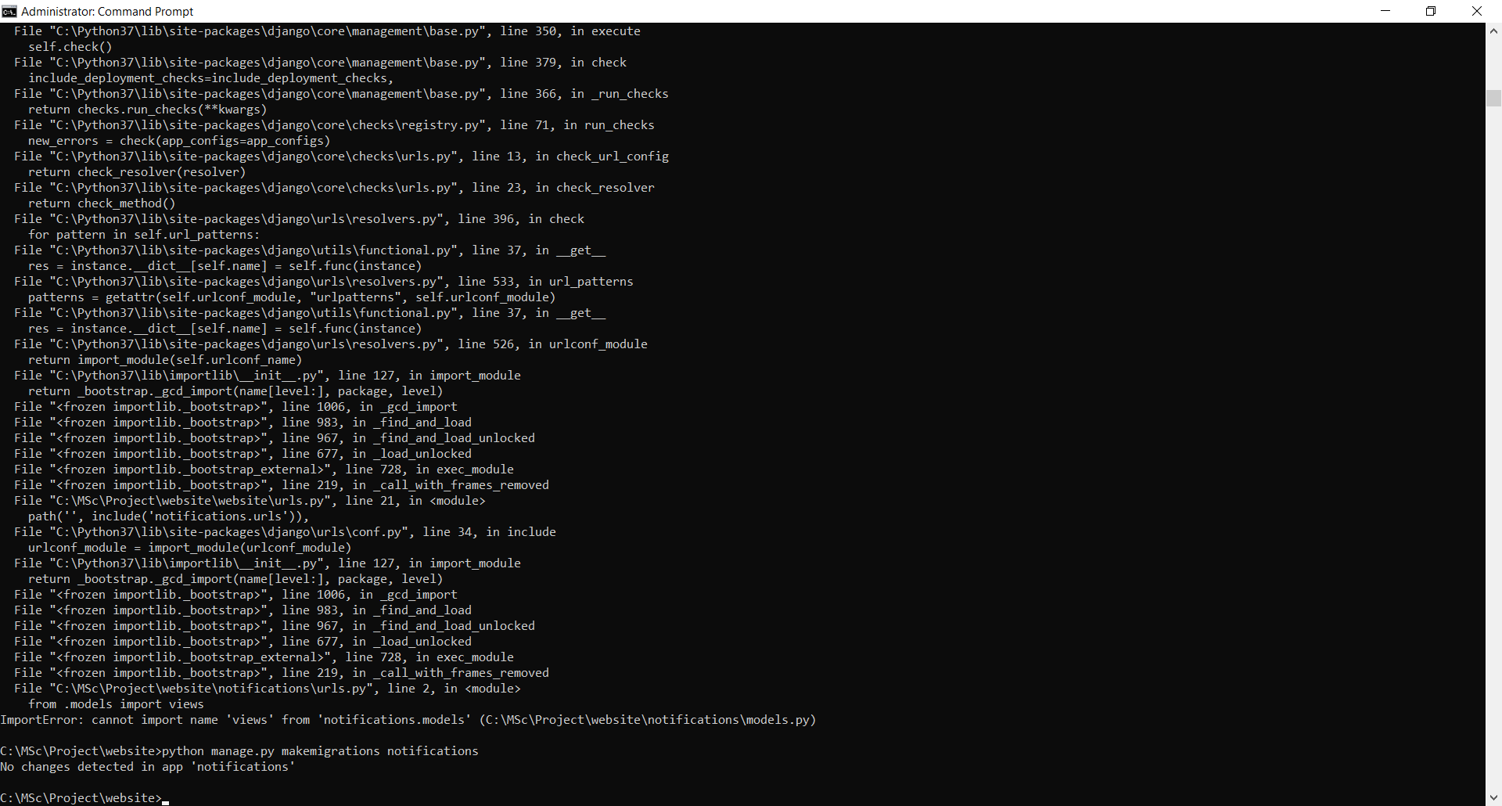

Migrate the changes: -

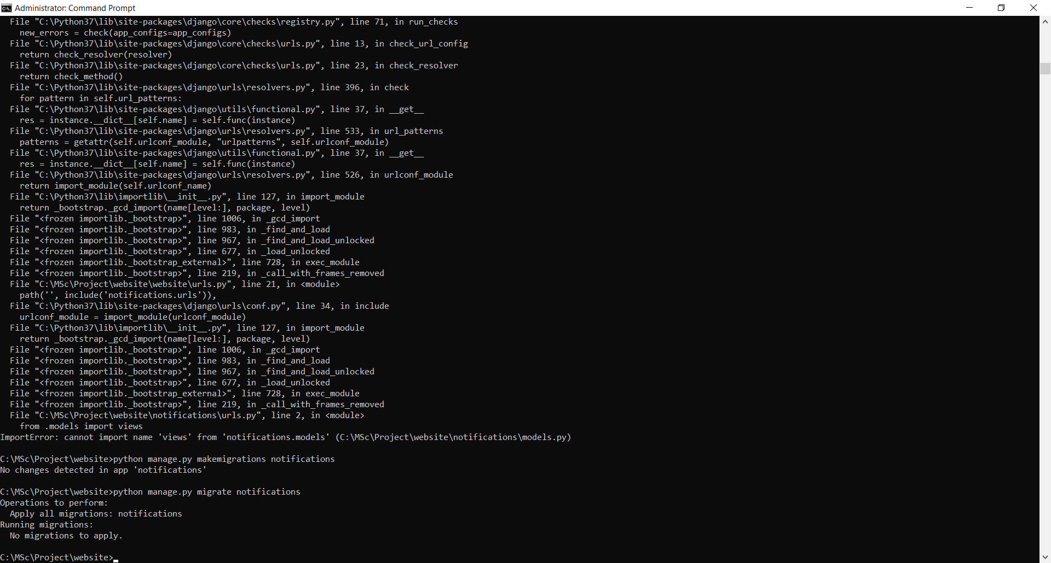

Run the server: -

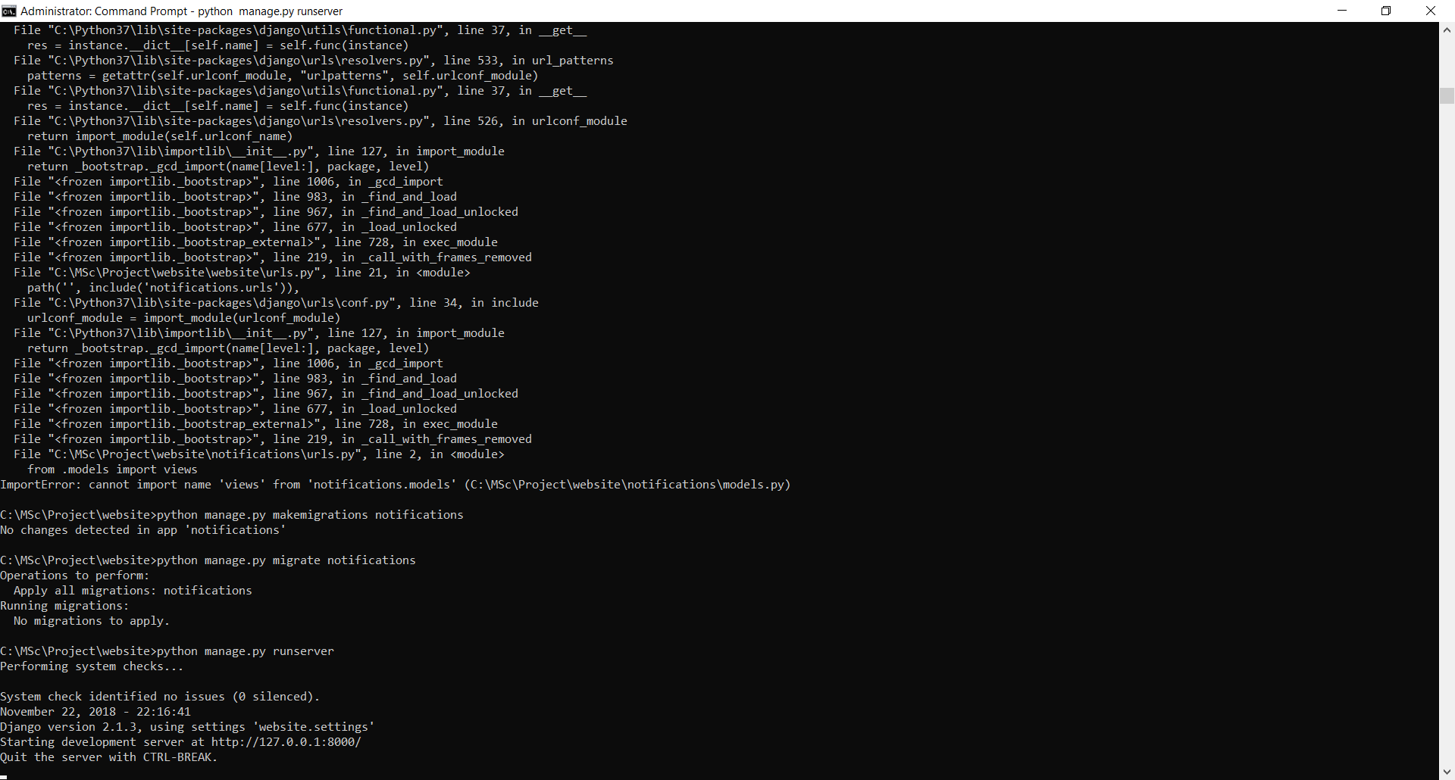

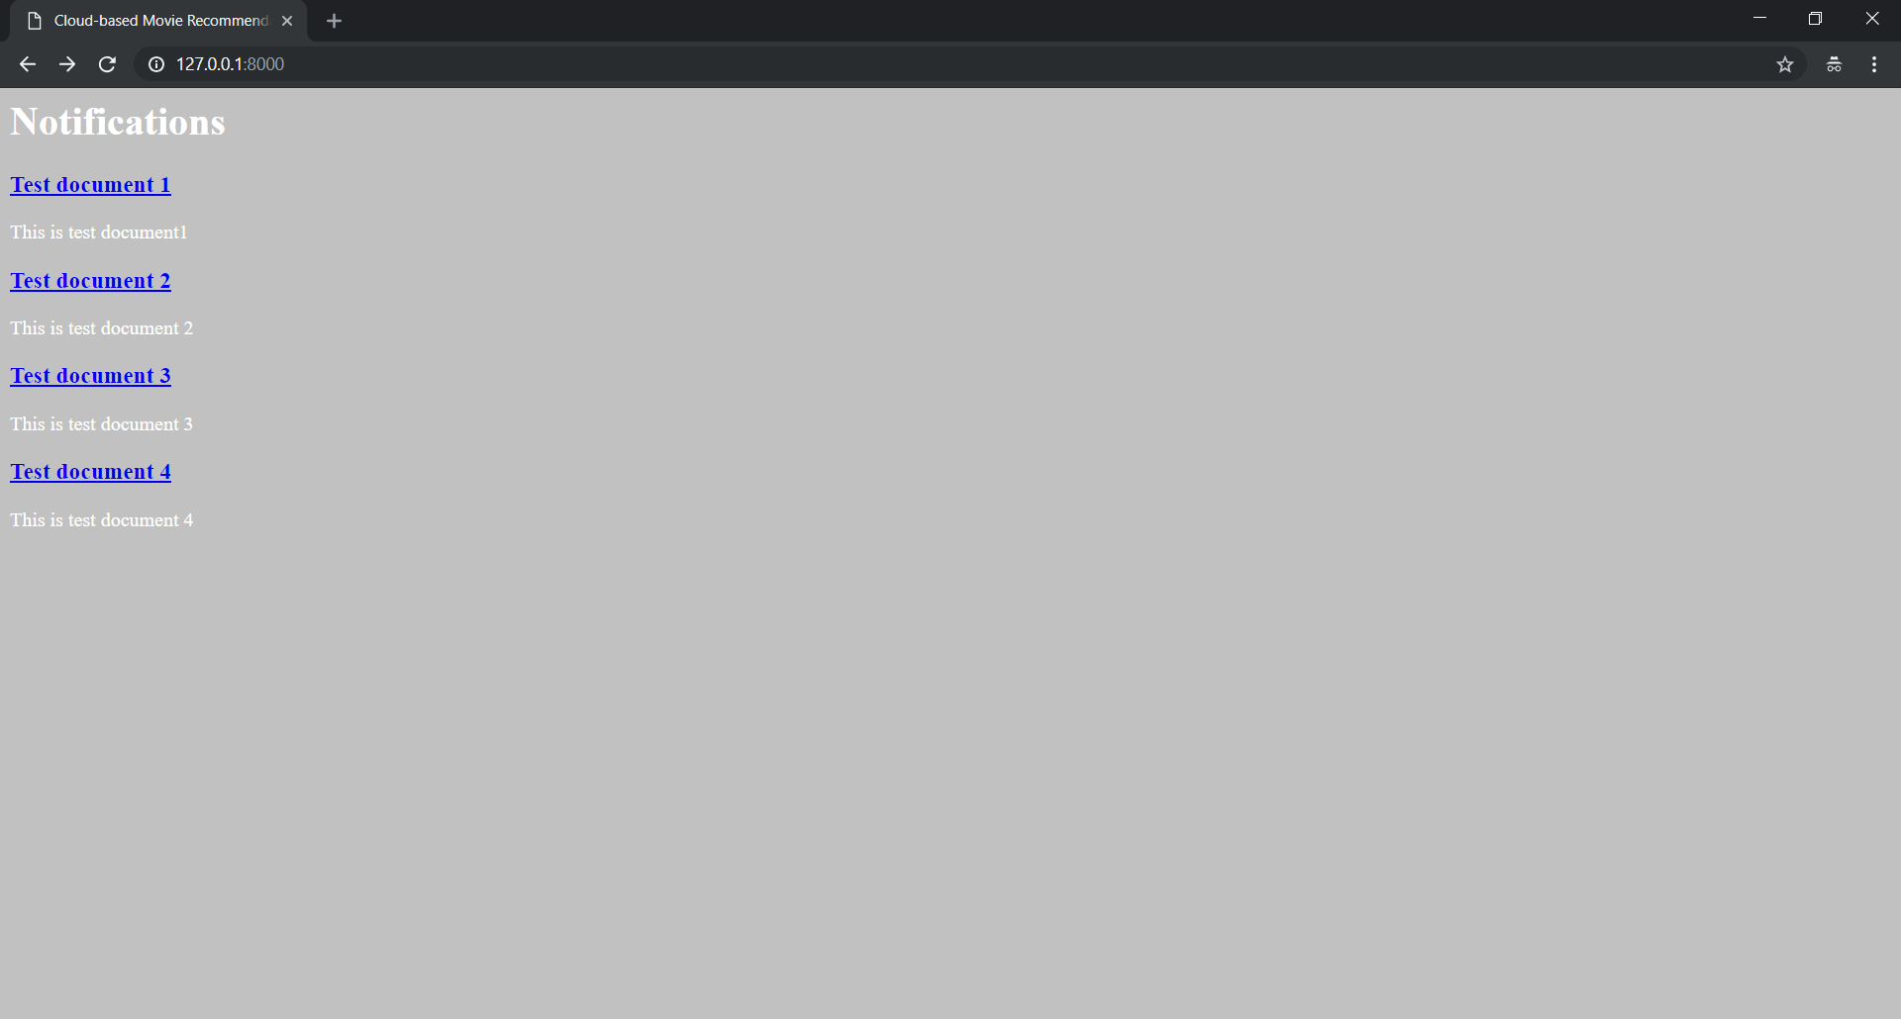

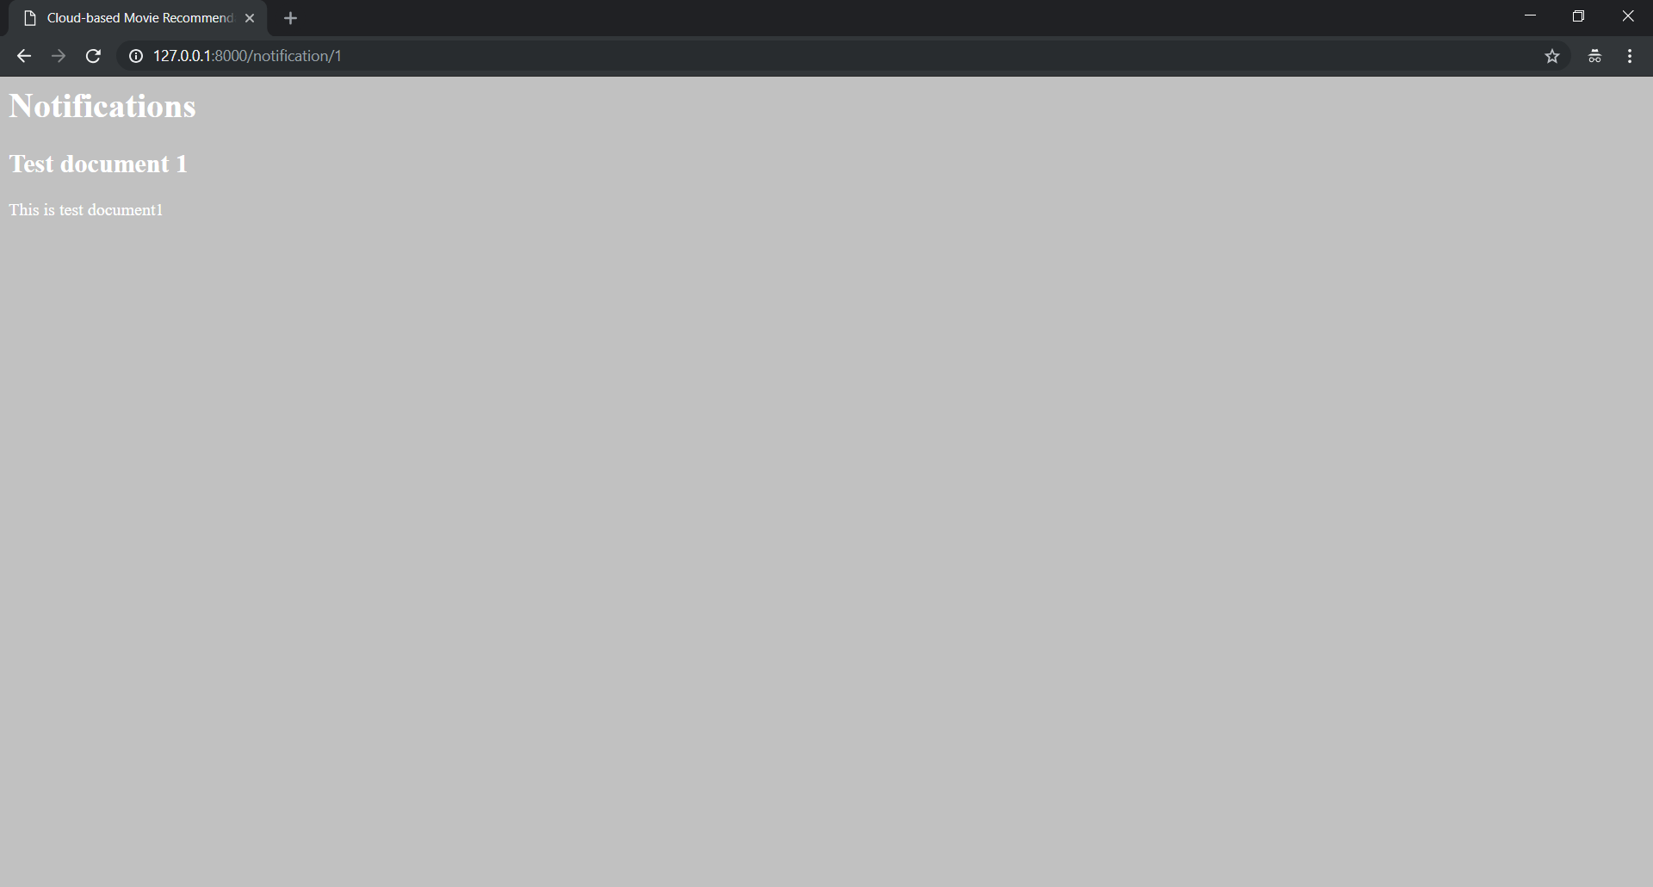

**Setup for Login:-**

Go to static –> css –> basestyles.css

body{

background-color: #636e72;

color: #FFF;

}

h1 {

font-size: 2.5rem;

text-align: center;

margin-top: 25px;

}

a{

color: #0984e3;

}

.container {

margin-top: 20px;

background-color: #b2bec3;

padding: 30px;

}

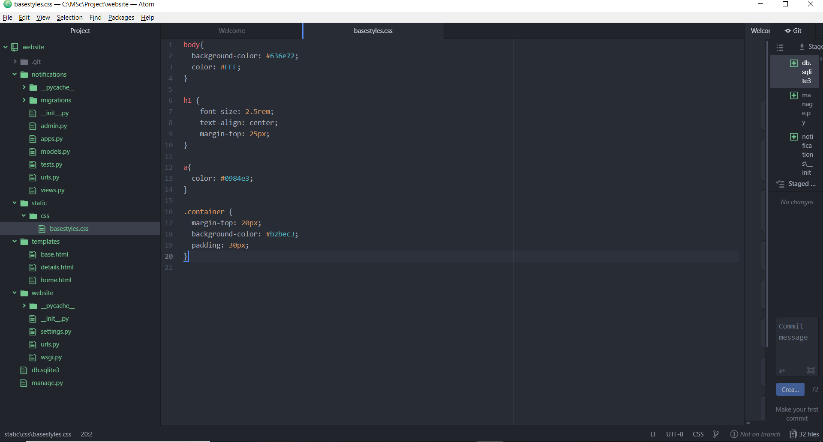

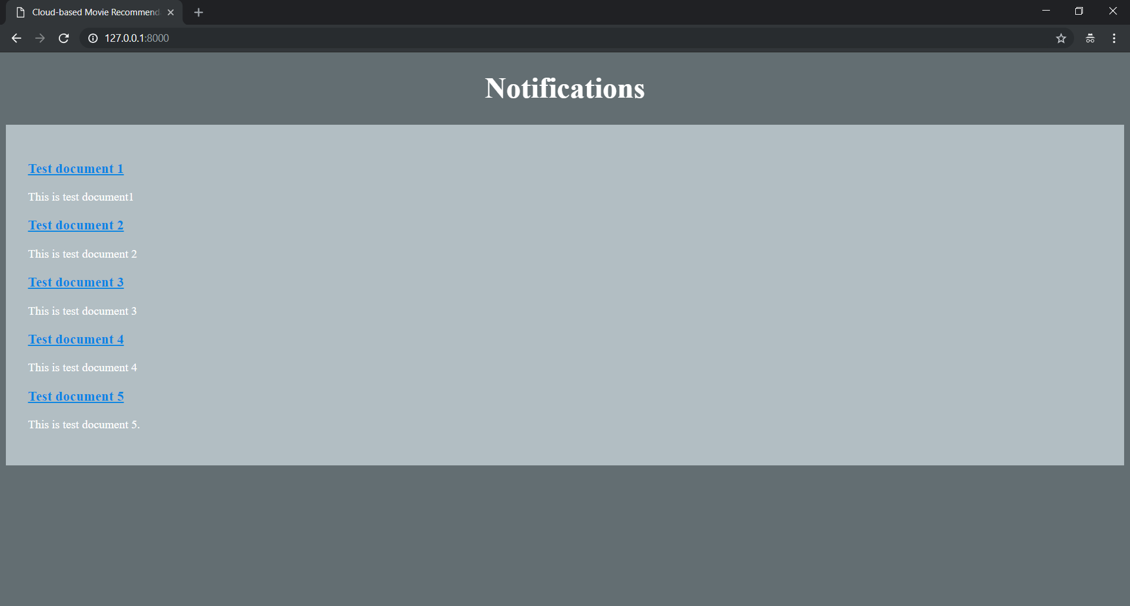

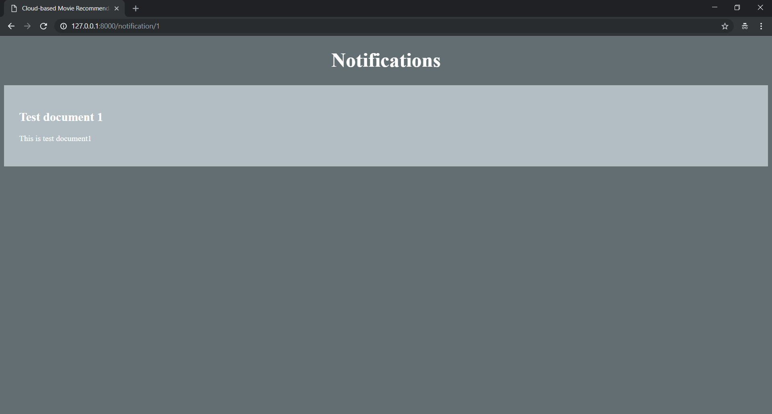

Go to website -> urls.py

path('accounts/', include('django.contrib.auth.urls')),

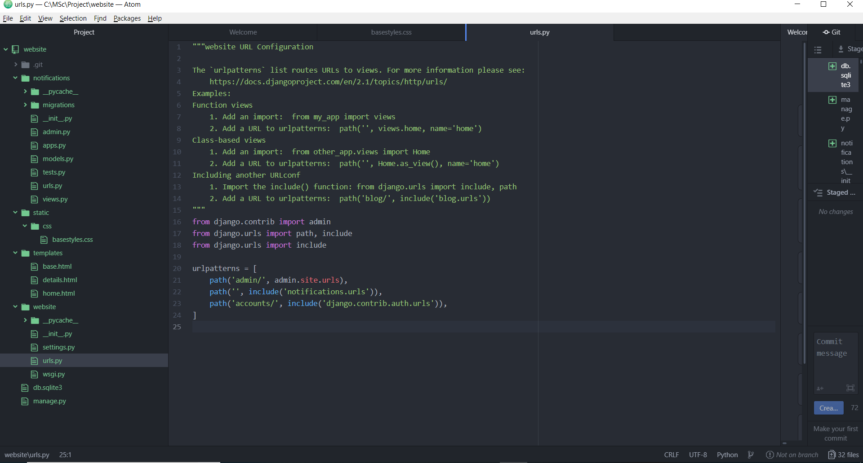

**Having a login view:-**

Right click on “templates” -> New Folder -> Name: registration

Right click on “registration” -> New File -> Name: login.html

{% extends 'base.html' %}

{% block content %}

<h3>This is Login Page !!! </h3>

<form method = "POST">

{% csrf_token %}

{{form.as_p}}

<button type = "submit"> Login Me !!! </button>

</form>

{% endblock content %}

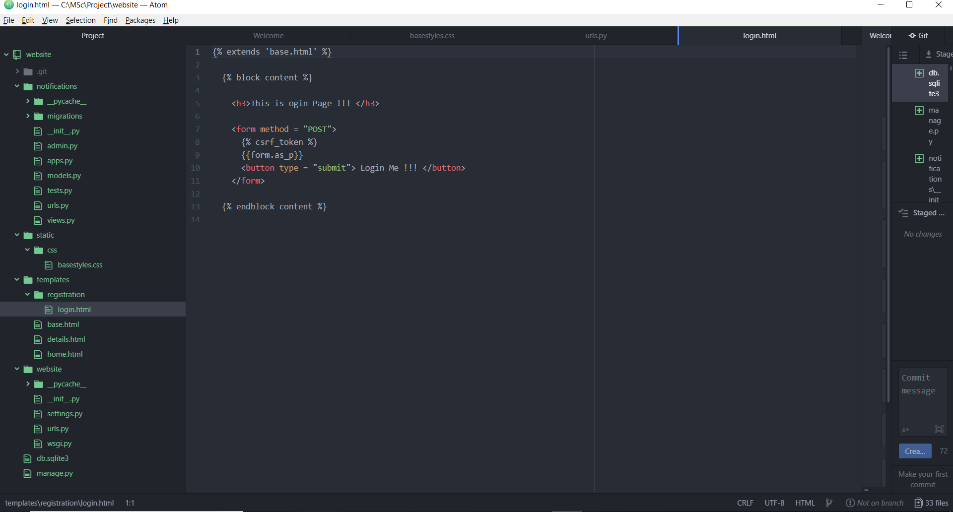

Go to website -> settings.py

LOGIN_REDIRECT_URL = 'home'

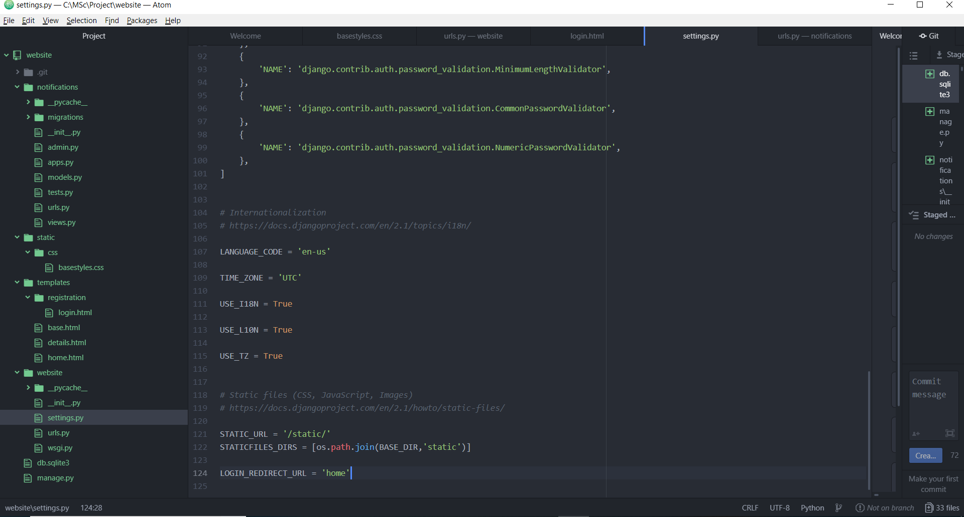

Run the server:-

Go to : <http://127.0.0.1:8000/accounts/login>

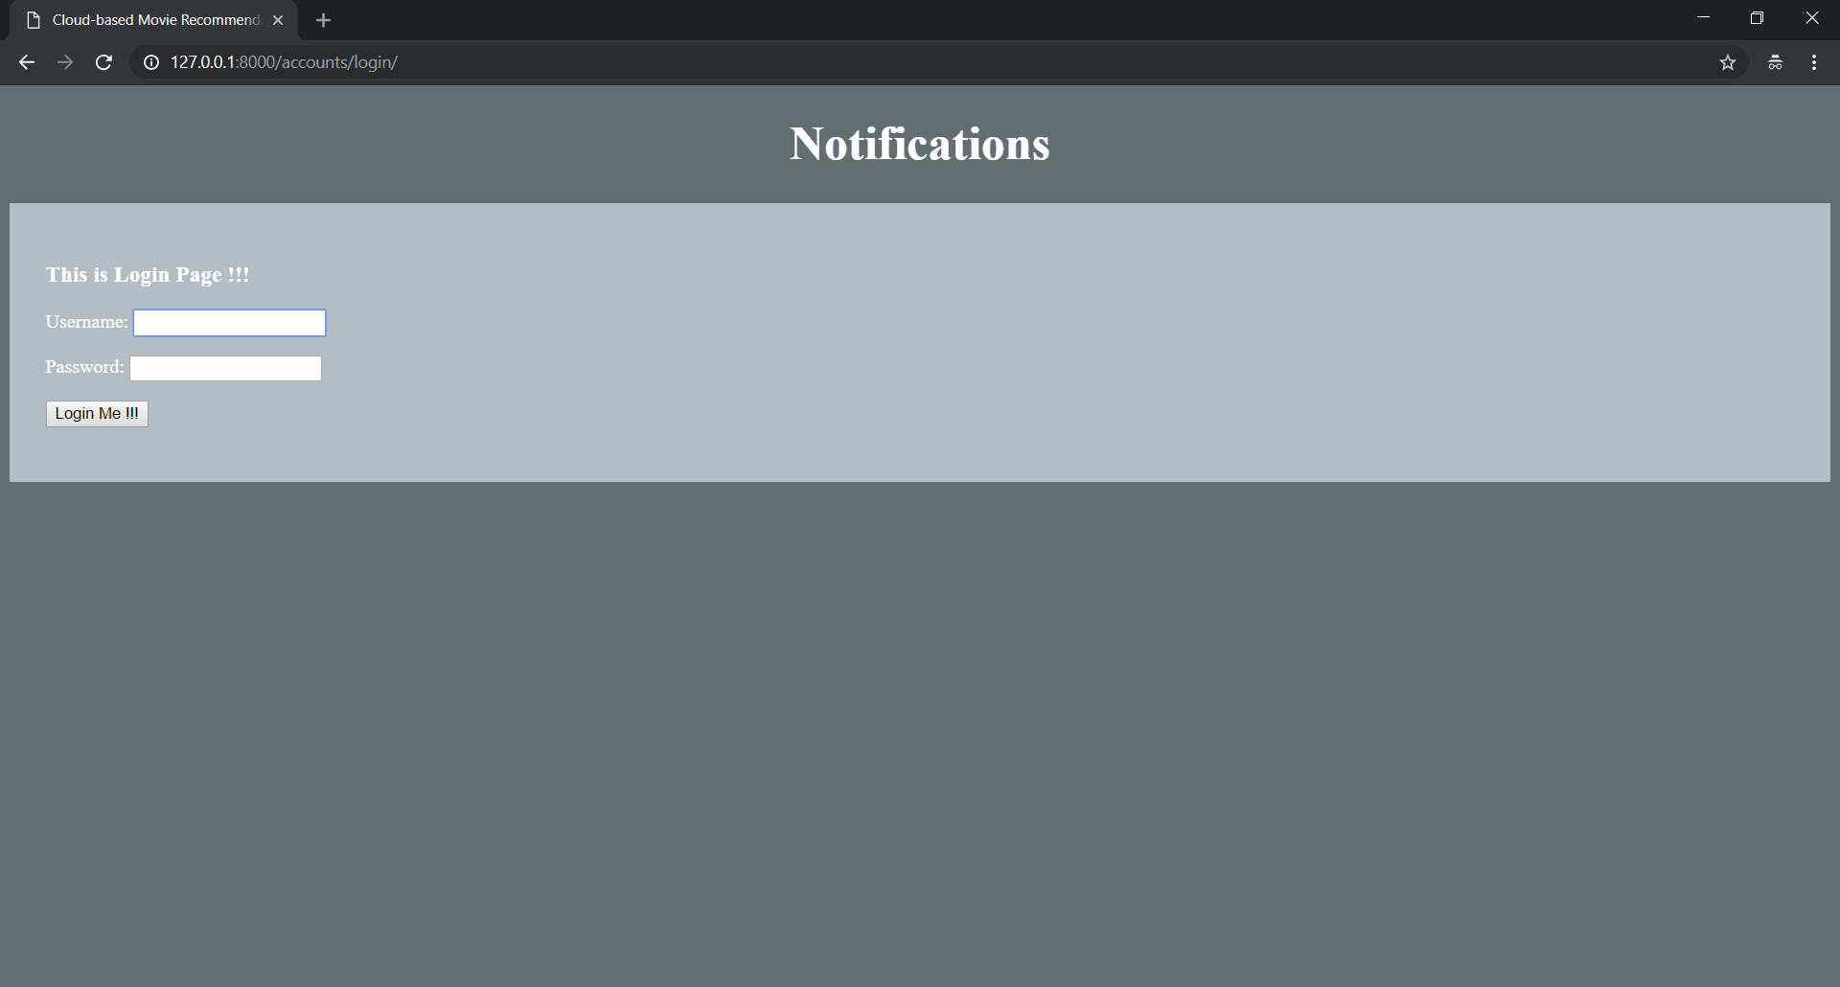

Login with sushmita/America@2020

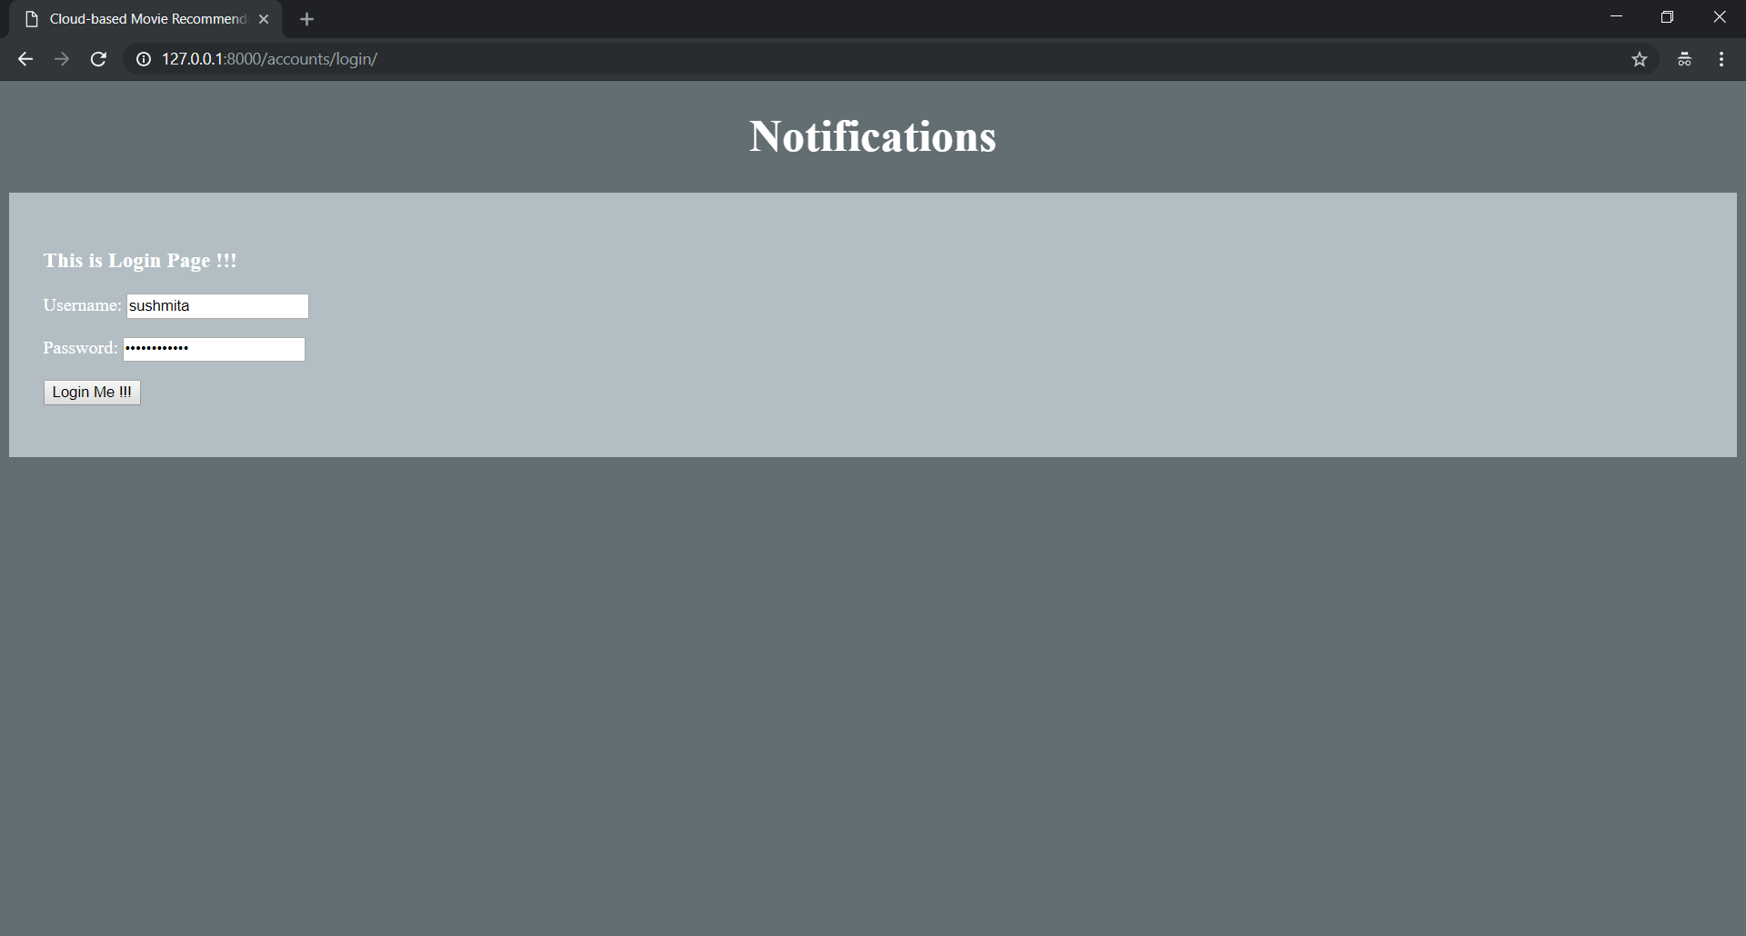

We are redirected to home page.

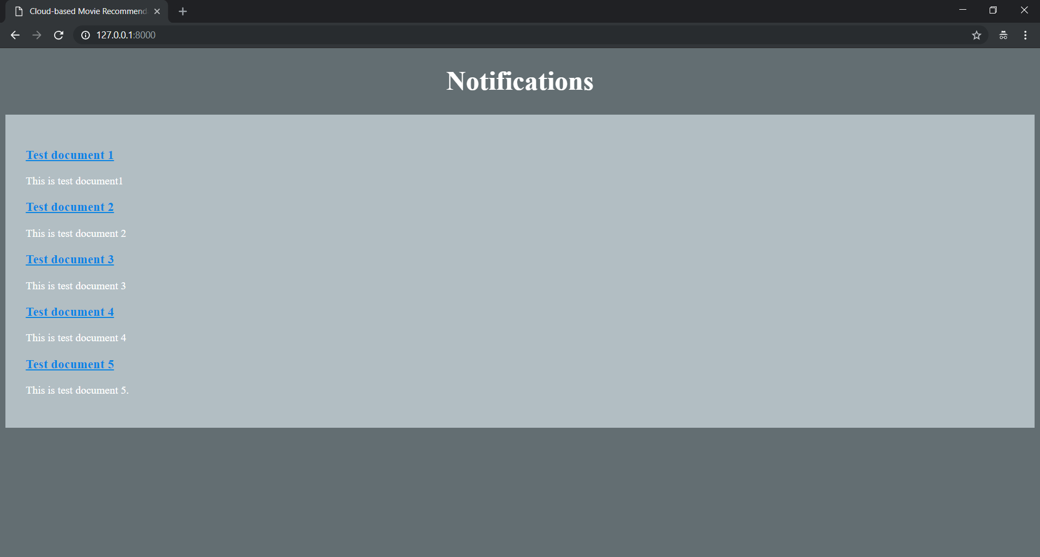

Display content based on login:-

Go to templates -> base.html:-

<div class="container">

{% if user.is_authenticated %}

<p> You are logged in !!! </p>

<p> Hello: {{user.username}}, How are you </p>

<p> Please <a href = "{% url 'logout' %}"> Logout </a> here </p>

{% else %}

<p>You are not logged in !!! </p>

<p> Please <a href = "{% url 'login' %}"> Login </a> here </p>

{% endif %}

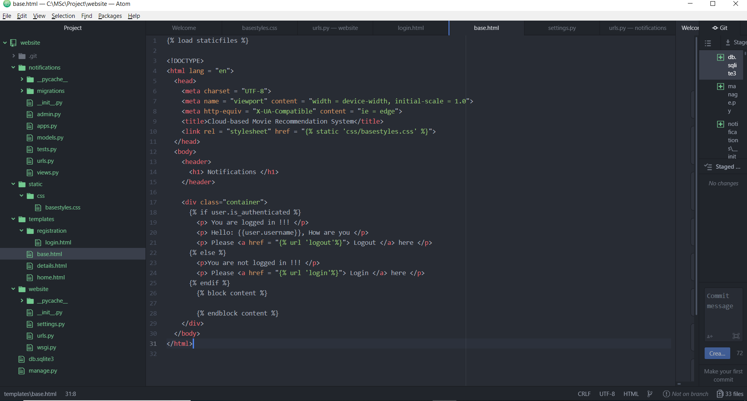

When clicked on Logout link, by default it redirects user to admin module. So use this line in website -> settings.py:-

LOGOUT_REDIRECT_URL = 'home'

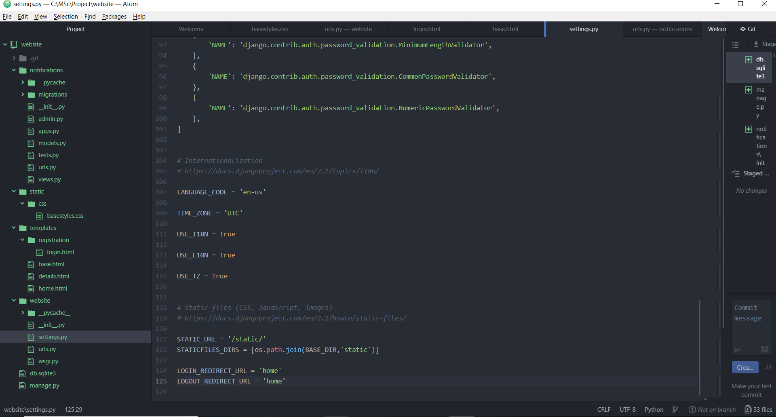

Run the server:-

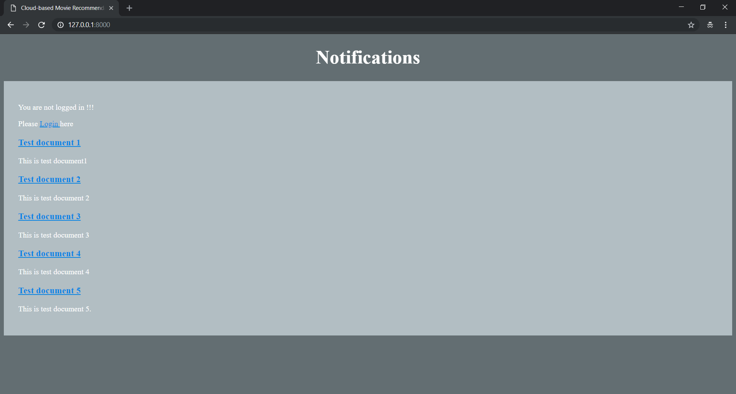

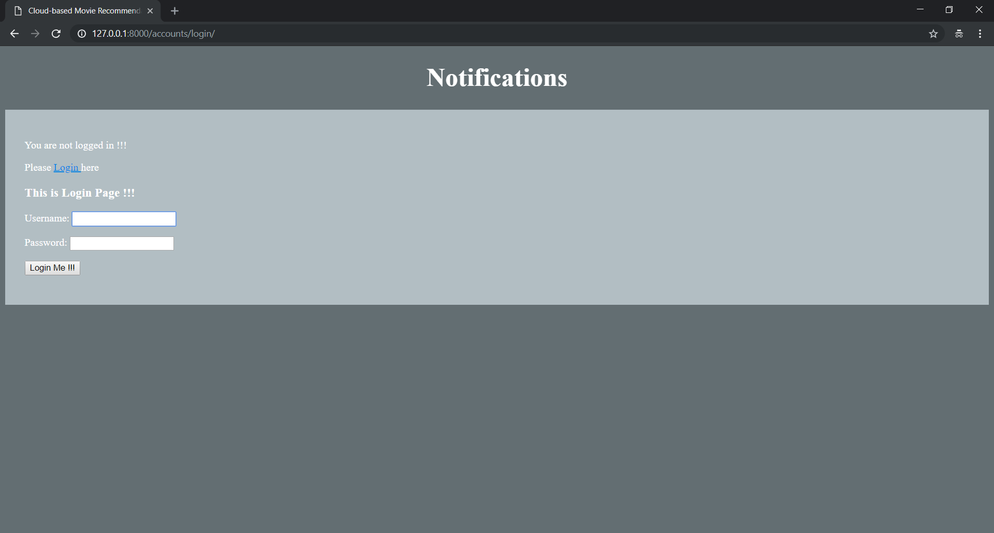

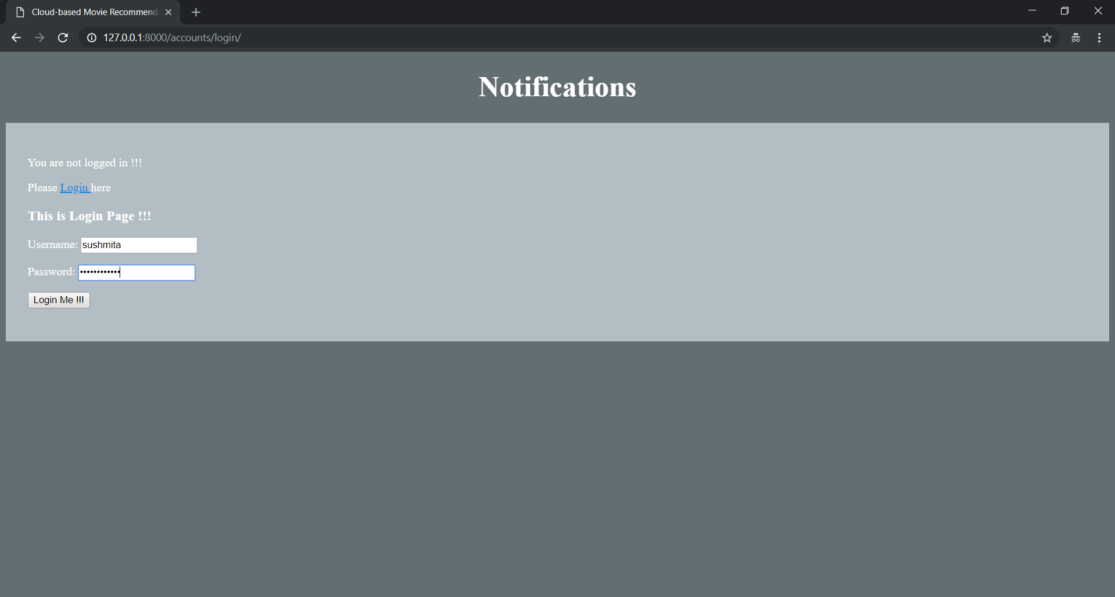

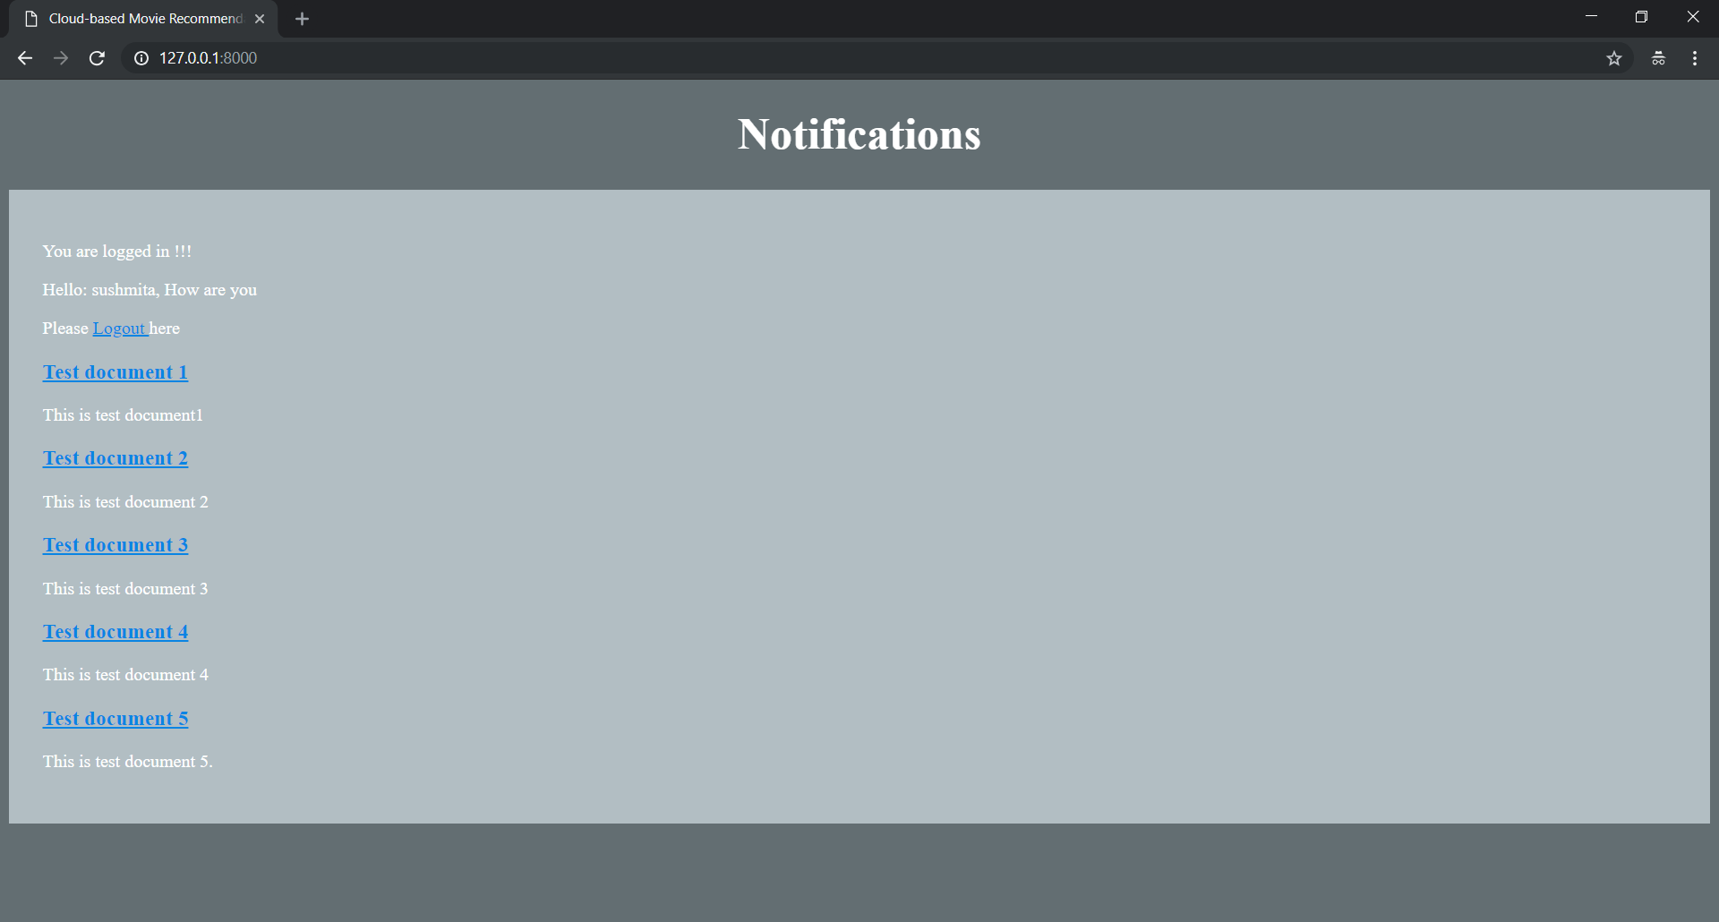



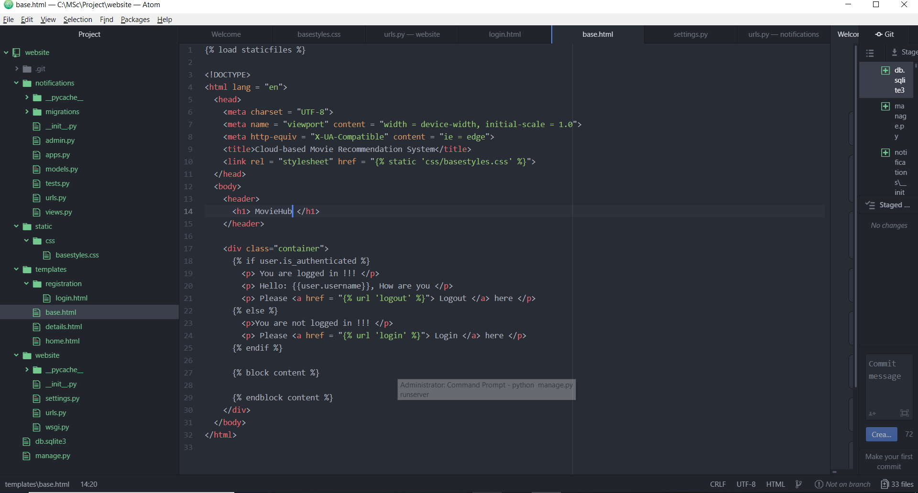

So, “Notification” is now “MovieHub”.

**Signup app:-**

Create new app:-

python manage.py startapp accounts

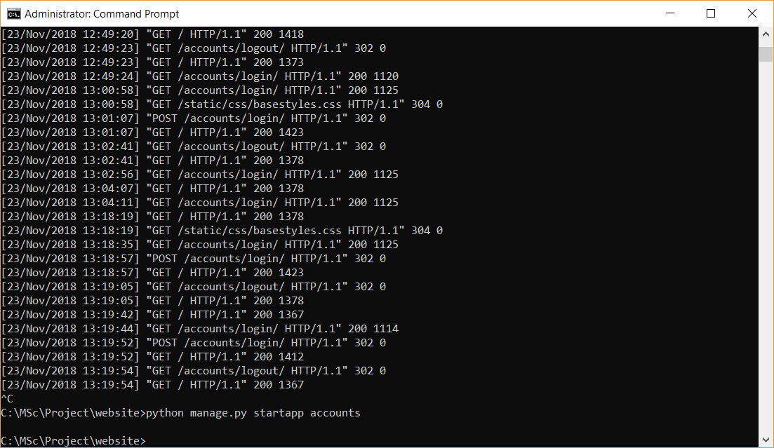

Go to website -> settings.py

‘accounts’,

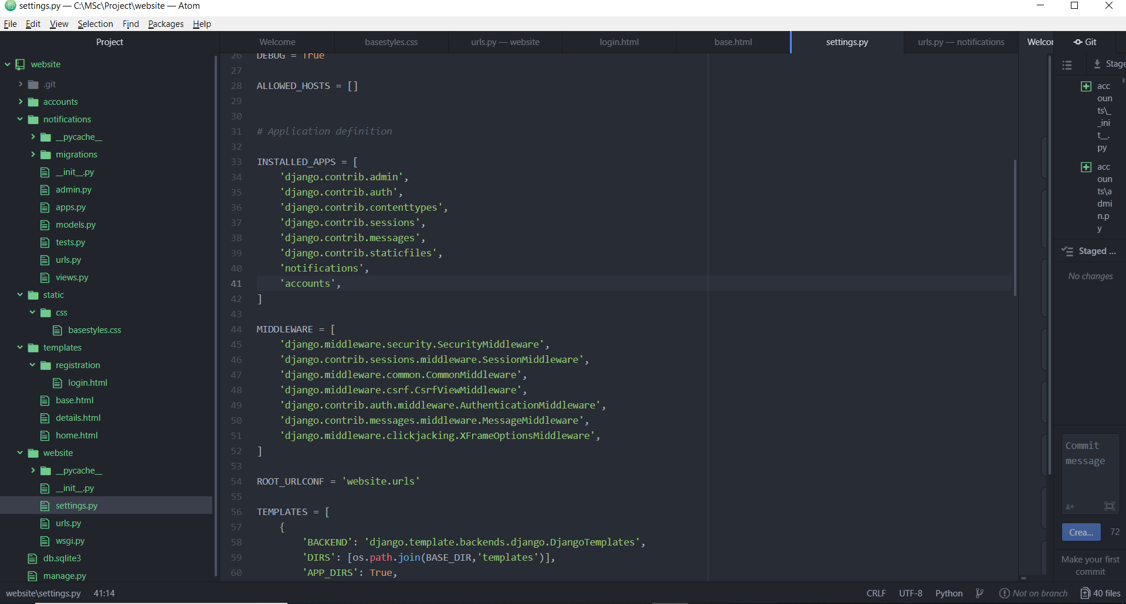

Go to website -> urls.py:-

path('accounts/',include('accounts.urls')),

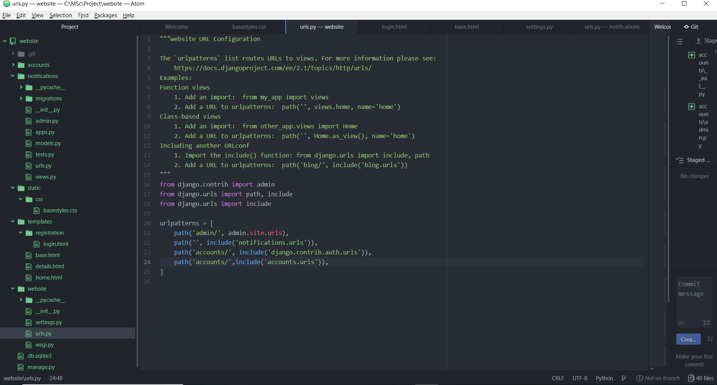

Right click on “accounts” -> New File -> Name: urls.py

from django.urls import path

from . import views

urlpatterns = [

path('signup/',views.SignUpView.as_view(), name = 'signup'),

]

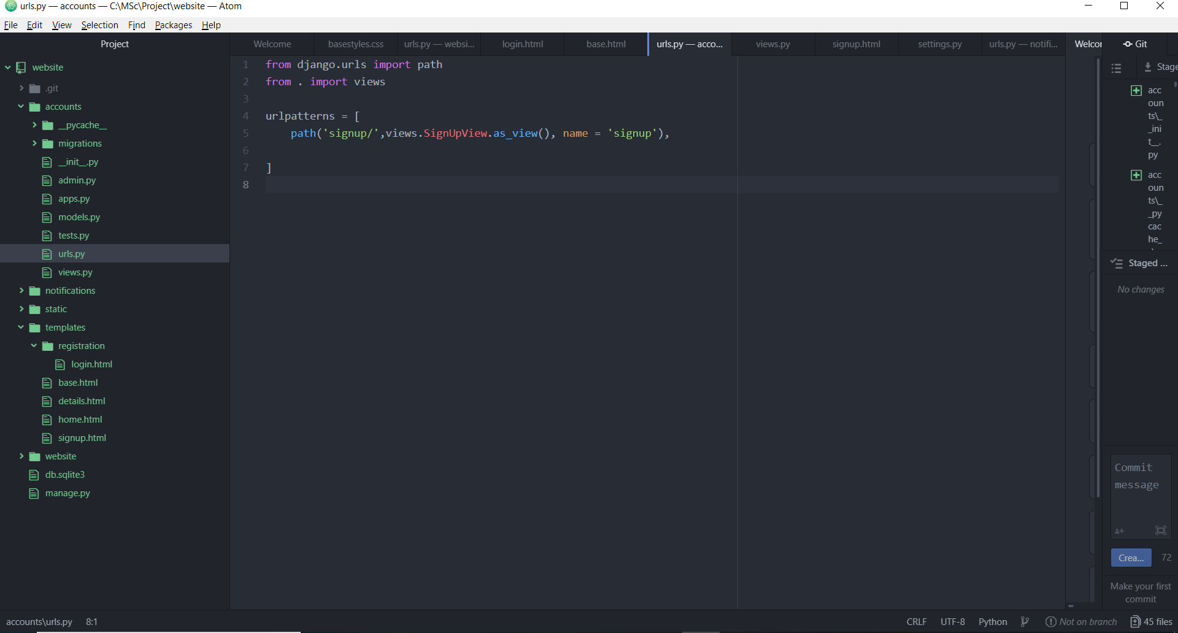

Go to accounts -> views.py

from django.views import generic

from django.contrib.auth.forms import UserCreationForm

from django.urls import reverse_lazy

class SignUpView(generic.CreateView):

form_class = UserCreationForm

success_url = reverse_lazy('login')

template_name = 'signup.html'

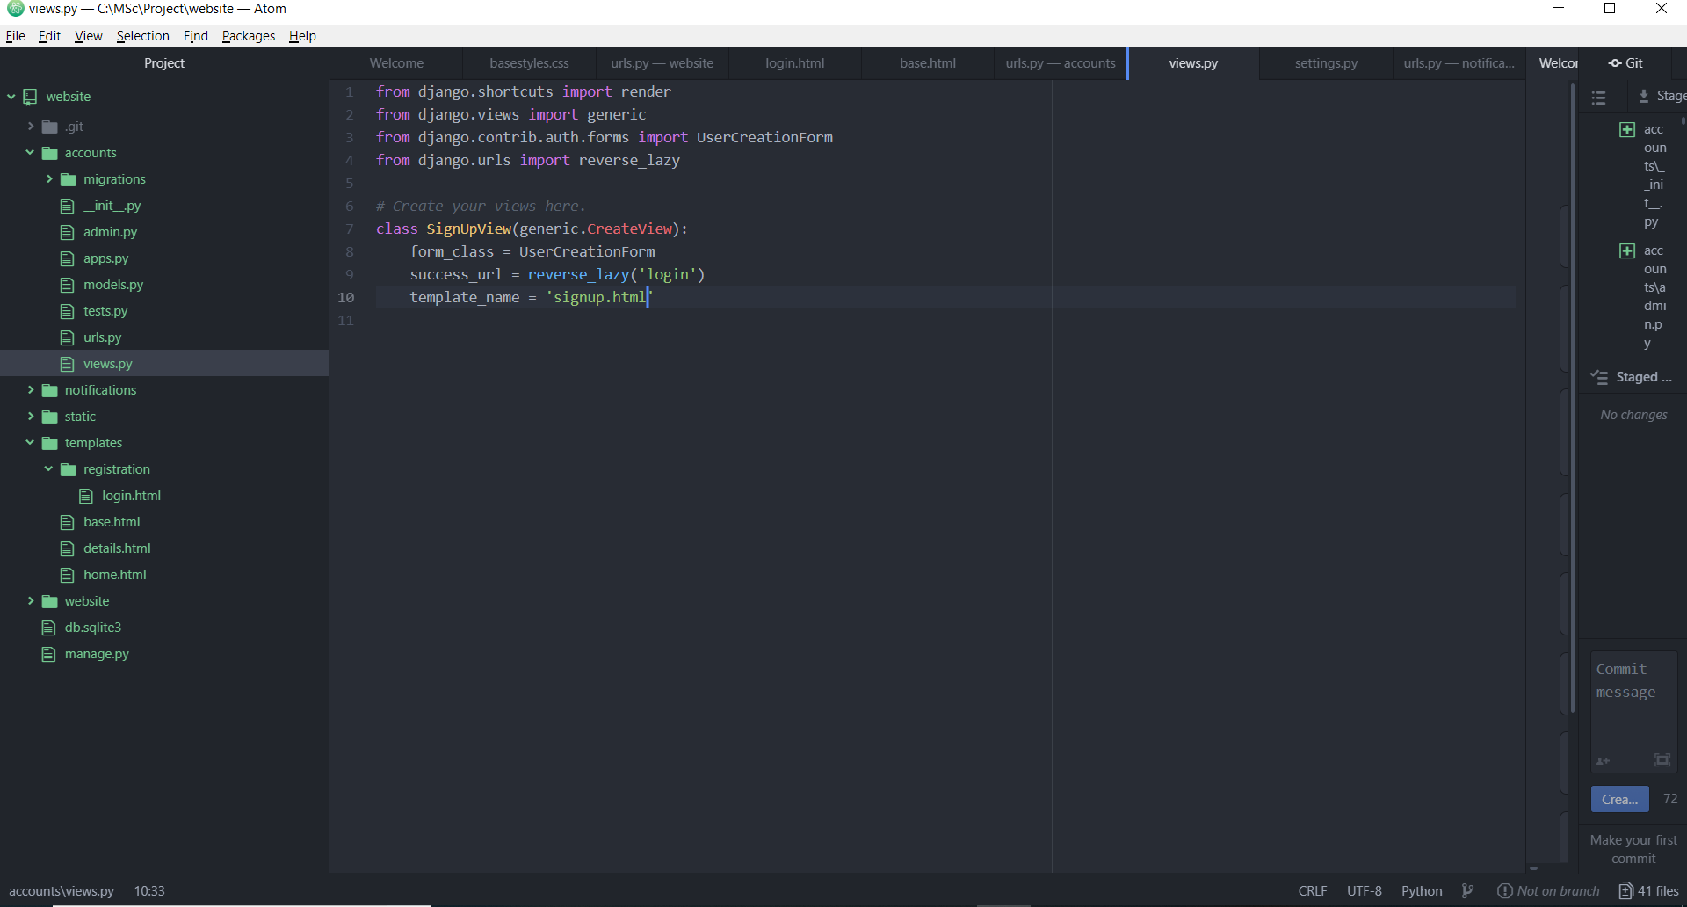

Right click on “templates” -> New File -> Name : signup.html

{% extends 'base.html' %}

{% block content %}

<h3>This is Sign-up page !!! </h3>

<form method="POST">

{% csrf_token %}

{{ form.as_p }}

<button type="submit"> Signup Me !!! </button>

</form>

{% endblock content %}

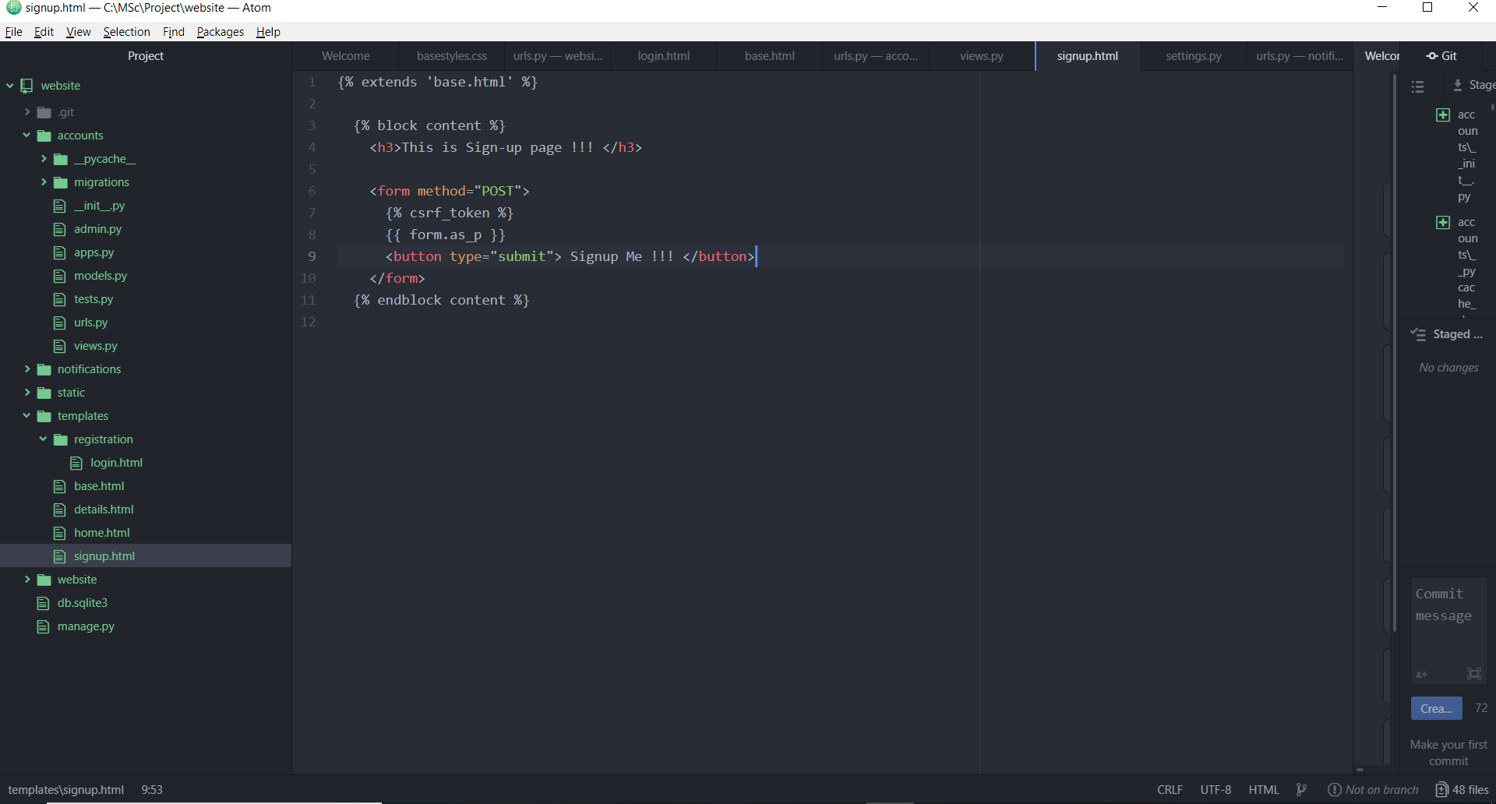

Preparing for migration: -

Apply migrations:-

Run server:-

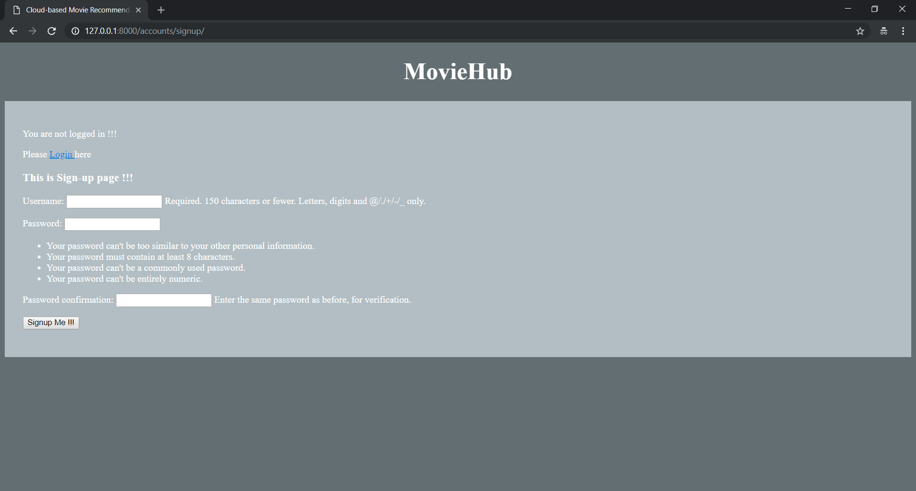

**Adding About Us Page:-**

Right click on “templates” -> New File -> Name: about.html

<h2>This is about us page</h2>

<p>Lorem ipsum dolor sit amet, consectetur adipisicing elit, sed do eiusmod tempor incididunt ut labore et dolore magna aliqua. Ut enim ad minim veniam, quis nostrud exercitation ullamco laboris nisi ut aliquip ex ea commodo consequat. Duis aute irure dolor in reprehenderit in voluptate velit esse cillum dolore eu fugiat nulla pariatur. Excepteur sint occaecat cupidatat non proident, sunt in culpa qui officia deserunt mollit anim id est laborum.</p>

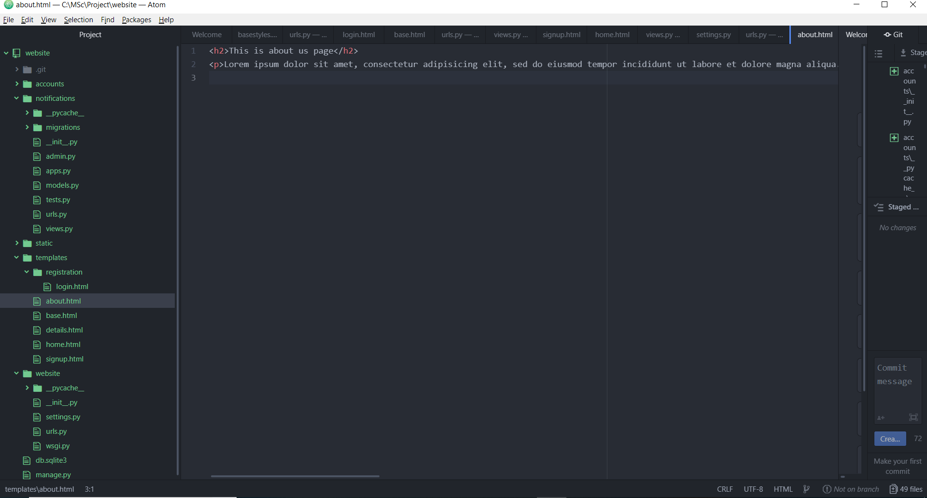

Go to notifications -> views.py

from django.views.generic import TemplateView

class AboutPageView(TemplateView):

template_name = 'about.html'

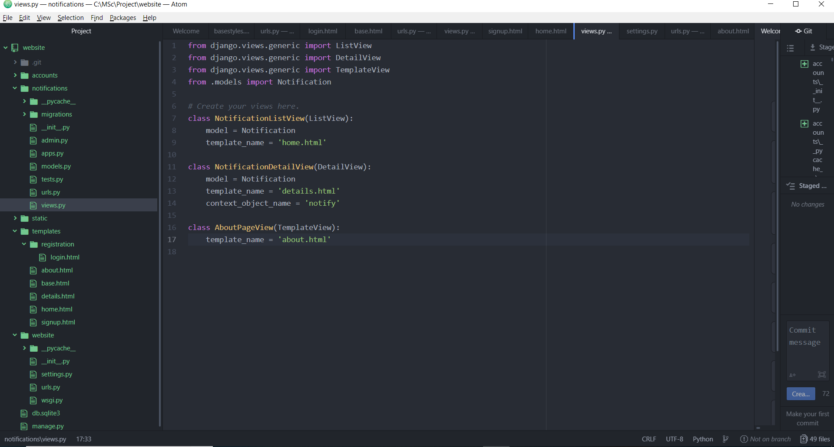

Go to notifications -> urls.py:-

path('about/', views.AboutPageView.as_view(), name = 'about'),

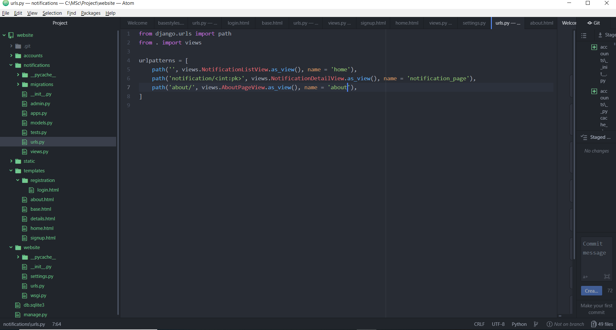

Make migrations:-

Run server:-

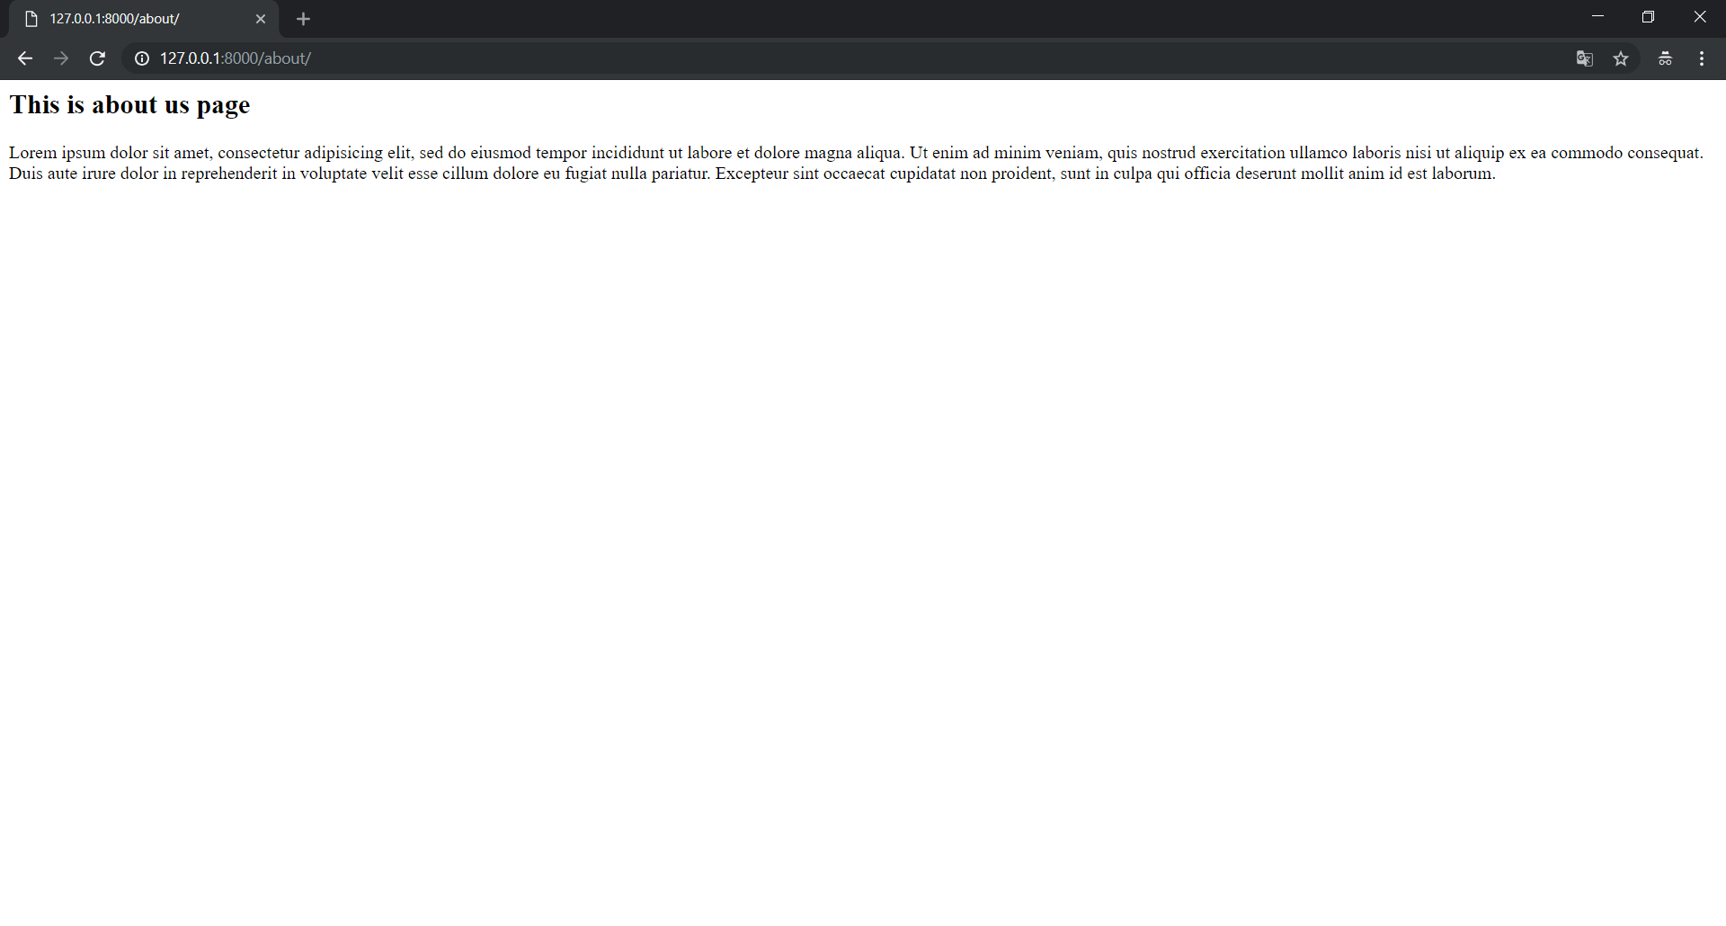

**Adding Contact Us Page:-**

Right click on “templates” -> New File -> Name: contact.html

<h2> This is contact us page </h2>

<p>Address:- </p>

<p>Mumbai, India</p>

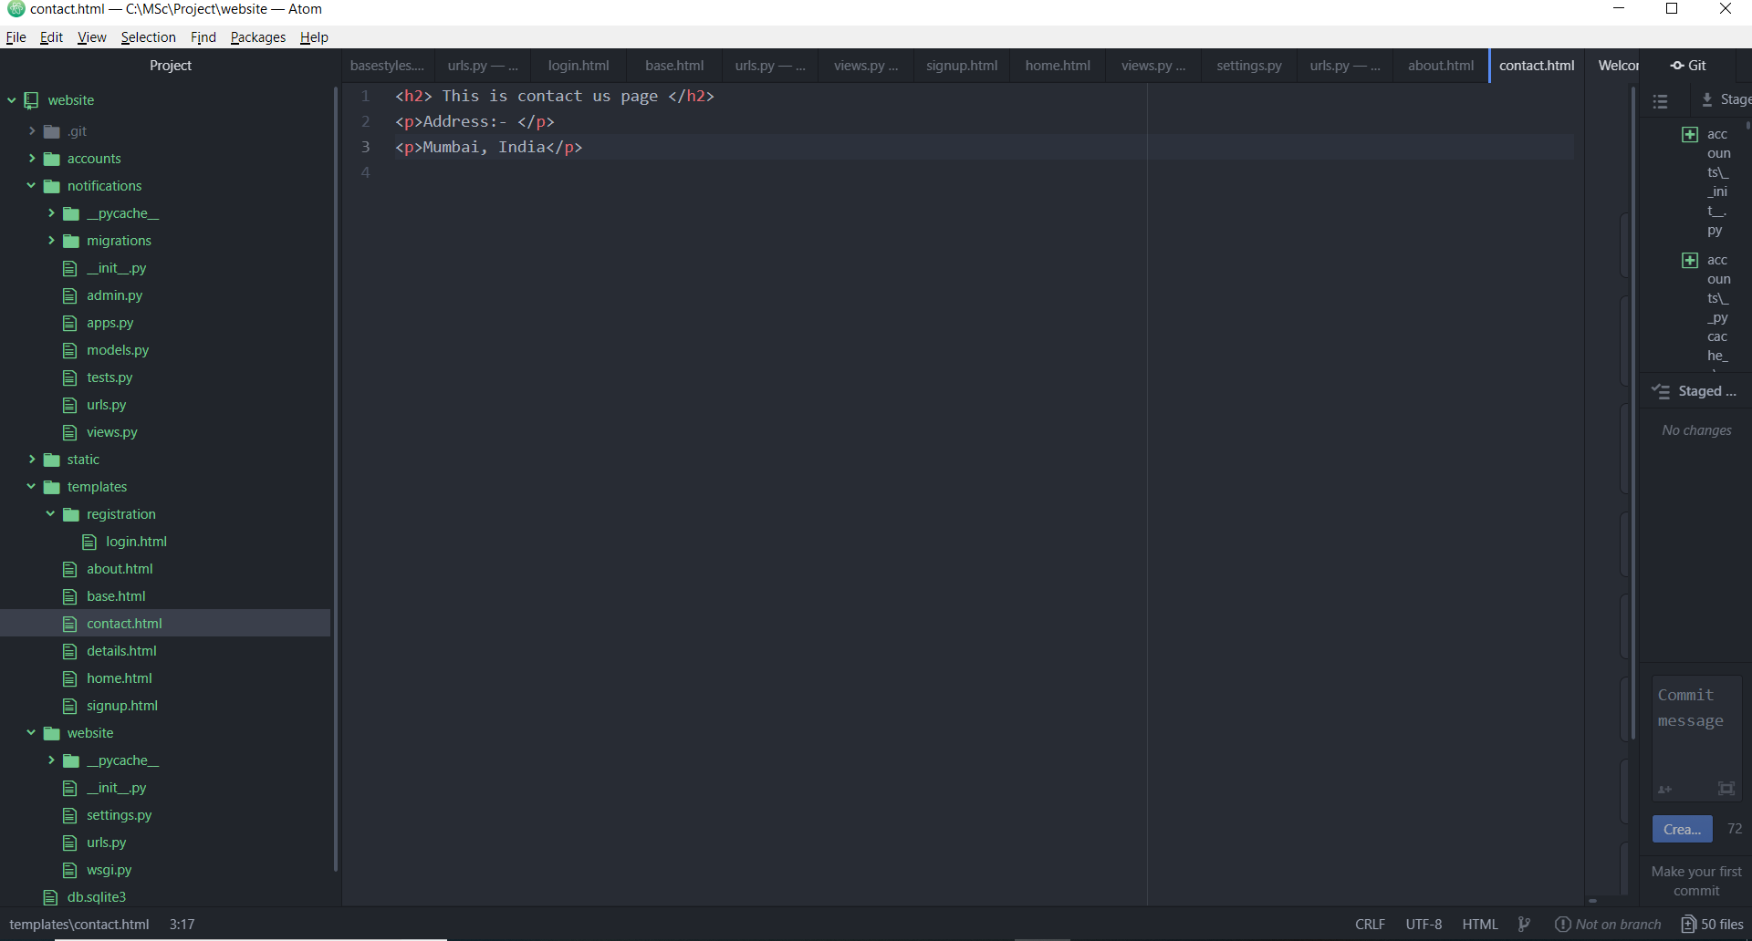

Go to notifications -> views.py

class ContactPageView(TemplateView):

template_name = 'contact.html'

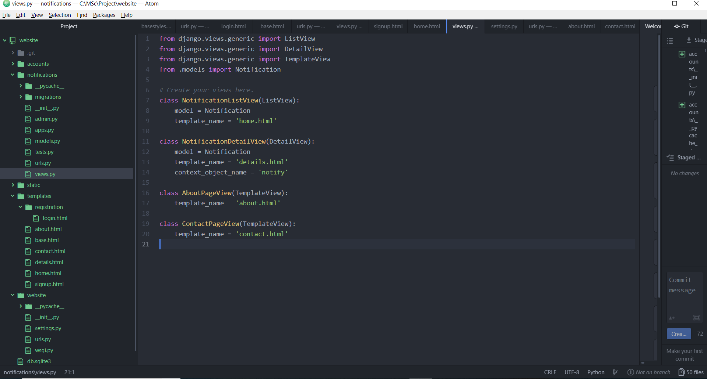

Go to notifications -> urls.py:-

path('contact/', views.ContactPageView.as_view(), name = 'contact'),

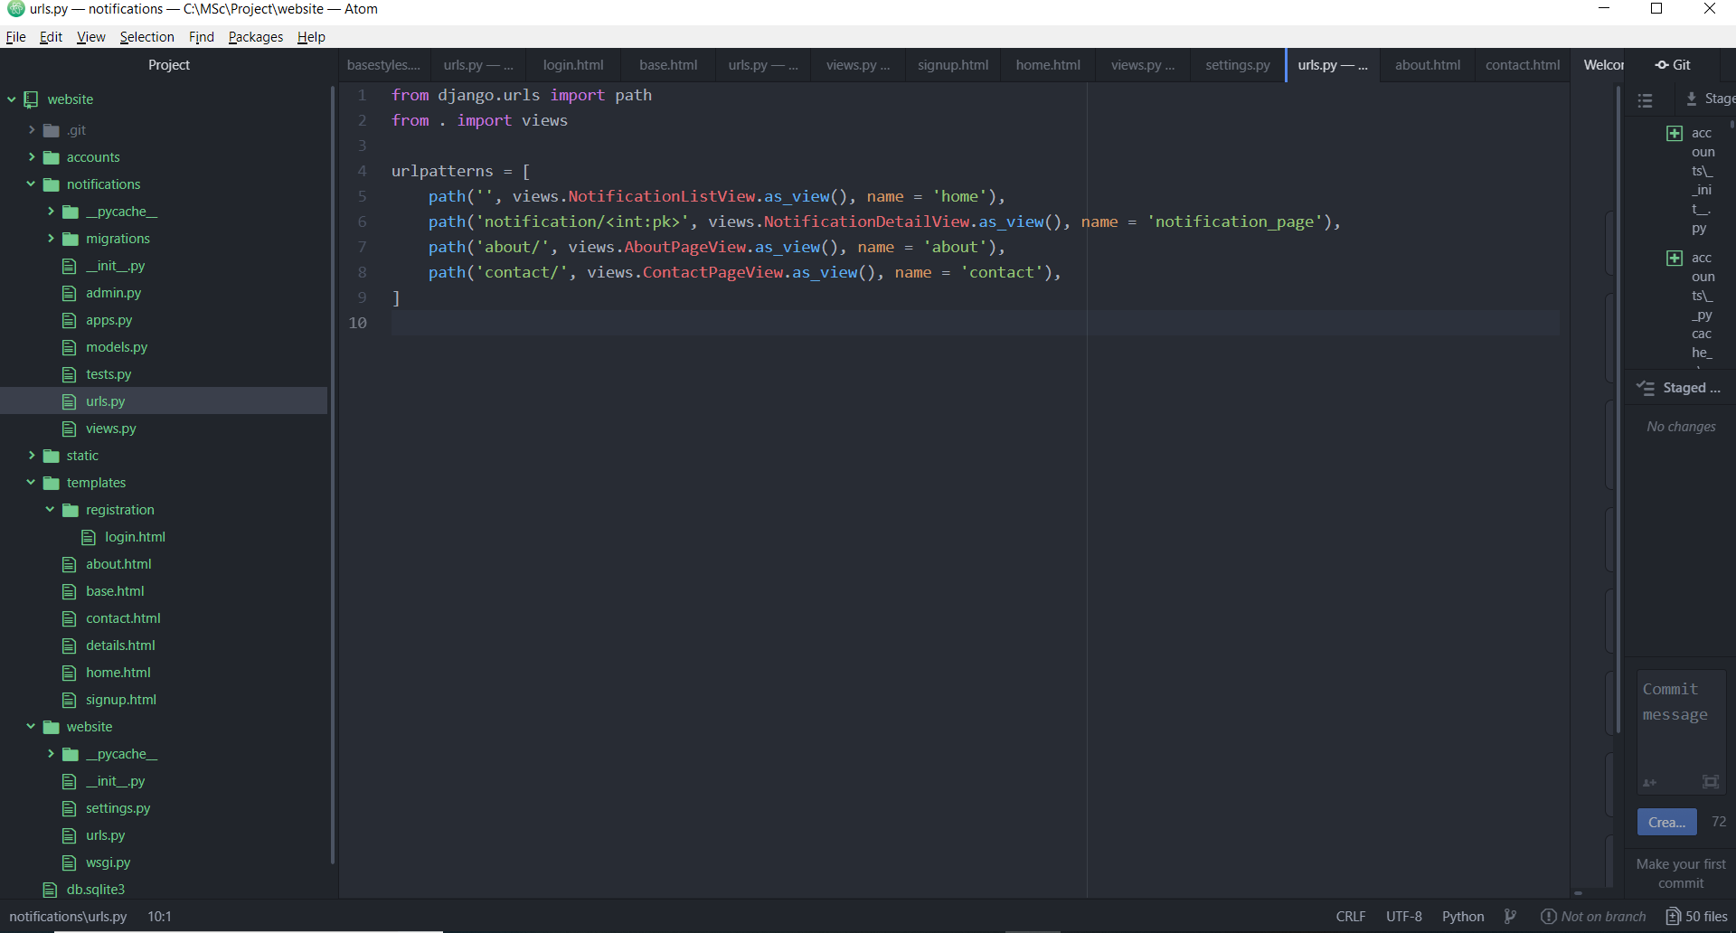

Make migrations:-

Run server:-

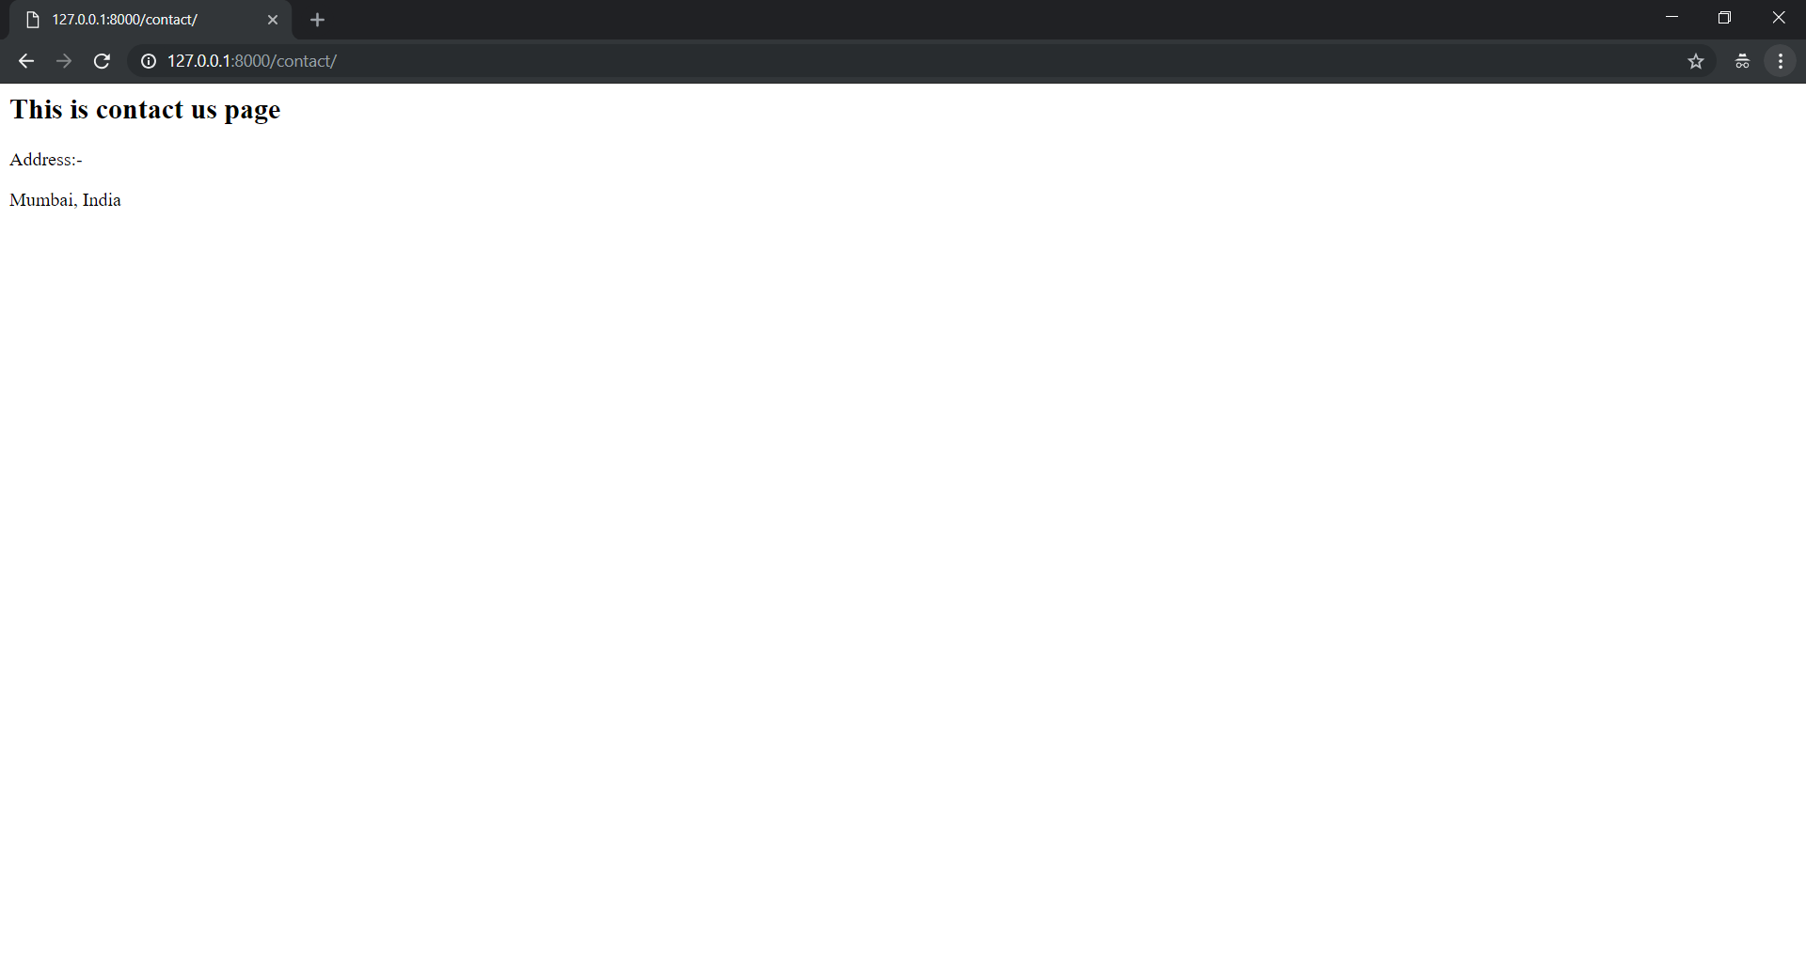

**Navigation Bar:-**

Right click on “templates” -> New File -> Name: navigationbar.html

<header>

<a href="{% url 'home' %}">Home</a> |

<a href="{% url 'about' %}">About Us</a> |

<a href="{% url 'contact' %}">Contact Us</a> |

</header>

{% block content %}

{% endblock content %}

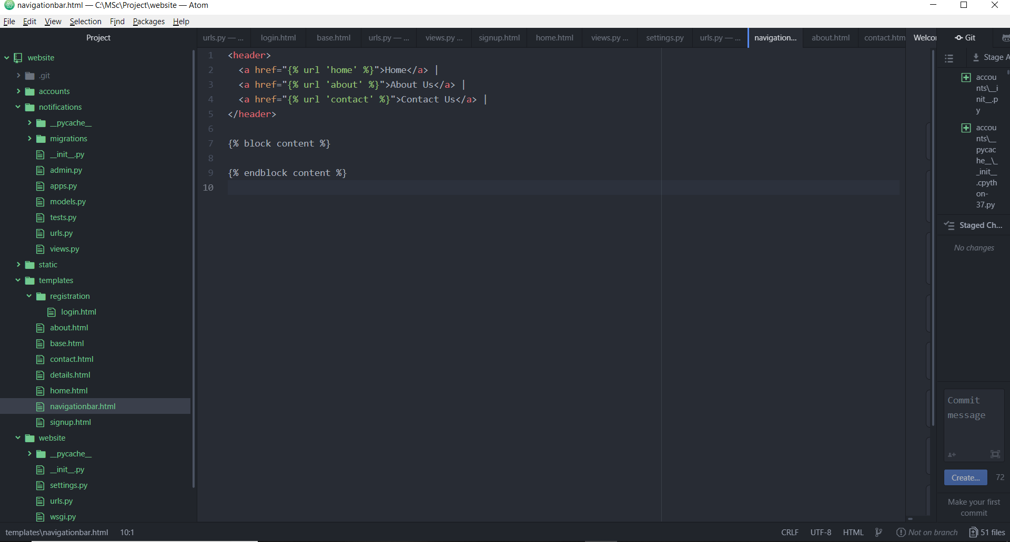

Go to base.html and add this navigationbar.html there:-

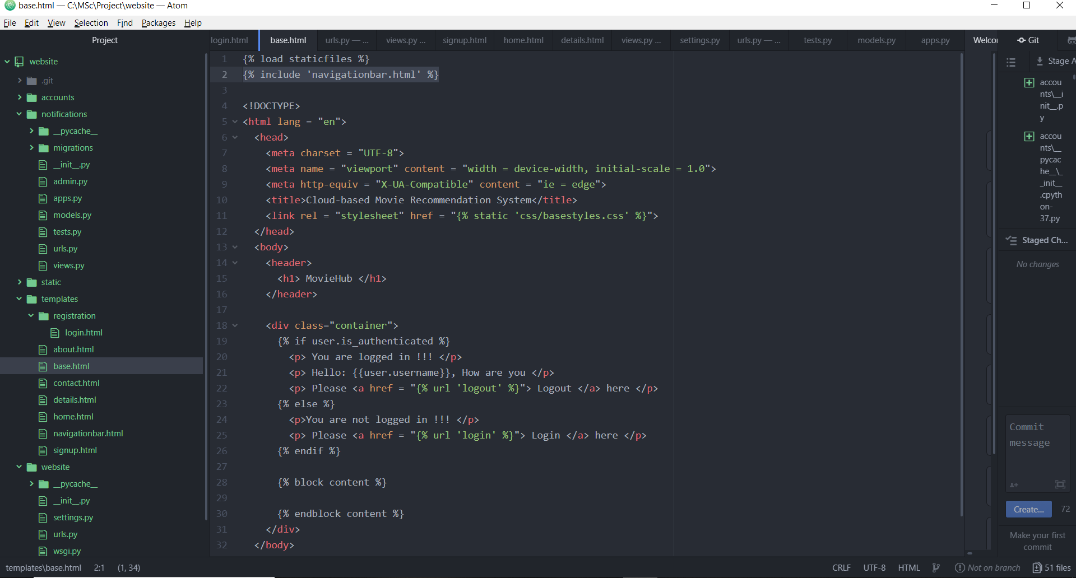

Go to about.html:-

{% include 'navigationbar.html' %}

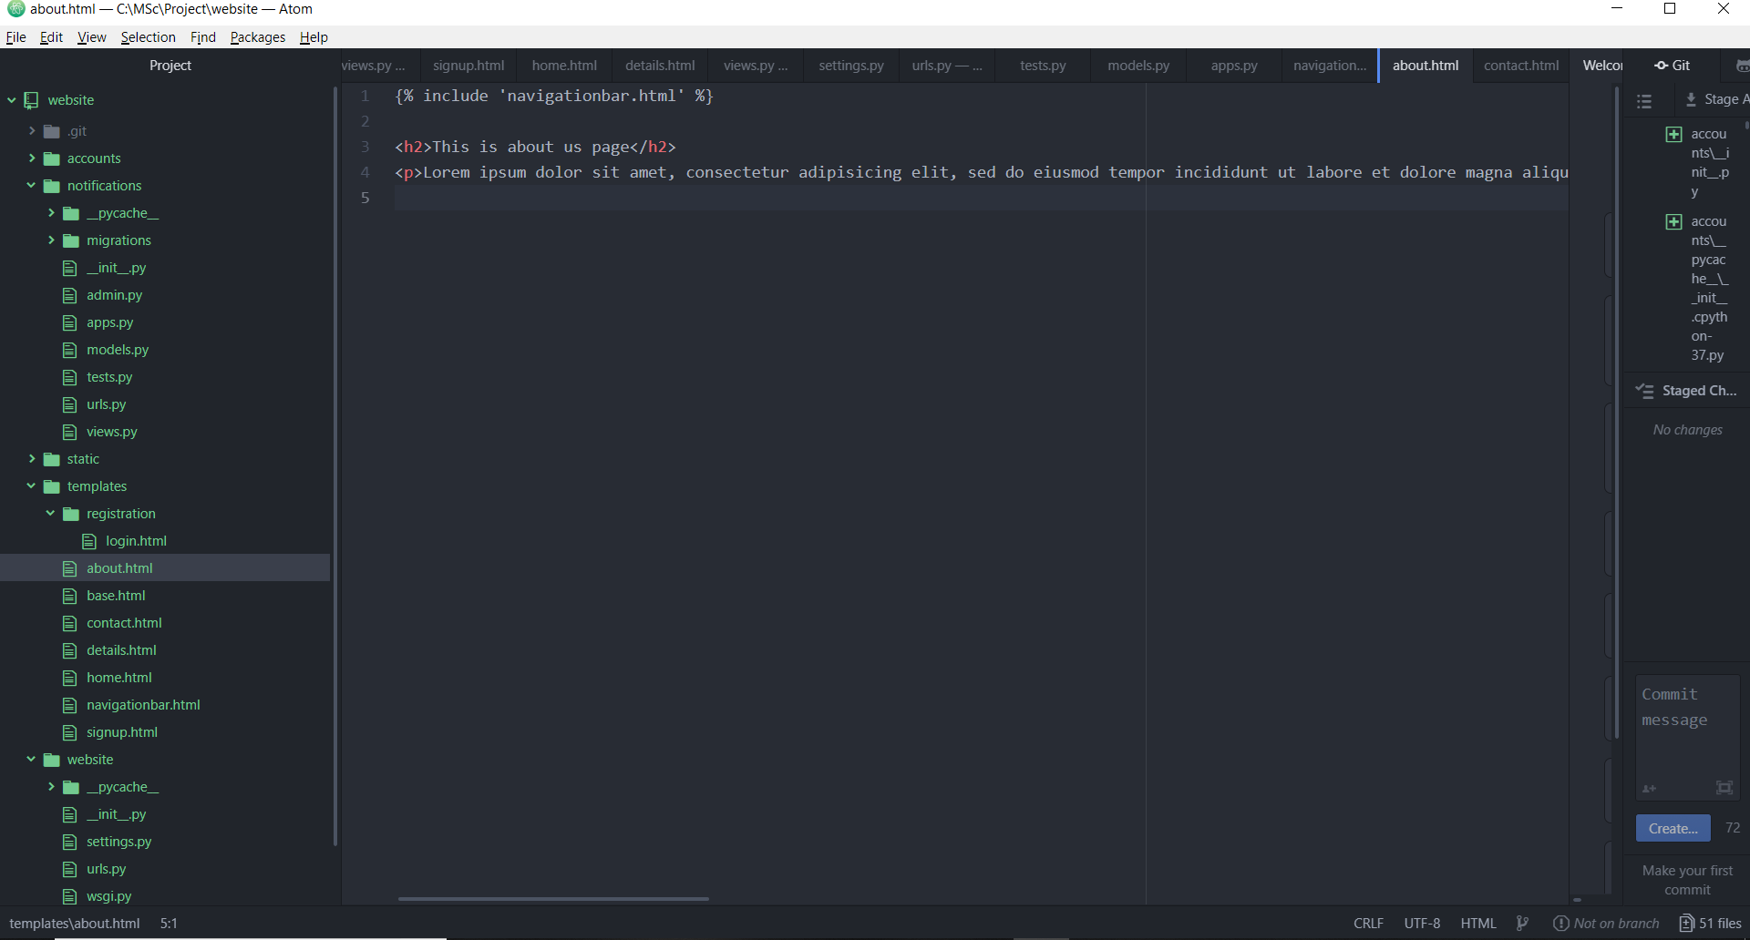

Go to contact.html:-

{% include 'navigationbar.html' %}

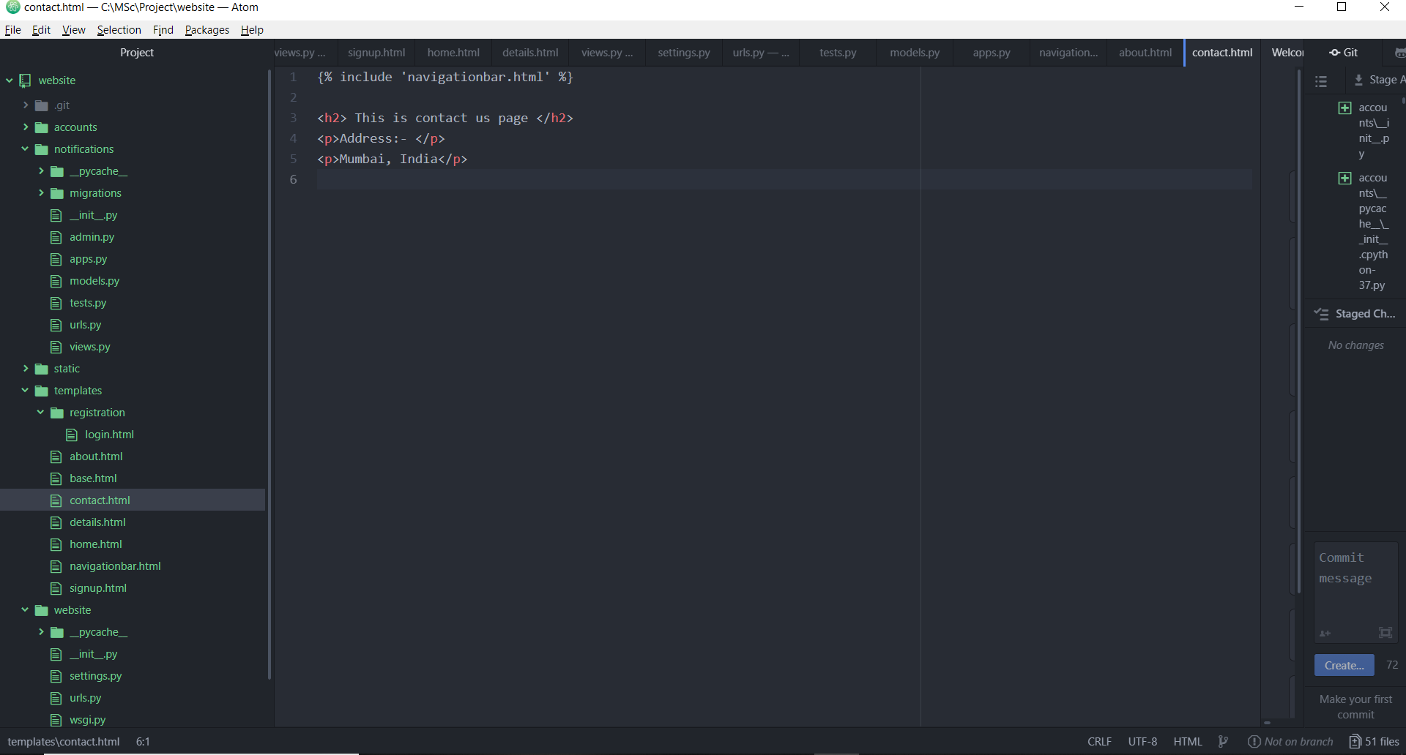

**UI Design:-**

**navigationbar.html:-**

{% load staticfiles %}

<nav class="navbar navbar-expand-lg navbar-dark bg-primary">

<!-- Image and text -->

<a class="navbar-brand" href="#">

<img src="{% static 'img/favicon.jpg' %}" width="30" height="30" class="d-inline-block align-top" alt="">

MovieHub

</a>

<!-- Remaining Navigation Bar contents -->

<div class="collapse navbar-collapse" id="navbarSupportedContent">

<ul class="navbar-nav mr-auto">

<li class="nav-item active">

<a class="nav-link" href="{% url 'home' %}">Home <span class="sr-only">(current)</span></a>

</li>

<li class="nav-item">

<a class="nav-link" href="{% url 'about' %}">About Us</a>

</li>

<li class="nav-item">

<a class="nav-link" href="{% url 'about' %}">Trending Movies</a>

</li>

<li class="nav-item">

<a class="nav-link" href="{% url 'contact' %}">Contact Us</a>

</li>

</ul>

{% if user.is_authenticated %}

<button type="button" class="btn btn-dark">Welcome</button>

{% else %}

<form class="form-inline my-2 my-lg-0">

<button type="button" class="btn btn-dark">Register</button>

<button type="button" class="btn btn-dark">Member Sign-in</button>

</form>

{% endif %}

</div>

</nav>

{% block content %}

{% endblock content %}

**base.html**

{% load staticfiles %}

{% include 'navigationbar.html' %}

<!DOCTYPE>

<html lang = "en">

<head>

<meta charset = "UTF-8">

<meta name = "viewport" content = "width = device-width, initial-scale = 1.0">

<meta http-equiv = "X-UA-Compatible" content = "ie = edge">

<title>Cloud-based Movie Recommendation System</title>

<link rel = "stylesheet" href = "{% static 'css/basestyles.css' %}">

<link rel = "stylesheet" href = "{% static 'bootstrap-4.1.3-dist/css/bootstrap.min.css' %}">

<script src="https://ajax.googleapis.com/ajax/libs/jquery/1.12.4/jquery.min.js"></script>

<script src = "{% static 'bootstrap-4.1.3-dist/js/bootstrap.min.js' %}"></script>

</head>

<body>

<div class="container">

{% if user.is_authenticated %}

<p> You are logged in !!! </p>

<p> Hello: {{user.username}}, How are you </p>

<p> Please <a href = "{% url 'logout' %}"> Logout </a> here </p>

{% else %}

<p>You are not logged in !!! </p>

<p> Please <a href = "{% url 'login' %}"> Login </a> here </p>

{% endif %}

{% block content %}

{% endblock content %}

</div>

</body>

</html>

**contact.html:-**

{% load staticfiles %}

{% include 'navigationbar.html' %}

<!DOCTYPE>

<html lang = "en">

<head>

<meta charset = "UTF-8">

<meta name = "viewport" content = "width = device-width, initial-scale = 1.0">

<meta http-equiv = "X-UA-Compatible" content = "ie = edge">

<title>Cloud-based Movie Recommendation System</title>

<link rel = "stylesheet" href = "{% static 'css/basestyles.css' %}">

<link rel = "stylesheet" href = "{% static 'bootstrap-4.1.3-dist/css/bootstrap.min.css' %}">

<script src="https://ajax.googleapis.com/ajax/libs/jquery/1.12.4/jquery.min.js"></script>

<script src = "{% static 'bootstrap-4.1.3-dist/js/bootstrap.min.js' %}"></script>

</head>

<body>

<h2>This is contact us page</h2>

<p>Address:- </p>

<p>Mumbai, India</p>

</body>

</html>

**about.html:-**

{% load staticfiles %}

{% include 'navigationbar.html' %}

<!DOCTYPE>

<html lang = "en">

<head>

<meta charset = "UTF-8">

<meta name = "viewport" content = "width = device-width, initial-scale = 1.0">

<meta http-equiv = "X-UA-Compatible" content = "ie = edge">

<title>Cloud-based Movie Recommendation System</title>

<link rel = "stylesheet" href = "{% static 'css/basestyles.css' %}">

<link rel = "stylesheet" href = "{% static 'bootstrap-4.1.3-dist/css/bootstrap.min.css' %}">

<script src="https://ajax.googleapis.com/ajax/libs/jquery/1.12.4/jquery.min.js"></script>

<script src = "{% static 'bootstrap-4.1.3-dist/js/bootstrap.min.js' %}"></script>

</head>

<body>

<h2>This is about us page</h2>

<p>Lorem ipsum dolor sit amet, consectetur adipisicing elit, sed do eiusmod tempor incididunt ut labore et dolore magna aliqua. Ut enim ad minim veniam, quis nostrud exercitation ullamco laboris nisi ut aliquip ex ea commodo consequat. Duis aute irure dolor in reprehenderit in voluptate velit esse cillum dolore eu fugiat nulla pariatur. Excepteur sint occaecat cupidatat non proident, sunt in culpa qui officia deserunt mollit anim id est laborum.</p>

</body>

</html>

**Adding Trending Movies Page:-**

**Create new app:-**

python manage.py startapp trendingmovies

**Go to website -> settings.py**

‘trendingmovies’,

**Go to website -> urls.py:-**

path('trendingmovies/',include('trendingmovies.urls')),

**Right click on “trendingmovies” -> New File -> Name: urls.py**

from django.urls import path

from . import views

urlpatterns = [

path('trendingmovies/',views.AllTimePopularMoviewsView, name = 'trendingmovies'),

]

**Go to trendingmovies -> views.py**

from django.shortcuts import render

import pandas as pd

import numpy as np

import matplotlib.pyplot as plt

import seaborn as sns

from scipy import stats

from ast import literal_eval

from sklearn.feature_extraction.text import TfidfVectorizer, CountVectorizer

from sklearn.metrics.pairwise import linear_kernel, cosine_similarity

from nltk.stem.snowball import SnowballStemmer

from nltk.stem.wordnet import WordNetLemmatizer

from nltk.corpus import wordnet

from surprise import Reader, Dataset, SVD, evaluate

import warnings; warnings.simplefilter('ignore')

def AllTimePopularMoviewsView(request):

# Loading the required dataset

md = pd. read_csv('C:/MSc/Project/input/movies_metadata.csv')

md['genres'] = md['genres'].fillna('[]').apply(literal_eval).apply(lambda x: [i['name'] for i in x] if isinstance(x, list) else [])

vote_counts = md[md['vote_count'].notnull()]['vote_count'].astype('int')

vote_averages = md[md['vote_average'].notnull()]['vote_average'].astype('int')

C = vote_averages.mean()

m = vote_counts.quantile(0.95)

md['year'] = pd.to_datetime(md['release_date'], errors='coerce').apply(lambda x: str(x).split('-')[0] if x != np.nan else np.nan)

qualified = md[(md['vote_count'] >= m) & (md['vote_count'].notnull()) & (md['vote_average'].notnull())][['title', 'year', 'vote_count', 'vote_average', 'popularity', 'genres']]

qualified['vote_count'] = qualified['vote_count'].astype('int')

qualified['vote_average'] = qualified['vote_average'].astype('int')

def weighted_rating(x):

v = x['vote_count']

R = x['vote_average']

return (v/(v+m) * R) + (m/(m+v) * C)

qualified['wr'] = qualified.apply(weighted_rating, axis=1)

qualified = qualified.sort_values('wr', ascending=False).head(250)

results = qualified.head(15)

return render(request, 'trendingmovies.html', {'result': results})

**Right click on “templates” -> New File -> Name : trendingmovies.html**

{% load staticfiles %}

{% include 'navigationbar.html' %}

<!DOCTYPE>

<html lang = "en">

<head>

<meta charset = "UTF-8">

<meta name = "viewport" content = "width = device-width, initial-scale = 1.0">

<meta http-equiv = "X-UA-Compatible" content = "ie = edge">

<title>Cloud-based Movie Recommendation System</title>

<link rel = "stylesheet" href = "{% static 'css/basestyles.css' %}">

<link rel = "stylesheet" href = "{% static 'bootstrap-4.1.3-dist/css/bootstrap.min.css' %}">

<script src="https://ajax.googleapis.com/ajax/libs/jquery/1.12.4/jquery.min.js"></script>

<script src = "{% static 'bootstrap-4.1.3-dist/js/bootstrap.min.js' %}"></script>

</head>

<body>

<h2>TrendingMovies</h2>

<p>Top All-Time Popular Movies</p>

<!-- This will create a responsive table : Bootstrap - Tables - Responsive Tables -->

<div class="table-responsive">

<!-- Bootsrap -> Table -> Striped, Bordered, Hoverable, Small Table -->

<table class="table table-striped table-bordered table-hover .table-sm">

<thead class = "thead-dark">

<tr>

<th scope="col">Title</th>

<th scope="col">Year</th>

<th scope="col">Vote count</th>

<th scope="col">Vote average</th>

<th scope="col">Popularity</th>

<th scope="col">Genres</th>

<th scope="col">Weighted Ratio</th>

</tr>

</thead>

<tbody>

<tr scope="row">

<td> {{ result.title }} </td>

<td> {{ result.year }} </td>

<td> {{ result.vote_count }} </td>

<td> {{ result.vote_average }} </td>

<td> {{ result.popularity }} </td>

<td>{{ result.genres }}</td>

<td>{{ result.wr }}</td>

</tr>

</tbody>

</table>

</div>

</body>

</html>

**navigationbar.html:-**

<li class="nav-item">

<a class="nav-link" href="{% url 'trendingmovies' %}">Trending Movies</a>

</li>

Preparing for migration: -

Apply migrations:-

Run server:-

**By Genre:-**

**Navigationbar.html:-**

<li class="nav-item">

<a class="nav-link" href="{% url 'bygenre' %}">By Genre</a>

</li>

**Create new app:-**

python manage.py startapp bygenre

**Go to website -> settings.py**

‘bygenre’,

**Go to website -> urls.py:-**

path('bygenre/',include('bygenre.urls')),

**Right click on “bygenre” -> New File -> Name: urls.py**

from django.urls import path

from . import views

urlpatterns = [

path('bygenre/',views.ActionPopularMoviewsView, name = 'bygenre'),

]

**Go to bygenres -> views.py**

from django.shortcuts import render

import pandas as pd

import numpy as np

import matplotlib.pyplot as plt

import seaborn as sns

from scipy import stats

from ast import literal_eval

from sklearn.feature_extraction.text import TfidfVectorizer, CountVectorizer

from sklearn.metrics.pairwise import linear_kernel, cosine_similarity

from nltk.stem.snowball import SnowballStemmer

from nltk.stem.wordnet import WordNetLemmatizer

from nltk.corpus import wordnet

from surprise import Reader, Dataset, SVD, evaluate

import warnings; warnings.simplefilter('ignore')

def ActionPopularMoviewsView(request):

md = pd. read_csv('C:/MSc/Project/input/movies_metadata.csv')

md['genres'] = md['genres'].fillna('[]').apply(literal_eval).apply(lambda x: [i['name'] for i in x] if isinstance(x, list) else [])

vote_counts = md[md['vote_count'].notnull()]['vote_count'].astype('int')

vote_averages = md[md['vote_average'].notnull()]['vote_average'].astype('int')

C = vote_averages.mean()

m = vote_counts.quantile(0.95)

md['year'] = pd.to_datetime(md['release_date'], errors='coerce').apply(lambda x: str(x).split('-')[0] if x != np.nan else np.nan)

qualified = md[(md['vote_count'] >= m) & (md['vote_count'].notnull()) & (md['vote_average'].notnull())][['title', 'year', 'vote_count', 'vote_average', 'popularity', 'genres']]

qualified['vote_count'] = qualified['vote_count'].astype('int')

qualified['vote_average'] = qualified['vote_average'].astype('int')

def weighted_rating(x):

v = x['vote_count']

R = x['vote_average']

return (v/(v+m) * R) + (m/(m+v) * C)

qualified['wr'] = qualified.apply(weighted_rating, axis=1)

qualified = qualified.sort_values('wr', ascending=False).head(250)

results = qualified.head(15)

s = md.apply(lambda x: pd.Series(x['genres']),axis=1).stack().reset_index(level=1, drop=True)

s.name = 'genre'

gen_md = md.drop('genres', axis=1).join(s)

def build_chart(genre, percentile=0.85):

df = gen_md[gen_md['genre'] == genre]

vote_counts = df[df['vote_count'].notnull()]['vote_count'].astype('int')

vote_averages = df[df['vote_average'].notnull()]['vote_average'].astype('int')

C = vote_averages.mean()

m = vote_counts.quantile(percentile)

qualified = df[(df['vote_count'] >= m) & (df['vote_count'].notnull()) & (df['vote_average'].notnull())][['title', 'year', 'vote_count', 'vote_average', 'popularity']]

qualified['vote_count'] = qualified['vote_count'].astype('int')

qualified['vote_average'] = qualified['vote_average'].astype('int')

qualified['wr'] = qualified.apply(lambda x: (x['vote_count']/(x['vote_count']+m) * x['vote_average']) + (m/(m+x['vote_count']) * C), axis=1)

qualified = qualified.sort_values('wr', ascending=False).head(250)

return qualified

results = build_chart('Action').head(15)

return render(request, 'bygenre.html', {'result': results})

**Right click on “templates” -> New File -> Name : bygenre.html**

{% load staticfiles %}

{% include 'navigationbar.html' %}

<!DOCTYPE>

<html lang = "en">

<head>

<meta charset = "UTF-8">

<meta name = "viewport" content = "width = device-width, initial-scale = 1.0">

<meta http-equiv = "X-UA-Compatible" content = "ie = edge">

<title>Cloud-based Movie Recommendation System</title>

<link rel = "stylesheet" href = "{% static 'css/basestyles.css' %}">

<link rel = "stylesheet" href = "{% static 'bootstrap-4.1.3-dist/css/bootstrap.min.css' %}">

<script src="https://ajax.googleapis.com/ajax/libs/jquery/1.12.4/jquery.min.js"></script>

<script src = "{% static 'bootstrap-4.1.3-dist/js/bootstrap.min.js' %}"></script>

</head>

<body>

<h2> By Genre</h2>

<!-- This will create a responsive table : Bootstrap - Tables - Responsive Tables -->

<div class="table-responsive">

<!-- Bootsrap -> Table -> Striped, Bordered, Hoverable, Small Table -->

<table class="table table-striped table-bordered table-hover .table-sm">

<thead class = "thead-dark">

<tr>

<th scope="col">Title</th>

<th scope="col">Year</th>

<th scope="col">Vote count</th>

<th scope="col">Vote average</th>

<th scope="col">Popularity</th>

<th scope="col">Weighted Ratio</th>

</tr>

</thead>

<tbody>

<tr scope="row">

<td> {{ result.title }} </td>

<td> {{ result.year }} </td>

<td> {{ result.vote_count }} </td>

<td> {{ result.vote_average }} </td>

<td> {{ result.popularity }} </td>

<td>{{ result.wr }}</td>

</tr>

</tbody>

</table>

</div>

</body>

</html>

**Register and Member Sign-in Link redirect:-**

Go to navigation bar.html:-

<form class="form-inline my-2 my-lg-0">

<a href="{% url 'signup' %}" class="btn btn-success" role="button">Register</a>

<a href="{% url 'login' %}" class="btn btn-success" role="button">Member Sign-in</a>

</form>

**Adding icons in navigationbar.html:-**

Put image in img folder and write:-

<img src="{% static 'img/home.png' %}" width="30" height="30" class="d-inline-block align-top" alt="">

**Login and signup – Adding css:-**

Reference:- https://www.youtube.com/watch?v=-oFIIgpZsVs

**In basestyles.css – add new css**

body{

background-color: #636e72;

color: #FFF;

}

h1 {

font-size: 2.5rem;

text-align: center;

margin-top: 25px;

}

a{

color: #0984e3;

}

.container {

margin-top: 20px;

background-color: lightseagreen;

padding: 30px;

border-radius:25px;

}

button {

background-color:cornflowerblue;

color:#FFF;

}

.center {

margin-left: 40%;

}

form[name="login_form"], form[name="signup_form"] {

font-family: cursive;

}

.center-elem {

text-align: center;

}

.text-font {

color:cornsilk;

}

form[name="login_form"] input:focus{

border-color: cornflowerblue;

}

form[name="signup_form"] input:focus{

border-color: cornflowerblue;

}

**In base.html – add any text/image:-**

{% load staticfiles %}

{% include 'navigationbar.html' %}

<!DOCTYPE>

<html lang = "en">

<head>

<meta charset = "UTF-8">

<meta name = "viewport" content = "width = device-width, initial-scale = 1.0">

<meta http-equiv = "X-UA-Compatible" content = "ie = edge">

<title>Cloud-based Movie Recommendation System</title>

<link rel = "stylesheet" href = "{% static 'css/basestyles.css' %}">

<link rel = "stylesheet" href = "{% static 'bootstrap-4.1.3-dist/css/bootstrap.min.css' %}">

<script src="https://ajax.googleapis.com/ajax/libs/jquery/1.12.4/jquery.min.js"></script>

<script src = "{% static 'bootstrap-4.1.3-dist/js/bootstrap.min.js' %}"></script>

</head>

<body>

<div class="container">

{% if user.is_authenticated %}

<p> You are logged in !!! </p>

<p> Hello: {{user.username}}. Your last login time is: {{user.last_login}} </p>

<p> Please <a href = "{% url 'logout' %}"> Logout </a> here </p>

{% else %}

<p>You are not logged in !!! </p>

<p> Please <a href = "{% url 'login' %}"> Login </a> here </p>

{% endif %}

{% block content %}

{% endblock content %}

<p class="center-elem"><a class="text-font" href="{% url 'login' %}">Already have an account? Sign-in</a> | <a class="text-font" href="{% url 'signup' %}">Don't have an account? Signup Now</a> | <a class="text-font" href="{% url 'home' %}"><img src="{% static 'img/back.png' %}" width="30" height="30" class="d-inline-block align-top" alt="Back">Return to HomePage</a></p>

</div>

</body>

</html>

**In login.html:-**

{% extends 'base.html' %}

{% load staticfiles %}

{% block content %}

<h1>MEMBER SIGN-IN</h1>

<div class="dropdown-divider"></div>

<div class="dropdown-divider"></div>

<img src="{% static 'img/login-img.png' %}" width="200px" height="200px" class="d-inline-block align-top center" alt="Login">

<form method = "POST" name="login_form" class="center-elem">

{% csrf_token %}

{{form.as_p}}

<button type = "submit" class="btn btn-dark"> Member Sign-in </button>

</form>

{% endblock content %}

**In signup.html:-**

{% extends 'base.html' %}

{% load staticfiles %}

{% block content %}

<h1>SIGN-UP</h1>

<div class="dropdown-divider"></div>

<div class="dropdown-divider"></div>

<img src="{% static 'img/signup.png' %}" width="200px" height="200px" class="d-inline-block align-top center" alt="Login">

<form method="POST" name="signup_form">

{% csrf_token %}

{{ form.as_p }}

<button type="submit" class="btn btn-dark" style="margin-left:45%;"> Signup Me !!! </button>

</form>

{% endblock content %}

**About..html – content and designing:-**

{% load staticfiles %}

{% include 'navigationbar.html' %}

<!DOCTYPE html>

<html lang="en">

<head>

<meta charset = "UTF-8">

<meta name = "viewport" content = "width = device-width, initial-scale = 1.0">

<meta http-equiv = "X-UA-Compatible" content = "ie = edge">

<title>Cloud-based Movie Recommendation System</title>

<link rel = "stylesheet" href = "{% static 'css/basestyles.css' %}">

<link rel = "stylesheet" href = "{% static 'bootstrap-4.1.3-dist/css/bootstrap.min.css' %}">

<link href="https://maxcdn.bootstrapcdn.com/font-awesome/4.6.3/css/font-awesome.min.css" rel="stylesheet" integrity="sha384-T8Gy5hrqNKT+hzMclPo118YTQO6cYprQmhrYwIiQ/3axmI1hQomh7Ud2hPOy8SP1" crossorigin="anonymous">

<script src="https://ajax.googleapis.com/ajax/libs/jquery/1.12.4/jquery.min.js"></script>

<script src="https://code.jquery.com/jquery-3.2.1.slim.min.js" integrity="sha384-KJ3o2DKtIkvYIK3UENzmM7KCkRr/rE9/Qpg6aAZGJwFDMVNA/GpGFF93hXpG5KkN" crossorigin="anonymous"></script>

<script src="https://cdnjs.cloudflare.com/ajax/libs/popper.js/1.11.0/umd/popper.min.js" integrity="sha384-b/U6ypiBEHpOf/4+1nzFpr53nxSS+GLCkfwBdFNTxtclqqenISfwAzpKaMNFNmj4" crossorigin="anonymous"></script>

<script src = "{% static 'bootstrap-4.1.3-dist/js/bootstrap.min.js' %}"></script>

<style>

#contact .card:hover i,#contact .card:hover h4

{

color: #87d37c;

}

</style>

</head>

<body>

<section id="contact">

<div class="container">

<div class="text-center w-100 m-auto">Reach out to us and we'll respond as soon as possible.. </div>

<div class="dropdown-divider"></div>

<div class="dropdown-divider"></div>

<h3 class="text-center text-uppercase">about the product</h3>

<div class="dropdown-divider"></div>

<div class="dropdown-divider"></div>

<p class="text-center w-100 m-auto">Lorem ipsum dolor sit amet, consectetur adipisicing elit, sed do eiusmod tempor incididunt ut labore et dolore magna aliqua. Ut enim ad minim veniam, quis nostrud exercitation ullamco laboris nisi ut aliquip ex ea commodo consequat. Duis aute irure dolor in reprehenderit in voluptate velit esse cillum dolore eu fugiat nulla pariatur. Excepteur sint occaecat cupidatat non proident, sunt in culpa qui officia deserunt mollit anim id est laborum.</p>

<div class="row">

<div class="col-sm-12 col-md-6 col-lg-3 my-5">

<div class="card border-0">

<div class="card-body text-center">

<img src="{% static 'img/recommendation-engine.png' %}" width="140" height="140" class="d-inline-block align-top" alt="Recommendation">

<h5 class="text-uppercase mb-5">recommendation engine</h5>

<p>Often termed as Recommender Systems, it aims to provide the most relevant and accurate items to the user by filtering useful stuff from of a huge pool of information base. The suggestions provided are aimed at supporting their users in various decision making processes. It discovers data patterns in the data set by learning consumers choices and produces the outcomes that co-relates to their needs and interests.</p>

</div>

</div>

</div>

<div class="col-sm-12 col-md-6 col-lg-3 my-5">

<div class="card border-0">

<div class="card-body text-center">

<img src="{% static 'img/data-analysis.png' %}" width="200" height="140" class="d-inline-block align-top" alt="Data Analysis">

<h5 class="text-uppercase mb-5">data analysis and interpretation</h5>

<p>The purpose of analysing data is to obtain usable and useful information. This analysis and interpretation of data may:<br>

- describe and summarise the data.<br><br>

- identify relationships between variables.<br><br>

- compare variables.<br><br>

- identify the difference between variables.<br><br>

- forecast outcomes.

</p>

</div>

</div>

</div>

<div class="col-sm-12 col-md-6 col-lg-3 my-5">

<div class="card border-0">

<div class="card-body text-center">

<img src="{% static 'img/data-visualization.jpg' %}" width="140" height="140" class="d-inline-block align-top" alt="Data Analytics">

<h5 class="text-uppercase mb-5">dashboards - data visualization</h5>

<p>Data visualization is the presentation of data in graphical format. Displayed in the form of dashboards, it enables decision makers to see analytics presented visually , so they can comprehend the information quickly. With interactive visualizations we take a step further by using technology to drill down into charts and graphs for more detail, interactively changing what data you see and how it's processed.</p>

</div>

</div>

</div>

<div class="col-sm-12 col-md-6 col-lg-3 my-5">

<div class="card border-0">

<div class="card-body text-center">

<img src="{% static 'img/dashboard.png' %}" width="140" height="140" class="d-inline-block align-top" alt="Dashboard">

<h5 class="text-uppercase mb-5">other add-on features</h5>

<p>Some other add-on features:<br><br>

- Regressor : This will predict the revenue.<br><br>

- Classifier : This will predict the expected success ratio.<br><br>

- To predict the genre of a movie by analyzing its poster.<br><br>

- Opinion mining on user ratings.<br><br>

- Exploration of movie roles by gender.

</p>

</div>

</div>

</div>

</div>

</div>

</section>

</body>

</html>

**Proper display of login, signup:-**

Login.html:-

{% extends 'base.html' %}

{% load staticfiles %}

{% block content %}

<h1>MEMBER SIGN-IN</h1>

<div class="dropdown-divider"></div>

<div class="dropdown-divider"></div>

<img src="{% static 'img/login-img.png' %}" width="200px" height="200px" class="d-inline-block align-top center" alt="Login">

<form method = "POST" name="login_form" class="center-elem">

{% csrf_token %}

{{form.as_p}}

<button type = "submit" class="btn btn-dark"> Member Sign-in </button>

</form>

{% endblock content %}

Home.html:-

{% extends 'base.html' %}

{% block content %}

{% for num_notifications in object_list %}

<div class = "notification">

<h3><a href = "{% url 'notification_page' num_notifications.pk %}">{{num_notifications.title}}</a></h3>

<p>{{num_notifications.text}}</p>

</div>

{% endfor %}

{% endblock content %}

Navigationbar.html:-

{% load staticfiles %}

<nav class="navbar navbar-expand-lg navbar-dark bg-primary">

<!-- Image and text -->

<a class="navbar-brand" href="{% url 'home' %}">

<img src="{% static 'img/favicon.jpg' %}" width="30" height="30" class="d-inline-block align-top" alt="MovieHub">

MovieHub

</a>

<!-- Remaining Navigation Bar contents -->

<div class="collapse navbar-collapse" id="navbarSupportedContent">

<ul class="navbar-nav mr-auto">

<li class="nav-item active">

<a class="nav-link" href="{% url 'home' %}"><img src="{% static 'img/home.png' %}" width="30" height="30" class="d-inline-block align-top" alt="Home">Home <span class="sr-only">(current)</span></a>

</li>

<li class="nav-item">

<a class="nav-link" href="{% url 'about' %}"><img src="{% static 'img/about.png' %}" width="30" height="30" class="d-inline-block align-top" alt="About Us">About Product</a>

</li>

<li class="nav-item">

<a class="nav-link" href="{% url 'contact' %}"><img src="{% static 'img/collection.png' %}" width="30" height="30" class="d-inline-block align-top" alt="Collection">Collection</a>

</li>

<li class="nav-item">

<a class="nav-link" href="{% url 'trendingmovies' %}"><img src="{% static 'img/trend.png' %}" width="30" height="30" class="d-inline-block align-top" alt="Trending Movies">Trending Movies</a>

</li>

<li class="nav-item">

<a class="nav-link" href="{% url 'bygenre' %}"><img src="{% static 'img/genre.png' %}" width="30" height="30" class="d-inline-block align-top" alt="By Genre">By Genre</a>

</li>

<li class="nav-item">

<a class="nav-link" href="{% url 'visualizations' %}"><img src="{% static 'img/dashboard.png' %}" width="30" height="30" class="d-inline-block align-top" alt="Dashboard">Dashboard</a>

</li>

<li class="nav-item">

<a class="nav-link" href="{% url 'contact' %}"><img src="{% static 'img/contactus.png' %}" width="30" height="30" class="d-inline-block align-top" alt="Contact Us">Contact Us</a>

</li>

</ul>

{% if user.is_authenticated %}

<a href="{% url 'logout' %}" class="btn btn-dark" role="button"><img src="{% static 'img/logout.ico' %}" width="30" height="30" class="d-inline-block align-top" alt="">Logout</a>

{% else %}

<form class="form-inline my-2 my-lg-0">

<a href="{% url 'signup' %}" class="btn btn-dark" role="button"><img src="{% static 'img/signup.png' %}" width="30" height="30" class="d-inline-block align-top" alt="">Register</a>

<a href="{% url 'login' %}" class="btn btn-dark" role="button"><img src="{% static 'img/login.png' %}" width="30" height="30" class="d-inline-block align-top" alt="">Member Sign-in</a>

</form>

{% endif %}

</div>

</nav>

{% block content %}

{% endblock content %}

Base.html:-

{% load staticfiles %}

{% include 'navigationbar.html' %}

<!DOCTYPE>

<html lang = "en">

<head>

<meta charset = "UTF-8">

<meta name = "viewport" content = "width = device-width, initial-scale = 1.0">

<meta http-equiv = "X-UA-Compatible" content = "ie = edge">

<title>Cloud-based Movie Recommendation System</title>

<link rel = "stylesheet" href = "{% static 'css/basestyles.css' %}">

<link rel = "stylesheet" href = "{% static 'bootstrap-4.1.3-dist/css/bootstrap.min.css' %}">

<script src="https://ajax.googleapis.com/ajax/libs/jquery/1.12.4/jquery.min.js"></script>

<script src = "{% static 'bootstrap-4.1.3-dist/js/bootstrap.min.js' %}"></script>

</head>

<body>

<!-- After navigation bar -->

<div style="background-color:#000;">

{% if user.is_authenticated %}

{% else %}

<p class="center-elem"><a class="text-font" href="{% url 'login' %}">Already have an account? Sign-in</a> <span class="text-font">|</span> <a class="text-font" href="{% url 'signup' %}">Don't have an account? Signup Now</a> <span class="text-font">| </span><a class="text-font" href="{% url 'home' %}"><img src="{% static 'img/back.jpg' %}" width="30" height="30" class="d-inline-block align-top" alt="Back">Return to HomePage</a></p>

{% endif %}

</div>

<div>

{% if user.is_authenticated %}

<p> Hello: {{user.username}}. Your last login was at : {{user.last_login}} </p>

{% else %}

{% endif %}

</div>

<div class="container">

{% block content %}

{% endblock content %}

</div>

</body>

</html>

Basestyles.css:-

body{

background-color: #636e72;

color: #FFF;

}

h1 {

font-size: 2.5rem;

text-align: center;

margin-top: 25px;

}

a{

color: #0984e3;

}

.container {

margin-top: 20px;

background-color: lightseagreen;

padding: 30px;

border-radius:25px;

}

button {

background-color:cornflowerblue;

color:#FFF;

}

.center {

margin-left: 40%;

}

form[name="login_form"], form[name="signup_form"] {

font-family: cursive;

}

.center-elem {

text-align: center;

}

.text-font {

color:cornsilk;

}

form[name="login_form"] input:focus{

border-color: cornflowerblue;

}

form[name="signup_form"] input:focus{

border-color: cornflowerblue;

}

**Visualizations:-**

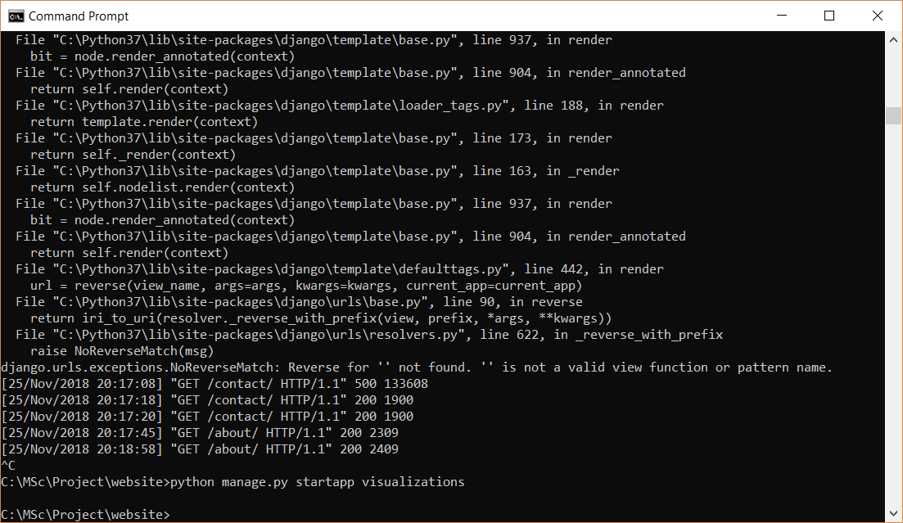

Go to website -> settings.py

'visualizations',

Go to website -> urls.py

path('visualizations/',include('visualizations.urls')),

Go to visualizations -> urls.py

from django.urls import path

from . import views

urlpatterns = [

path('',views.barchartview, name = 'visualizations')

]

Go to visualizations -> views.py

from django.shortcuts import render

from django.http import HttpResponse

# Create your views here.

def barchartview(request):

return HttpResponse("Hello")

navigationbar.html:-

<li class="nav-item">

<a class="nav-link" href="{% url 'visualizations' %}">Dashboard</a>

</li>

Run server:- Hello is displayed

**Recommendation algorithm:-**